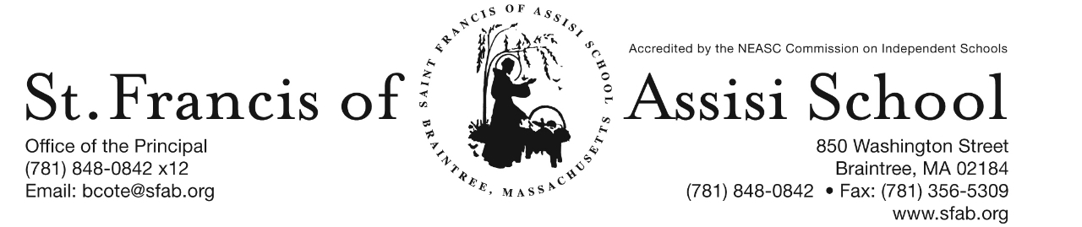

Volume 4, Issue 11 – November 23, 2016
IMPORTANT DATES

Wed, Nov. 23rd
- 11:30 Early Dismissal Day

Thur, Nov. 24th
- Thanksgiving

Sun, Nov. 27th
- 1st Sunday of Advent

Fri, Dec. 2nd
- Picture Make-Up Day

Sun, Dec. 4th
- 2nd Sunday of Advent

Mon, Dec. 5th
- 1st Trimester (PK-grade 5) ends

Thur, Dec. 8th
- All School Liturgy (Feast of the Immaculate Conception); 8: 45

Fri, Dec. 9th
- Santa’s Workshop

Thur, Dec. 15th
- The Chateau Fundraiser; 11:15 - closing

Fri, Dec. 16th
- SFA Christmas Concerts

Sat, Dec 17th
- Santa’s Breakfast; 8:30 – 11:00 a.m.

Fri, Dec. 23rd
- 11:30 Early Dmissal Day; Busing provided; No Lunch or P.M. Extended Day Service.

Christmas Break
- Dec. 26th – Jan. 2nd

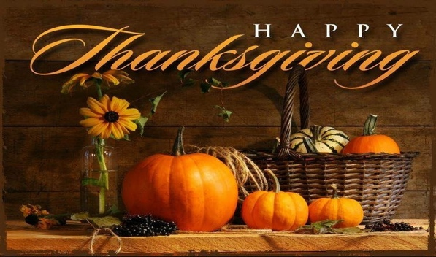
Give Thanks!
Great God, giver of all good gifts, we ask you, above all, to give us truly grateful hearts. May we give thanks for the beauty all around us, in Your creation, in our relationships, in our families and in our school community. May we never take for granted your daily gifts and always enjoy them with thanksgiving.
Thank you, too, for the comfort of our homes, for the blessing of our family life, and the richness of our school community. And though sometimes we feel the heavy weight of our burdens and care, thank You for the grace to see them through.
We we come to the end of each day, may our hearts still be grateful and hopeful and our prayer full of thanksgiving. Amen

On behalf of the Administration and Faculty at SFA, I want to wish you a Safe, Healthy and Happy Thanksgiving.

PICTURE MAKE-UP DAY
Lifetouch Photographers will be at SFA for a re-take/make-up day on Friday, December 2nd.

ADVENT 2016 – With the upcoming hustle and bustle of Christmas shopping, all of the decorating and wrapping of gifts, it is important, as Catholics, to remember that the Season of Advent begins this weekend. It is a difficult season to celebrate because of the commercialism of the secular world in which we live.
The Season of Advent allows us time to prepare ourselves for Christmas, as we ponder how Jesus came into this world in such a stunningly humble way and it is also a time when we look forward to His second coming at the end of the ages.

During the next four weeks, the SFA school community will make this Season of Advent a central focus of our actions and discussions within our classrooms. Some of our planned Advent activities will include prayer and liturgies, penance services, arts and crafts, Christmas stories, songs, and service projects. In addition, the faculty and students will participate in several outreach service projects – making the “spirit of giving” tangible for us. We wish to make the holidays a little brighter and bring joy to those who are far from home, as well as less fortunate.

ADVENT PENANCE SERVICES
- Grade 3 Tuesday, December 20th at 1:00 p.m.
- Grade 4 Tuesday, December 20th at 8:00 a.m.
- Grade 5 Monday, December 19th at 8:00 a.m.
- Grade 6 Monday, December 12th at 1:00 p.m.
- Grade 7 Monday, December 19th at 1:00 p.m.
- Grade 8 Monday, December 5th at 1:00 p.m.

HOLIDAY CALENDAR CAMPGAIGN

With Thanksgiving right around the corner, what an ideal time to ask family and friends to support our school by purchasing one of our Holiday Calendars.

Just a reminder that our Holiday Calendar Campaign will end on December 15th, with our first drawing taking place on January 5th.

Need Your Assistance! We will be seeking students and parents who would be interested in assisting us in selling Holiday Calendars at the end of the weekend masses at St. Francis of Assisi Parish the weekends of December 10/11 and 17/18. The mass schedule includes Saturday at 4:00; Sunday at 7:00, 9:30, and 10:30. If you could help us with one of these times, it would be greatly appreciated. If interested, please contact Mrs. Daly at 781-848-0842 x10 or email cdaly@sfab.org.

OPEN GYM
Open gym for all interested 5th and 6th grade girls and all interested 3rd and 4th boys and girls. Thursday, December 1st from 4:00 – 5:00 pm at the Morrison School in Braintree. This is a “Try before you buy” session! If your child is uncertain about committing, have them attend and see what our program is all about. With a focus on learning fundermental skills, building confidence, and self-esteem and being a part of a team, this is a great program for all levels of ability.

Care pooling from Extended Day is available with required dismissal notes. For information, please call Ms.Marie Lenane at 617-594-7605.

BASKETBALL INFORMATION
One of the several extracurricular activities that St. Francis of Assisi School offers is its organized basketball teams for both girls and boys. Our school is a member and participates in the South Shore Parochial School League (S.S.P.S.L.). This league runs a basketball program for full-time students in grades three through eight, attending Boston's "South Shore" Parish/Catholic Schools. This program is overseen by the Office for New Evangelization of Youth & Young Adults and administered by the Archdiocese of Boston CYO Program.

The schedule of games has been finalized and may be accessed at www.sspsl.net or a link has been added to our school’s website (www.sfab.org) that will automatically bring you to the various schedules.

Please note that SFA’s home court will be at the University Sports Complex, 645 Washington Street in Hanover, not the Daughraty School as currently posted on the website. Looking forward to a wonderful basketball season.

BASKETBALL COACH
We are in desperate need of a basketball coach for our SFA Boys’ 7th and 8th Grade Basketball Team. If you are available to assist us in this capacity, please contact Mr. Cote a.s.a.p. In the event that we may not find a coach, we may not be able to have a 7th and 8th grade team this season. Thanks!

1st TRIMESTER ends
Please note that the 1st trimester for students in grades pre-kindergarten through five will officially end on Monday, December 5th. Report cards will be distributed on Monday, December 12th. Parent-Teacher Conference will take place on Wednesday, January 11th.

UPCOMING SFA IMPORTANT DATES

- Dec. 9th – Santa’s Workshop;
- Dec. 15th – The Chateau from 11:15 am – Close; SFA will receive 20% of food and beverages (eat-in or take-out included);
- Dec. 16th – Christmas Concerts;
- Dec. 17th – Santa’s Breakfast

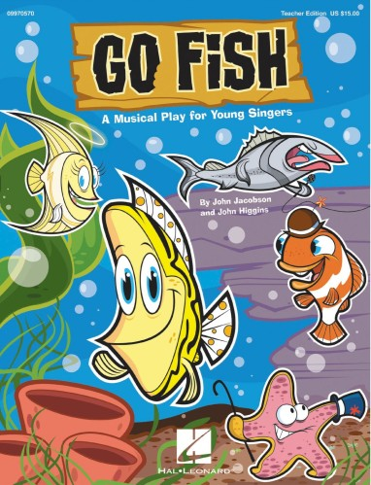
Congratulations to the cast of our SFA Jr. Drama Club for an outstanding performance of "Go Fish" on Friday evening. They were fantastic! A special word of appreciation and thanks to Mrs. Murray, our drama/music director for sharing her gifts and talents with all of us at SFA. Special thanks to Miss Murray for her assistance in making our performance such a huge success. Finally, thank you to our parents for their continued support of our school! Check out some of the highlights of this outstanding performance located on our SFA Facebook Page.

THANK YOU
On behalf of Braintree Holidays, St. Francis of Assisi St. Vincent dePaul and St. Francis of Assisi School, we want to express our appreciation and thank you for your participation in our recent Dress Down Day, as well as Thankgiving Basket Drive, which were huge success.

“At the end of life we will not be judged by how many diplomas we have received, how much money we have made, how many great things we have done.
We will be judged by "I was hungry, and you gave me something to eat, I was naked and you clothed me. I was homeless, and you took me in.”
― Mother Teresa

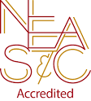
NEASC – RE-ACCREDITATION
In this preparatory phase of the self-study, our parents/guardians are given the opportunity to give feedback about our school (its mission, admission policy, programs, curriculum, etc...). We welcome all constructive information that will assist us in writing our self-study, as well as our multi-year plan.

We want to take this opportunity to express our appreciation and thank the many parents who have already completed the survey. If you have not, we ask that you please do; your input and feedback is so important and valuable to us.

The parent survey may be accessed with the following link: https://www.surveymonkey.com/r/BMT9VTG

FACEBOOK
Make sure you check and like us on our school’s facebook page.
https://www.facebook.com/sfabraintree

