Monday | Tuesday | Wednesday |  |  | Thursday |  | Friday | Special Entree  St. Francis of Assisi Braintree Lunch Menu  December 2016  MENU SUBJECT TO CHANGE WITHOUT NOTICE  (All Weekly Specials include the choice of the day’s fruit, veggie and milk)  Did you know… *Braintree Schools proudly supports local farming and fishing! The Fish-in-Chips on the menu is locally fished from the Gulf of Maine. It is also certified sustainable by GMRI – the Gulf of Maine Research Institute, meaning the fisherman catch in moderation, allowing the fish population to remain steady over time.  We thank North Coast Seafoods for providing this delicious seafood.  Available as entrée choices everyday:  PB & J sandwich with graham crackers and cheese stick  Fresh Garden Salad with Pita Bread
You can now prepay and check balances and transactions online! Go to www.myschoolbucks.com to register.  This institution is an equal opportunity provider | Price of lunch: $3.25 (free and reduced price $0.40 meals available for families that qualify)  Al a Carte Milk: $0.50  Milk and assorted veggies and fresh and cupped fruit is included at every meal every day.  Price for the month of December is $48.75 |  | Applications for free or reduced meals available at school office and at www.braintreeschools.org  Contact Megan Ahrenholz, RD with questions or comments at mahrenholz@braintreema.gov  Or 781-848-4000x7045. | 1  Homemade Beef Chili in a Bread Bowl  Shredded Cheese  Tostitos Baked Scoops Steamed Broccoli  Applesauce |  | 2  Personal Pizza  Carrot Sticks  Pepper Slices  Creamy Ranch Hummus  Fresh Fruit  Cookie |  |  | Tuna salad on a hamburger roll
5  Unbelievably Good Homemade Lasagna  Breadstick  Steamed Broccoli Florets | 6  Grilled Cheese Sandwich  Homemade Southwest Tortilla Soup  Candied Honey Cinnamon Chic Peas  Green Beans  Applesauce |  | 7  American Chop Suey  Garden Side Salad  Smiley Fries  Fresh Orange “smiles” | 8  *Fish-In-chips  Acadian Red fish breaded in Cape Cod potato chips  Baked Krinkle Cut French fries  Homemade cole slaw  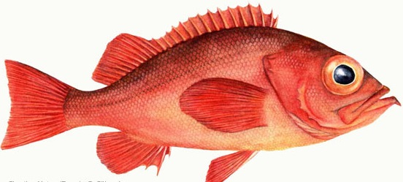  Choice of condiment (tartar sauce, BBQ Sauce, or ketchup)  Dinner roll  Fresh Fruit |  | 9  Stuffed Crust Pizza  Carrot Sticks  Pepper Slices  Zesty Buffalo Bean dip  Fresh Fruit  Cookie |  |  | Choco-Sunbutter & Banana wrap  Sunflower butter and sliced fresh bananas with a sprinkling of mini chocolate chips rolled into a whole wheat wrap

12  Chicken Nuggets  Corn  Green Beans  Pasta  Condiments  Fruit | 13  Ribbq on a WW Bun  Tomato and lettuce toppers  Pickles  Condiments  Homemade Baked Beans  Pears | 14  Homemade whole wheat creamy Mac & Cheese  Carrot coins  Green Beans  Peaches | 15  Personal Pizza  Baby Carrots  Celery  Cherry Tomatoes  Light ranch Dip  Cookie | 16  Half Day  No Lunch served | Ham & cheese sub
19  Chicken Fajita  Cheese  Salsa  Corn  Mixed Fruit | 20  Pulled Pork on a Roll  Tomato & Lettuce Toppers  Baked Potato Wedges  Ketchup  Crispy Crunchy Chic Peas Orange Smiles | 21  Whole Wheat Spaghetti Offered with meatsauce or meatless sauce  Homemade Kale chips  Fruit | 22  Domino’s Pizza  Assorted Fresh Veggies  Light Ranch Dip  Cookie  Fresh Fruit | 23  Half Day  No Lunch served  Merry Christmas! | Buffalo Bill Chicken Wrap  Diced chicken in spicy buffalo sauce served with lettuce in a wheat tortilla

