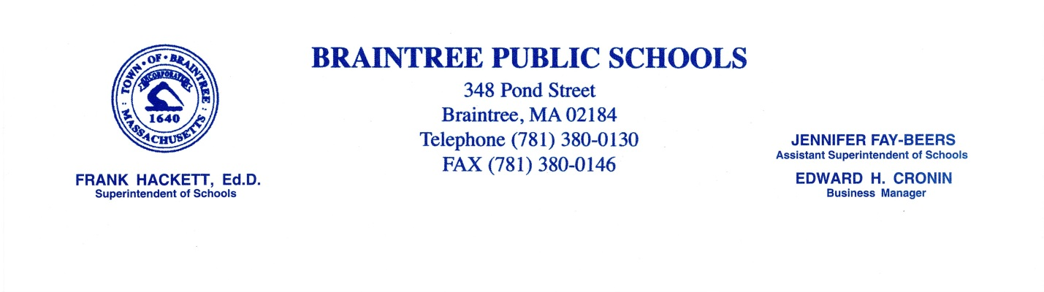Dear Parent/Guardian:
RE: School Seasonal Influenza (Flu) Vaccination Program

The Centers for Disease Control (CDC) is recommending that schools again offer Seasonal Influenza (flu) vaccinations to school aged children for the 2016-2017 school year.

In collaboration with the Braintree Health Department, we have the ability to offer the Seasonal Flu vaccination to students in grades 6 through 12. Unfortunately, we are not able to offer this flu vaccination to elementary school aged students. We are therefore recommending that parents of elementary school aged children contact their primary care provider if they are interested in having their child vaccinated.

If you are interested in having your child participate in the School Seasonal Influenza Vaccination Program, please review the enclosed vaccine information statement (VIS) regarding Inactivated Seasonal Influenza Vaccine and complete the enclosed School Seasonal Influenza Vaccination Program consent form.

The consent form must be returned to your child’s homeroom teacher by October 7, 2016. The vaccination clinics will be held at East and South Middle Schools on Wednesday October 12th and at Braintree High School on the morning of Tuesday October 18th. After receiving the vaccination, your child will be handed a form documenting the administration of the Seasonal Flu vaccine for your records. Please share this information with your child’s Primary Care Provider.

Should you have any questions, please feel free to contact your school nurse or Laurie Melchionda, R.N., School Nursing Director at (781) 848-4000 x 7840; or Mary Mulready, R.N., Public Health Nurse at (781) 794-8094.

Sincerely

Dr. Frank Hackett Superintendent of Schools

Attachment

