BIBLE STUDY
The Gospel of John
with Celia Sirois of CHRISM
Tuesdays from 7 – 8:30PM
Oct 4–Nov 1
St. Francis of Assisi Church Hall

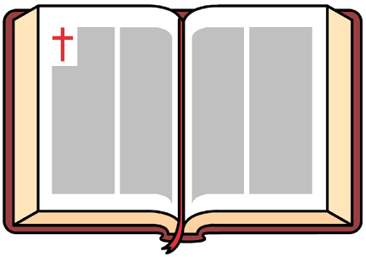

No Need to Pre-Register
Bring your Bible
The suggested offering for all CHRISM courses is $5 per session.
Questions? 781.843.1332

