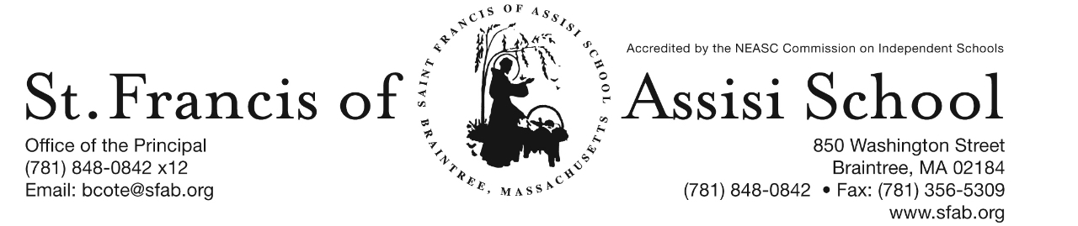

**Volume 4, Issue 4 – September 28, 2016**

**IMPORTANT DATES**

**Thur, Sept 29th**

* Grade 5 MAP Testing; 8:20 a.m.
* Grade 6C MAP Testing; 9:30 a.m.

**Fri, Sept 30th**

* Professional Day – No School

**Mon, Oct 3rd**

* Grades 6L MAP Testing; 8:20 a.m.
* Grade 3G MAP Testing; 10:00 a.m.

**Tue, Oct 4th**

* All-School Liturgy; 8:45

**Wed, Oct 5th**

* 11:30 Early Dismissial Day; No Hot Lunch; Busing & Extended Day Services provided
* Grade 6C MAP Testing; 8:20 a.m.
* Grade 4 MAP Testing 9:30 a.m.
* Grade 3M MAP Testing 10:15 a.m.

**Thur, Oct 6th**

* Grade 3M MAP Testing; 9:00 a.m.
* Grade 3G MAP Testing; 10:00 a.m.

**Fri, Oct 7th**

* Grade 4 MAP Testing; 8:20 a.m.
* Grade 3M MAP Testing; 8:30 a.m.
* Grade 3G MAP Testing; 10:00 a.m.



**Register Today! –**

**4thAnnual Pumpkin Run**

**Sat. October 22nd – 10:00 a.m.**

**Professional Day (No School) this FRDIAY, SEPTEMBER 30th!** Our faculty and staff of Saint Francis of Assisi School will join with the faculties of Saint John the Evangelist, Canton and Saint Paul School, Hingham for a professional development day entitled *“Forming Disciples in Mission: A Workshop in School-Based Evangelization.”*

**All-School Liturgy**

On Tuesday, October 4th, our school will be attending an All-School Liturgy at 8:45 a.m. as we celebrate and honor the Feast Day of St. Francis of Assisi. Our grade 6 teachers and students are planning and coordinating this special liturgy. All are welcome to attend.

**Early Dismissal Day**

Please note that on Wednesday, October 5th, it is an 11:30 a.m. Early Dismissal Day. There will be no Hot Lunch; but Busing and Extended Day Services will be provided. A faculty meeting will take place in the afternoon.

**Columbus Day**

Reminder that on Monday, October 10th there will be No School as we honor and celebrate Columbus Day!

**4th SFA ANNUAL PUMPKIN RUN**

***Calling all runners and walkers!*** Join us at our 4th Annual St. Francis of Assisi School Pumpkin 5K Run (Walk) on Saturday, October 22nd at 10:00 a.m. at SFA. Following the run, there will be post-race festivities and awards! Don’t miss out on this event!

***Remember the first 100 registrants receive the free tee-shirt!***

**Additional Prizes will be awarded to:**

* **“Homecoming” Awards - will be given to the 1st place male & female of a former SFA student (currently in grade 9+). Make sure to share this information with friends & family!**
* **the class with the highest % of student runners/walkers will be treated to a yogurt at The Yogurt Bar by our Principal!!!**

***In addition to runners and walkers, we need sponsors and volunteers! Please consider a family or business sponsorships that will be listed on the backs of the Race Shirts. What a great way to advertise your business! Deadline is October 10th!***

**We need people to help set up, clean up, direct foot traffic, man the start and finish, and assist with post-race festivities. For more information, please contact Grace White at** [**gracekellywhite@beld.net**](mailto:gracekellywhite@beld.net) **or 617-501-1669.**

Attached to this email is the ***Pumpkin Run Registration and/or Race Sponsor Form. Families may also register online at sfapumpkinrun.racewire.com.***

**Communications from our Nurse**

On Wednesday, October 12th, a Flu Shot Clinic will be held at St. Francis of Assisi School for students in grades 6 – 8. Attached to this email is information about the Flu Shot (Vaccine Information Statement & MIIS Fact Sheet for Parents and Patients) as well as the necessary Consent Form. ***Please note: a signed Consent Form is required in order for your child to receive the Flu Shot.*** If you intend to have your child receive the Flu Shot, please return the Consent Form to the attention of Mrs. Margeson, our School Nurse.

**Colder Weather**

As we approach October in a few days, the weather also appears to be changing. Just a reminder that the students will remain going out to recess (weather permitting) and should wear a coat, jacket, etc…

**MAP Testing**

Listed below is the finalized MAP Testing schedule for the week of October 3rd

|  |  |  |  |  |
| --- | --- | --- | --- | --- |
| Monday | Tuesday | Wednesday | Thursday | Friday |
| 3  8:20 – Gr. 6L Lang.  10 – Gr. 3G Reading | 4 | 5  8:20 - Gr. 6C Lang.  9:30 –Gr. 4 Math  10:15- 3M Lang. | 6  9:00 – Gr. 3M Math  10:00 – Gr. 3G Math | 7  8:20 – Gr. 4 Language  8:30 – Gr.3M Reading  10:00 – Gr. 3G Lang. |

**Enrichment Programs**

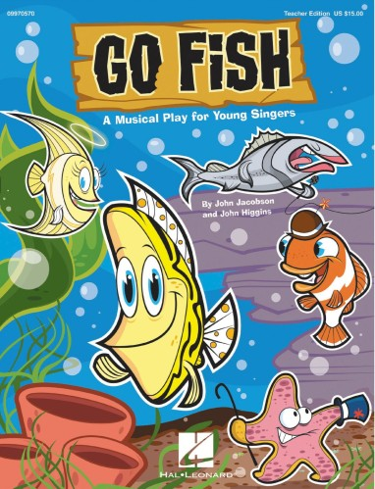

**SFA Junior Drama Club for Students in Grades 1 – 3**

We are extremely excited to announce that this year, SFA is once again offering a Drama Club for students in grades 1 – 3. Our performance will be of the Junior Musical “Go Fish” scheduled for Friday evening, November 18, 2015.

Attached to this email, you will please find the more information regarding the SFA Junior Drama Club, as well as the Permission Slip and Participation Agreement forms.

**Chess Wizards** – Chess Wizards for the Fall 2016 will begin on Tuesday, October 4th from 2:00 – 3:00 p.m.! It’s not too late to register! Chess Wizards is a premier chess education company providing fun, informative and challenging chess lessonsto students. Chess Wizards teaches children many important life concepts, such as learning the ability to win graciously and accept defeat with dignityand sportsmanship.Students will be divided into groups according totheir chess experience. At the end of this session, each student will have had the chance to participate in a mini-chess tournament. Attached to this email is a flyer outlining this enrichment program, dates, and registration information.

**Fall Archery**

*Ready … Aim … Shoot!* SFA once again welcomes back “On the Mark Archery” program as another Fall Enrichment Program for students in C:\Documents and Settings\Owner\Local Settings\Temporary Internet Files\Content.IE5\3IVL1NON\MC900417522[1].wmfgrades 4 – 8 that will meet on Wednesday afternoons beginning on October 5h until November 2nd. This program is only limited to 16 students, so enroll today! Attached to this email includes an Introductory Letter; as well as Emergency Contact Information and Archery Waiver and Release of Liability forms.

**Facebook** – Make sure you check and like us on our school’s facebook page.

[**https://www.facebook.com/sfabraintree**](https://www.facebook.com/sfabraintree)