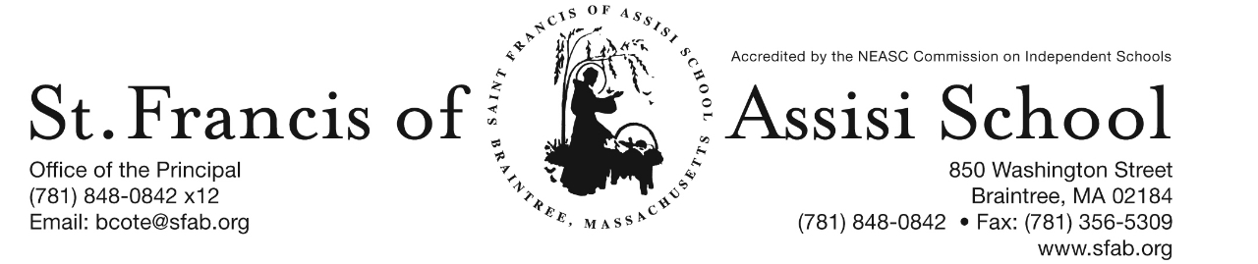

**Volume 5, Issue 4 – October 4, 2017**

**IMPORTANT DATES**

**Wed, Oct. 4th**

* All-School Liturgy in honor of the feast of St. Francis of Assisi; 8:45; all are welcome!

**Thur, Oct. 5th**

* Gr. 2 (Language) MAP testing; 815

**Fri, Oct. 6th**

* 1st Term Mid-Point (grades 6-8)

**Mon, Oct 9th**

* Columbus Day – No School

**Oct. 17-19th**

* Scholastic Book Fair

**Wed, Oct. 18th**

* 1st Trimester Mid-Point (grs. PK-5)

**Sat, Oct. 21st**

* 5 Annual SFA Pumpkin Run; 10:00

**“Pinwheels for Peace”** – September 21st was International Peace Day and the students at SFA joined the Pinwheel for Peace Project this year to share symbols and words of peace with our SFA School community.

Pinwheels for Peace is an art project started in 2005 by two teachers in Florida as a way for student to express their feelings about what’s going on in the world and in their lives. Last year, more than 4.5 million pinwheels were spinning in the wind, across the United States, Great Britain, South America, Australia, the Middle East, Canada, Africa, Europe and Asia; pinwheels all over the world! Pinwheels of all shapes and sizes – colorful pinwheels, decorated with drawings paintings, collages, photographs – pinwheels with words of peace and harmony written on them.

Over the last couple of weeks, many of our SFA classes created a pinwheel in Spanish class with Spanish words and symbols of peace and displayed them around our school playground as we continued to be true to our mission by imitating St. Francis of Assisi as “instruments of peace.”



**5th SFA ANNUAL PUMPKIN RUN**

Calling all runners, walkers and sponsors! Join us at the 5th Annual Saint Francis of Assisi School Pumpkin Run-Walk on Saturday, October 21st at 10:00 a.m. at SFA.

The event consists of a 5K Run or Walk with a Post-Race Party, Raffles and Awards for the Winners. ***Register today online at sfapumpkinrun.racewire.com.***The cost is $20 for an adult, $10 for a youth (under 18) and $50 family maximum. Day of the Run/Walk entries will also be welcomed! Come support our school!

**For more information, please contact Kim Dee at 617-639-7642 /** [**kimdee421@gmail.com**](mailto:kimdee421@gmail.com) **or Mari-Joy O’Leary at 617-271-3705 / mjeisele@hotmail.com.**



Mrs. Clark’s sixth grade classroom has been working on descriptive writing pieces. The Common Core National Standards lists three types of writing that all students need to be familiar with: narrative descriptive writing, informational writing and persuasive opinion writing. The purpose of descriptive writing is to describe a person, place, or thing in such a way that a picture is formed in the reader's mind.  Teaching students to write more descriptively improves their writing by making it more interesting and engaging to read. Descriptive writing also encourages students to use new vocabulary words. Mrs. Clark invited the students to design and to write about their own super hero character.  Using brainstorm techniques, Mrs. Clark had the students use their senses to develop a word bank of adjectives, nouns, and verbs that could be used to describe a super hero character.  Using the “hamburger” paragraph template, the students organized their writing.   Best of all, after  completing their writing, the students were able to create a super hero  puppet that represents their descriptive writing. When students have a chance to take part in creative projects, it builds their imagination, self- expression, and communication.

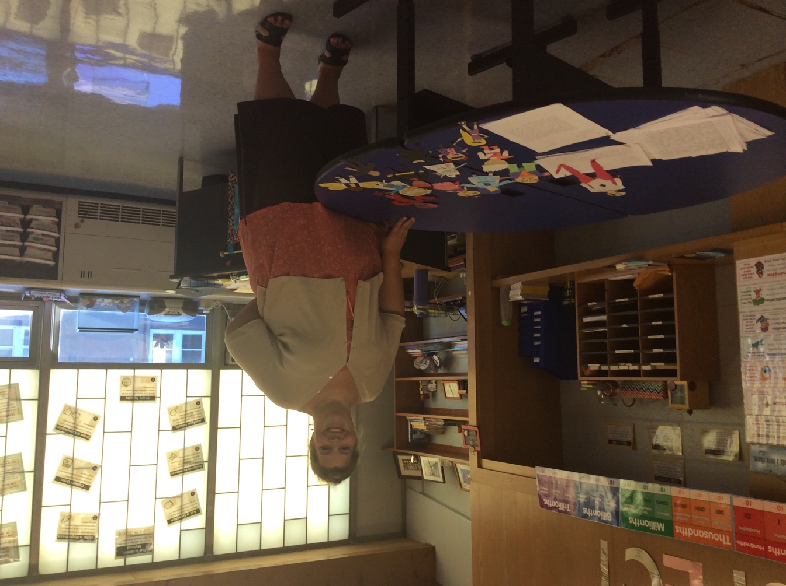

**MAP Testing**

St. Francis of Assisi School, along with all of our schools in the Archdiocese of Boston will continue to use and implement the *NWEA MAP* on-line assessment tool for all students in grades one through eight. This testing is not done to measure one school against another or solely to identify a student’s strengths or weaknesses. Test results are evaluated by teachers to assure that individual academic growth occurs and that the flow of curriculum avoids repetition and allows for our curriculum to fully benefit each child.

Listed below is the proposed Fall 2017 schedule:

|  |  |  |  |  |
| --- | --- | --- | --- | --- |
| Monday | Tuesday | Wednesday | Thursday | Friday |
| 2  8:15 – Gr. 5 Lang. | 3  8:15 – Gr. 4 Lang.  8:15 – Gr. 3 Lang. | 4 | 5  8:15 – Gr. 2 Lang. |  |

http://www.disneyclips.com/imagesnewb6/imageslwrakr01/cliff5s.gif**Scholastic Book Fair**

Saint Francis of Assisi School will be holding its fall Scholastic Book Fair on Tuesday October 17th – Thursday October 19th in the Church Hall. Our Schollastic Book Fair is a reading event that provides the books kids want to read. It’s a wonderful selection of engaging and affordable books for every reading level.

We are in need for volunteers to assist us in setting-up, breaking-down or working at our Book Fair. Attached you will please find a letter with more information regarding our Book Fair, as well as, a Volunteer’s Form.

**SFA Basketball 2017 – 2018 -** Once again, it is time to offer to our middle school students (grades five through eight) the opportunity to play on our SFA Basketball Teams. It is our hope to possibly have four SFA teams consisting of: grades 5/6 girls; grades 5/6 boys; grades 7/8 girls; and grades 7/8 boys; depending upon the interest and participation. Today you have received Basketball Registration Forms and please note that all Registration Forms must be returned with the $150. All registration forms and fees must be returned by October 28th. ***Please note that we are in need of additional players in the various grade levels in order to have enough players for our teams this year***. Please consider being a part of our Basketball Teams.

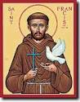

**Thank You –** A word of gratitude and thanks to Mrs. Shea and our students in grade seven for their fine work in planning and coordinating our Liturgy today in honor or the Feast of St. Francis of Assisi Also, a word of Thanks to Mrs. Murray and our Choir for leading us in song and making our Liturgy such a wonderful spiritual experience.

**SFA Instrumental Lesson -**  It is with great pleasure to announce that we have forty students participating in our Instrumental Program, which will begin on next Wednesday, October 11th. The students will receive their instuments as part of the 1st lesson. Your child should be bring home a letter from Paul Effman Music today!

**Upcoming Enrichment Programs**

**Chess Wizards** – Once again, SFA presents Chess Wizards for the Fall 2017! Chess Wizards is a premier chess education company providing fun, informative and challenging chess lessons to students. Chess Wizards teaches children many important life concepts, such as learning the ability to win graciously and accept defeat with dignity and sportsmanship. Students will be divided into groups according to their chess experience. At the end of this session, each student will have had the chance to participate in a mini-chess tournament. Attached to this email is a flyer outlining this enrichment program, dates, and registration information.

**Archery –** On The Mark Archery will once again be held at SFA. Learn to shoot a bow this fall and discover your inner archer! Archery is an exciting focus oriented sport that helps students improve muscle memory, coordination and mental discipline. All equipment is provided. This afterschool program for grades 4 and up will take place on Tuesday afternoon from October 31st – November 21st from 2:15 – 3:15 p.m. The cost of the program is $96 and registration deadline is Friday, Octber 27th. Sign up Now at www.on themarkarchery.com/SFA.

**SAVE THE DATE -**  SFA presents a Fundraising event at The Yogurt Bar in Braintree on Wednedsay, November 1st from 12:00 – 9:00 p.m. Come One, Come All! *A percentage of all sales will be donated to SFA! Tell your Friends and Stop In!*

**Facebook** – Make sure you check and like us on our school’s facebook page.

[**https://www.facebook.com/sfabraintree**](https://www.facebook.com/sfabraintree)