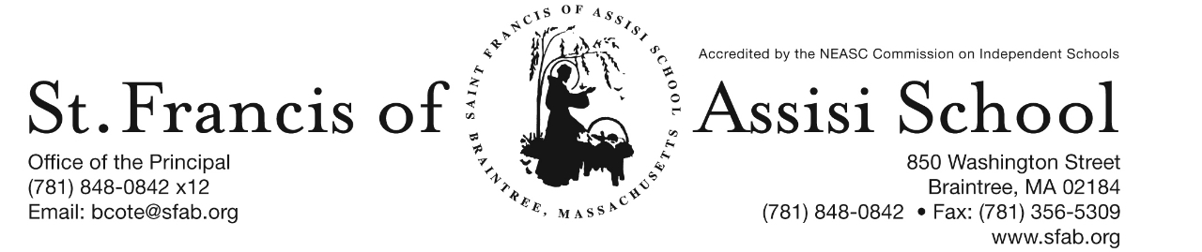

**Volume 5, Issue 7 – October 25, 2017**

**IMPORTANT DATES**

**Wed, Oct. 25th**

* 11:30 a.m. Early Dismissal: No Hot Lunch; Extended PM Care and Busing provided.
* Faculty Meeting; 12:30 – 2:00 p.m.

**Fri, Oct. 27th**

* Middle School Dance; St. Paul School Hingham; 6:30 – 9:30

**Mon, Oct. 30th**

* Windy City Player’s presents “Robin Hood” at 8:30 a.m. in the Church Hall.

**Tue, Oct. 31st**

* Halloween!
* Braintree Fire Fighters; 9:00 – 10:15

**Wed, Nov. 1st**

* All-School Liturgy; 8:45; planned by grade 4
* The Yougurt Bar fundraiser
* The Parent Connection Meeting; 7:00; School Hall

**55th SFA ANNUAL PUMPKIN RUN**

Our 5th Annual 5K Pumpkin Run/Walk for Saint Francis of Assisi School held Saturday was a fabulous and a successful event. The weather was absolutely perfect and there was such excitement and enthusiasm at this wonderful event. There are so many people to thank in making this event possible and such a great success. I would like to take this opportunity to express my appreciation and thank Mrs. Dee and Mrs. O’Leary, as well as their fantastic Pumpkin Run Committee for their many hours in planning and coordinating this event. I would like to also thank Grace White for her role as a consultant to ensure that our event ran smoothly and was successful. I would like to also offer a special word of appreciation and gratitude to all of our volunteers, as well as to the Braintree Police for their assistance in ensuring the safety of all who participated. To all of our generous family and business sponsors, we thank you for your support of this event. I would be remised not to especially thank our community members, parishioners, faculty members, parents, family members, alumni/ae, friends and students who participated in this great event.

Following the run/walk, a post-party was enjoyed by all. We had music provided by DJ Gerard, a visit from “Wolfie” our Mascot, pumpkin decorating, pizza, chances at our Plinko game, dunk the principal and parents in the dunk tank, lots of chances to win fabulous raffle prizes, and Michaela’s Photography that captured the memories.Medals were awarded to the top three male and female winners; overall winner in each of the grade levels; Best Costume and the Homecoming Award for a former SFA student in grade 9 or above. The winners were as follows:

Overall Male Winners:

* John Deery 18:45.9; Manny Paula 20:56.1; and Marc-Andy Mexil 21:14.6.

Overall Female Winners:

* Lindsey Tertan 22:17.1; Nicole Yun 26:39.1; and Natalie Pereira 27:10.8

Grade Level Winners:

* Joseph MacQuarrie 30:07.0; Vincent Russo 32:49.2; Gwendolyn Bradbury 34:35.5; Chase Mazzeo 31:46.3; Patrick Crisman 26:55.2; Natalie Pereira 27:12.6; Andrew Marcotte 26:52.0; Kyle Benjamin 22:46.9; Jack Paula 24:23.8 and Shane Kelly 25:42.8

Homecoming Award: Caroline Kelly 28:18.2 and Best Costume: Nicole Yun (Surf and Turf)

Congratulations to all of our winners!

**“Robin Hood Performance”**

On Monday, October 30th, the Windy City Players, a National Touring Theater group will present their version of the classic musical “Robin Hood” to our entire school community. Our students will certainly enjoy and be entertained with this outstanding performance. As we attempt to educate the whole child, it is wonderful that we can offer these types of cultural experiences to our students.

**Halloween**

****On Halloween (Tuesday, October 31st), the students may dress up and wear their Halloween costumes to school. ***Please note that the costumes must be school appropriate and no weapons, accessories, masks or open shoes are allowed***.

**November** begins with All Saints’ Day on the first and All Souls’ Day on the second.  Veteran’s Day is celebrated on the eleventh and Thanksgiving is on the twenty-fourth.  It certainly will be a month of saints, souls, giving thanks, and providing prayer and community service to those in need.

**All Saints’ Lturgy**

On Wednesay, November 1st, our school will be gathering for an all-school liturgy in honor of All Saints’ Day. The litugy will be at 8:45 a.m. and is being planned and coordinated by our fourth grade teachers and students. All are welcome.

**SFA Parent Connection**

The SFA Parent Connection is an association that includes all current parents of St. Francis of Assisi School students. The Parent Connection is responsible for organizing a number of events through the year, as well as assisting the administration and faculty with a variety of school activities. Every parent at St. Francis of Assisi School is a member of the Parent Connection, and is encouraged to support their child’s education by volunteering for one or more events.

Some of the event that the Parent Connection sponsors include: Pumpkin Run/Walk, Breakfast with Santa, Catholic Schools Week, Student and Teacher Appreciation Days, and Spring Social.

The Parent Connection also provides volunteers to assist with school activities such as Morning Coffees, the Scholastic Book Fairs, Drama Productions, Open House, First Communion, Enrichment programs, and Field Day.

Room Parents, another arm of the Parent Connection, are primarily involved with activities specific to the class room, such as field trips, special class projects, and enhancing school-home communications.

The Parent Connection also fulfills an important role in providing financial support for our school. By being an active member of the Parent Connection, you can help support the mission and goals of St. Francis of Assisi School!

**Please join us at our 1st SFA Parent Connection meeting scheduled for Wednesday evening, November 1st at 7:00 p.m. in the School Hall!**

If you have a new idea or wish to get involved, please contact our Parent Connection Co-Chairs:

Serenity Belo

Kate Herbst

[parentconnection@sfab.org](mailto:parentconnection@sfab.org)

The Kindergarten children gathered closely around Mrs. Burke as she began a language arts lesson on rhyming, an **important** phonological awareness skill.

Students practiced rhyming words which led them to an activity assessing their understanding. The children were being given directions on matching rhyming pictures.

The kindergarten students sat as Mrs. Burke modelled what the students would be doing independently. This gave students more confidence to complete the activity, and promoted greater success for children who are visual learners.

Students then quietly transitioned to the activity at their seats. Calling students according to table color. Their directions were to color the rhyming pictures, glue, and cut. Mrs. Burke made her way around the tables offering assistance, praising effort given, and encouraging the students to work hard to find answers. She spoke quietly to individuals, and at times, praised the whole class for working so quietly. This seemed to help students stay engaged and finish the task. Short periods of individual attention appeared to make the lesson “tailor made” for the child, each feeling that the Mrs. Burke was invested in them.

Many of the strategies used by Mrs. Burke promote growth mindset. Children realize with an “I will try” attitude, hard work, and guidance from Mrs. Burke, they will be successful. Mistakes can lead to learning and growth.

Some children finished earlier than others. Mrs. Burke asked them to practice writing numbers and/or their names on the back. She continued walking around offering support, encouragement, and help. Mrs. Burke made stars on the work when finished. Receiving one brought smiles on their faces, showing they had successfully completed the activity.

There were many happy learners in the room!

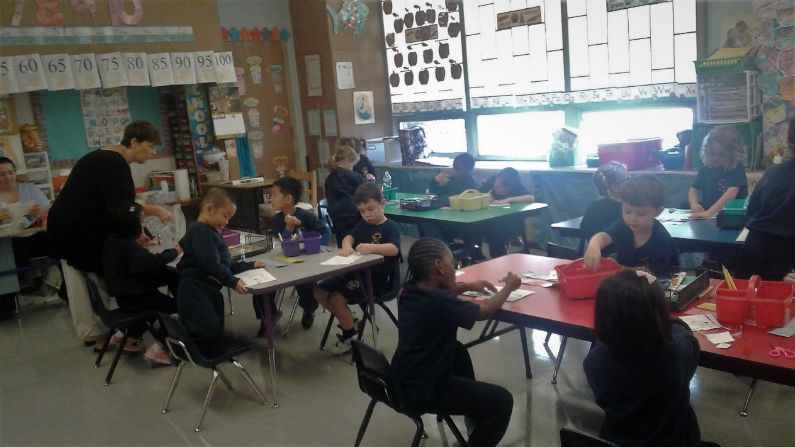

**../../../Desktop/St.%20Francis%20-NOV%202017%20FUNDRAISER%2001.p**

**SFA Basketball 2017 – 2018 -** Once again, it is time to offer to our middle school students (grades five through eight) the opportunity to play on our SFA Basketball Teams. It is our hope to possibly have four SFA teams consisting of: grades 5/6 girls; grades 5/6 boys; grades 7/8 girls; and grades 7/8 boys; depending upon the interest and participation. Today you have received Basketball Registration Forms and please note that all Registration Forms must be returned with the $150. All registration forms and fees must be returned by October 28th. ***Please note that we are in need of additional players in the various grade levels in order to have enough players for our teams this year***. Please consider being a part of our Basketball Teams.



**DAYLIGHT SAVING TIME ENDS**

Remember to Turn Your Clock Back on November 5th!

**ELECTION DAY – NO SCHOOL**

On Tuesday November 7th, as indicated on our monthly/yearly calendar, it will be NO SCHOOL for our students. Our Faculty and Staff will be using this day working on our self-study for NEASC re-accreditation.

http://www.disneyclips.com/imagesnewb6/imageslwrakr01/cliff5s.gif**SCHOLASTIC BOOK FAIR**

Special word of thanks to all who supported our recent fall Scholastic Book Fair, as well as to all of our volunteers who assisted us in making this event possi

ble for our students. Your time, talents and treasures are greatly appreciated!

**Upcoming Enrichment Programs**

**Archery –** On The Mark Archery will once again be held at SFA. Learn to shoot a bow this fall and discover your inner archer! Archery is an exciting focus oriented sport that helps students improve muscle memory, coordination and mental discipline. All equipment is provided. This afterschool program for grades 4 and up will take place on Tuesday afternoon from October 31st – November 21st from 2:15 – 3:15 p.m. The cost of the program is $96 and registration deadline is Friday, Octber 27th. Sign up Now at www.on themarkarchery.com/SFA.

**Facebook** – Make sure you check and like us on our school’s facebook page.

[**https://www.facebook.com/sfabraintree**](https://www.facebook.com/sfabraintree)