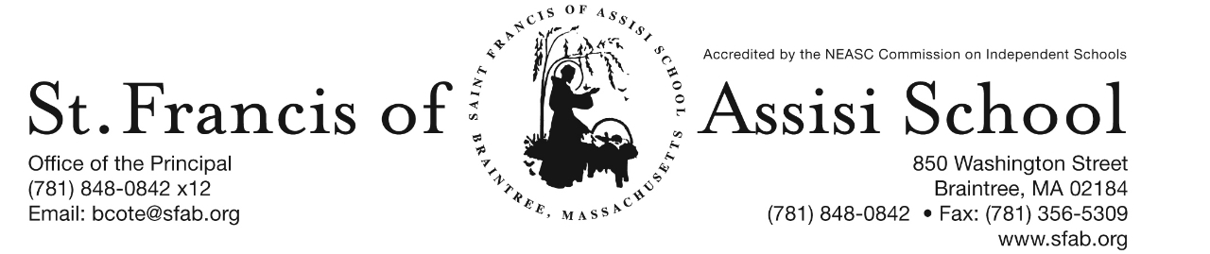

**Volume 5, Issue 5 – October 11, 2017**

**IMPORTANT DATES**

**Oct. 17-19th**

* Scholastic Book Fair

**Wed, Oct. 18th**

* 1st Trimester Mid-Point (grs. PK-5)
* Grade 8 visits AWHS; 8:30 – 1:00

**Sat, Oct. 21st**

* 5 Annual SFA Pumpkin Run; 10:00

**Tue, Oct. 24th**

* Lifetouch Individual Picture Day

**Wed, Oct. 25th**

* 11:30 a.m. Early Dismissal: No Hot Lunch; Extended PM Care and Busing provided.
* Faculty Meeting; 12:30 – 2:00 p.m.

**Mon, Oct. 30th**

* Windy City Player’s presents “Robin Hood” at 8:30 a.m. in the Church Hall.

**Tue, Oct. 31st**

* Halloween!

http://www.disneyclips.com/imagesnewb6/imageslwrakr01/cliff5s.gif**Scholastic Book Fair**

St. Francis of Assisi School will be holding it’s Fall Scholastic Book Fair on Tuesday October 17th – Thursday October 19th in the Church Hall. Our Scholastic Book Fair is a reading event that provides the books kids want to read. It’s a wonderful selection of engaging and affordable books for every reading level.



**5th SFA ANNUAL PUMPKIN RUN**

Calling all runners and walkers!! Join us at the 5th Annual Saint Francis of Assisi School Pumpkin Run-Walk on Saturday, October 21st at 10:00 a.m. at SFA.

***Register today online at sfapumpkinrun.racewire.com.***The cost is $20 for an adult, $10 for a youth (under 18) and $50 family maximum. Day of the Run/Walk entries will also be welcomed! Come support our school!

The event consists of a 5K Run or Walk with a Post-Race Party, Raffles and Awards for the Winners. **Come dressed in your Halloween Costume …** ***there will even be an Award for the Best Halloween Costume (optional)!***

**SFA Parent Connection**

The SFA Parent Connection is an association that includes all current parents of St. Francis of Assisi School students. The Parent Connection is responsible for organizing a number of events through the year, as well as assisting the administration and faculty with a variety of school activities. Every parent at St. Francis of Assisi School is a member of the Parent Connection, and is encouraged to support their child’s education by volunteering for one or more events.

Some of the events that the Parent Connection sponsors include: Pumpkin Run/Walk, Breakfast with Santa, Catholic Schools Week, Student and Teacher Appreciation Days, and Spring Social.

The Parent Connection also provides volunteers to assist with school activities such as Morning Coffees, the Scholastic Book Fairs, Drama Productions, Open House, First Communion, Enrichment programs, and Field Day.

Room Parents, another arm of the Parent Connection, are primarily involved with activities specific to the class room, such as field trips, special class projects, and enhancing school-home communications.

The Parent Connection also fulfills an important role in providing financial support for our school. By being an active member of the Parent Connection, you can help support the mission and goals of St. Francis of Assisi School!

**Please join us at our 1st SFA Parent Connection meeting scheduled for Wednesday evening, November 1st at 7:00 p.m. in the School Hall!**

If you have a new idea or wish to get involved, please contact our Parent Connection Co-Chairs:

Serenity Belo

Kate Herbst

[parentconnection@sfab.org](mailto:parentconnection@sfab.org)



Mrs. Koulopoulos’s fifth grade class is studying the settlements of the Pilgrims and the Puritans. The fifth graders are demonstrating their knowledge of these early American settlers using project based learning.  Project based learning is a teaching method in which students gain knowledge and skills by working for a period of time investigating a  real life and engaging problem, question, or challenge.  The SFA fifth graders are investigating the reasons why early settlers might have chosen a specific colony: Jamestown, New Amsterdam, New France, Plymouth, or Boston to start a community.  First, the students gather information about a specific colony.  Next, they will be creating a poster that convinces other people to live in a specific colony.  Finally, they will be making a commercial that gives persuasive reasons to settle in the colony.  There are many benefits to project based learning.  As students are given a purposeful, real- life learning opportunity, they are highly engaged in the projects and are motivated to learn.  Project based learning also gives students a chance to demonstrate their knowledge using creativity and imagination. Using technology helps students to  gain confidence in communication skills.  Creativity, imagination, and technology are all important 21st century skills that employers are seeking for future jobs in our global community.

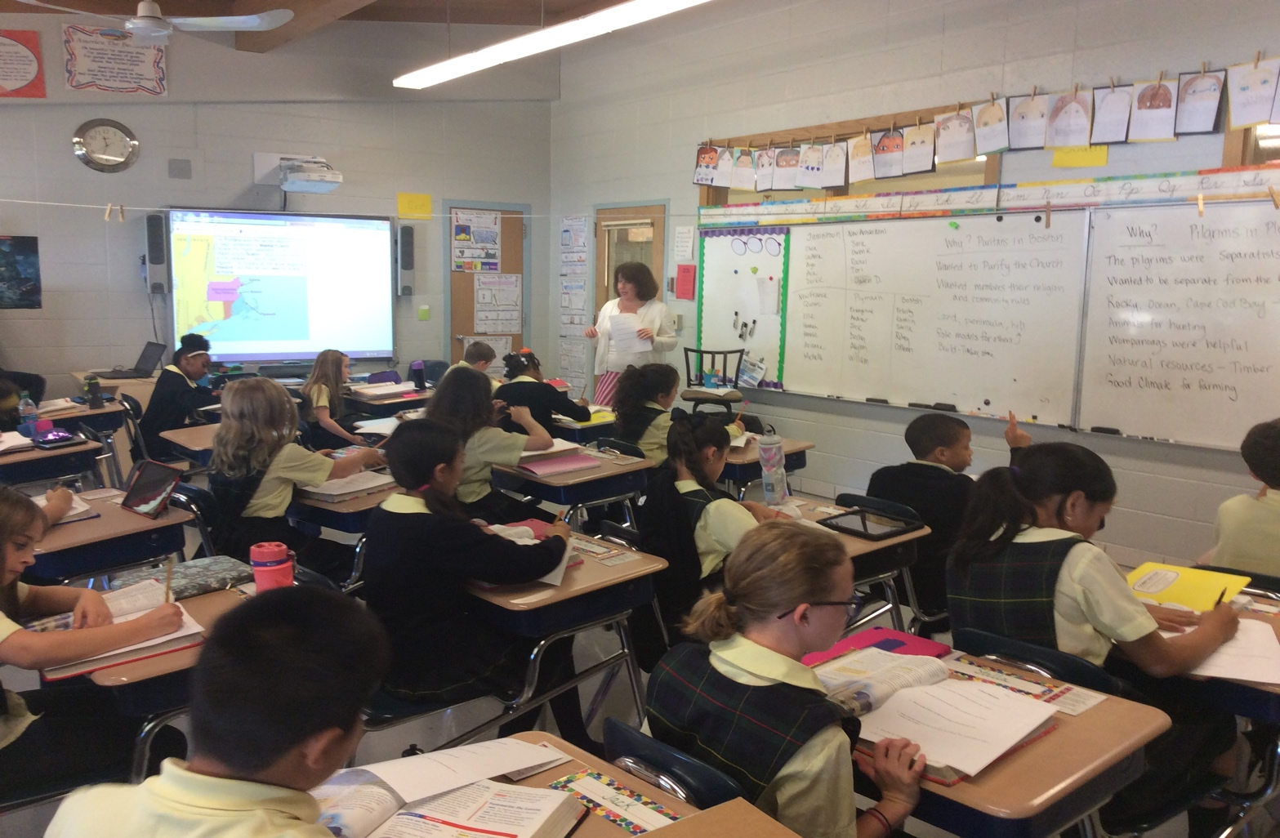

**Upcoming Field Trips**

* **Grade 8 Visit to Archbishop Williams High School**

On Wednesday, October 18th, our grade eight students will be visiting Archbishop Williams High School, Braintree from 8:30 a.m. – 1:00 p.m.

**Upcoming Dates/Events**

* **1st Trimester Mid-Point – Wednesday, October 18th**
* **St. Thomas School’s Accreditation Visit**

Mr. Cote will be chairing a NEASC Visiting Committee for St. Thomas School in Sanford, Maine from Sunday, October 22nd to Wednesday, October 25th. During this time period, Mr. Leo Egan will serve as acting principal at SFA.

* **Picture Day**

On Tuesday, October 24th, representatives from Lifetouch School Portraits will be at SFA for our annual Fall Individual Picture Day. Pictures will take place in the Church Hall.

* **The Yogurt Bar Fundraiser**

On Wednesday, November 1st from 12:00 p.m. – 9:00 p.m., SFA presents a special fundraising event at The Yogurt Bar. A percentage of all sales will be donated to our school! Tell your friends and stop in!

* SFA Parent Connection Meeting

Join us at our 1st SFA Parent Connection Meeting scheduled for Wednesday, November 1st at 7:00 p.m. in our School Hall.

**SFA Basketball 2017 – 2018 -** Once again, it is time to offer to our middle school students (grades five through eight) the opportunity to play on our SFA Basketball Teams. It is our hope to possibly have four SFA teams consisting of: grades 5/6 girls; grades 5/6 boys; grades 7/8 girls; and grades 7/8 boys; depending upon the interest and participation. Today you have received Basketball Registration Forms and please note that all Registration Forms must be returned with the $150. All registration forms and fees must be returned by October 28th. ***Please note that we are in need of additional players in the various grade levels in order to have enough players for our teams this year***. Please consider being a part of our Basketball Teams.

**Upcoming Enrichment Programs**

**Archery –** On The Mark Archery will once again be held at SFA. Learn to shoot a bow this fall and discover your inner archer! Archery is an exciting focus oriented sport that helps students improve muscle memory, coordination and mental discipline. All equipment is provided. This afterschool program for grades 4 and up will take place on Tuesday afternoon from October 31st – November 21st from 2:15 – 3:15 p.m. The cost of the program is $96 and registration deadline is Friday, Octber 27th. Sign up Now at www.on themarkarchery.com/SFA.

**SAVE THE DATE -**  SFA presents a Fundraising event at The Yogurt Bar in Braintree on Wednesday, November 1st from 12:00 – 9:00 p.m. Come One, Come All! *A percentage of all sales will be donated to SFA! Tell your Friends and Stop In!*

**Facebook** – Make sure you check and like us on our school’s facebook page.

[**https://www.facebook.com/sfabraintree**](https://www.facebook.com/sfabraintree)