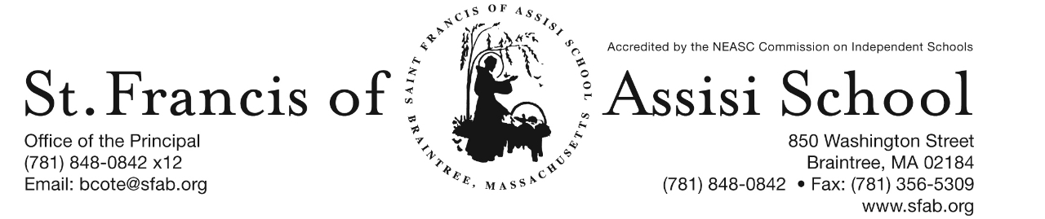

**Volume 4, Issue 9 – November 9, 2016**

**IMPORTANT DATES**

**Wed, Nov. 9th**

* 1st Term ends

**Thur, Nov. 10th**

* Dress Down Day

**Fri, Nov. 11th**

* Veteran’s Day – No School

**Tue, Nov. 15th**

* Uniform Swap Day; 6:00 – 7:00 p.m.
* Report Cards (middle school) distributed

**Wed, Nov. 16th**

* Uniform Swap Day; 8:00 – 10:00 a.m.
* Middle School Parent-Teacher Conferences
* 11:30 a.m. Early Dismissal (grades 6 – 8) only

**Fri, Nov. 18th**

* SFA Jr. Drama Club presents “Go Fish”; 7:00 p.m.

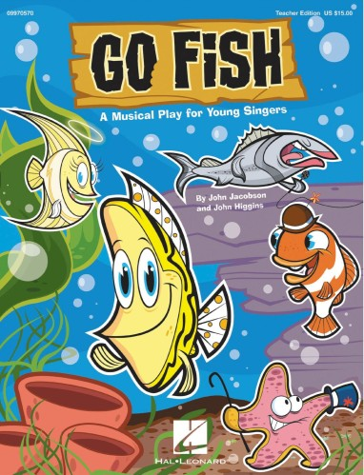

**DRESS DOWN DAY**

In observance of Veterans Day, SFA will be holding a red, white, and blue **dress down day** (optional) **tomorrow, Thursday, November 10th**. We will be collecting $1.00 from students to donate to the Wounded Warrior Project. The mission of the Wounded Warrior Project is to foster service members in our nation, raise awareness of the needs of injured service members, and help injured service members aid and assist each other.

**VETERANS DAY**

Please note that there will be No School on Friday, November 11th in observance of Veteran’s Day.

**SFA Celebrates Veterans Day**

In honor of our veterans, St. Francis of Assisi School in Braintree celebrates Veterans Day with America's White Table. Following tradition, branches of the United States Military set "America's White Table" for dinner on Veterans Day in remembrance of all Veterans. This year for Veteran's Day, students at St. Francis of Assisi School set a White Table in the school lower foyer. Surrounding the White Table is a large display of stars which lists the names of veterans who are family members and friends of our school community. Students are reading the book, "America's White Table" which shares the details of the White Table tradition. Classes will also be discussing the tremendous personal sacrifices which our veterans have made for our country.

If you are interested in reading/viewing the book, we have provided you with the book slides that can be accessed at <http://www.slideshare.net/aheern/americas-white-table-5742673>

**BRAINTREE ROTARY CLUB**

On Monday, November 14th, members of the Braintree Rotary Club will present a dictionary to all of our students in grade three and a thesaurus to students in grade five.

**UNIFORM SWAP DAY**

Saint Francis of Assisi School will hold a Uniform Swap Day on Tuesday, November 15th from 6:00 p.m. – 7:00 p.m., and on Wednedsay, November 16th from 8:00 a.m. – 10:00 a.m. in the Lower Foyer. Attached to this email includes more information/details as well as the Uniform Swap Form.

**PARENT-TEACHER CONFERENCES**

Optional parent-teacher conferences for the Middle School (grades 6 – 8) will be held on Wednesday, November 16, 2016 from 12:30 – 8:00 p.m. ***Students in grades 6 – 8 only, will be dismissed at 11:30 a.m. on Wednesday, November 16th.*** Buses will comply with our schedule. Extended Day Program will be available.

Following your child’s progress on TeacherEase should assist you in determining whether or not to schedule a conference. We will be using the on-line system to make appointments for these conferences again this year. If you would like to schedule a conference, log onto https://pickatime.com/client?ven=11604701. The site will be open on Monday, November 14th at 8:00 a.m.and closed on Tuesday, November 15th at 8:00 p.m. You will be brought to a home page and need to use your email address and create a password to enter the site

Please note ***to make an appointment for Mrs. Shea and Mrs. Dobrev, please sign up under Mrs. Dobrev. These conferences will be with the two teachers together, held in the Grade 8 classroom.***

.

**BREAKFAST WITH SANTA ORGANIZATIONAL MEETING**

One of the traditional events held at ST. Francis of Assisi School is our annual Breakfast with Santa. This year, the event is schedule for Saturday, December 17th from 8:30 a.m. – 11:00 a.m. **Next Wednesday evening, November 16th at 6:30 p.m., we will hold an organizational meeting in the Art Room. We are hoping that you will be able to join us and assist us in our planning of this special event.**



**SFA JR. DRAMA CLUB PRESENTS “GO FISH!”**

Join us on Friday, November 18th in our School Hall as our SFA Junior Drama Club presents the musical, “Go Fish*!” Can you imagine … a Tuna Fish who can’t carry a tune? A Star Fish who can’t get an acting job? A seven-Legged Octopus? A Zebra Fish with spots? A Tiger Shark who wants to be friends with everyone? Join in the aquatic fun as little Tiger Shark and his unique collection of friends discover how their differences make them each special.* There will be an Open Dress Rehearsal at 4:00 p.m. amd Performace at 7:00 p.m. Tickets can purchased at the door! Let’s show our school spirit and support our SFA Fine Arts department. A flyer is attached to this email with additional information and details.

**C:\Documents and Settings\Owner\Local Settings\Temporary Internet Files\Content.IE5\TCSVBUA3\MC900050976[2].wmf**

**THANKSGIVING BASKETS DRIVE 2016**

Dear SFA Families,

As the Thanksgiving holiday approaches, we are reminded of how fortunate and blessed we are. At this time, the Saint Francis of Assisi School community would like to reach out to those in need within SFA parish and town of Braintree (Braintree Holidays). Each year, we collect non-perishables, money, and supermarket gift cards to provide holiday food items for families in need.

Your child’s teacher will explain the Thanksgiving Basket Drive to the class. Each classroom teacher will ask for donations of non-perishable items, supermarket gift cards, and money. We also welcome any additional donations that could be used for the holiday meals. Canned vegetables, packages of stuffing, gravy mix, rice, crackers, canned cranberry sauce, mixes of quick breads, tea bags, and coffee are always needed. Any other type of nonperishables you may have will be appreciated, as well. Your money donations, cards, and non-perishables may be sent to school through Thurs., Nov. 17th . Distribution time is needed.

Thank you for any help you can give us in making this holiday food drive a success.

*.*

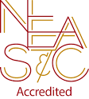**NEASC – RE-ACCREDITATION**

In this preparatory phase of the self-study, our parents/guardians are given the opportunity to give feedback about our school (its mission, admission policy, programs, curriculum, etc...). We welcome all constructive information that will assist us in writing our self-study, as well as our long-range strategic plan.

We want to take this opportunity to express our appreciation and thank the many parents who have already completed the survey. If you have not, we ask that you please do; your input and feedback is so important and valuable to us.

The parent survey may be accessed with the following link: <https://www.surveymonkey.com/r/BMT9VTG>

**ST. FRANCIS OF ASSISI FRIAR’S CLUB**

Congratulations to the winners of the St. Francis of Assisi Friar’s 500 Club for the months of September and October:

The Adebiyi Family $500

Mr. & Mrs. Tu Dao $100

Mr. & Mrs. Villot Mars $25

Mr. & Mrs. Ryan Mulready $25

The Dang Family $25

Mr. Sean Sullivan $25

Mr. & Mrs. Luis Belo $25

Mr. & Mrs. Brian DiMaggio $25

Mr. & Mrs. Andy Beepath $500

Mr. & Mrs. Gary Butterfield $100

The Vijjeswarapu Family $25

Mr. & Mrs. Tim Crisman $25

Mr. & Mrs. John Itcech $25

Mr. & Mrs. Chris Iwunze $25

The Benoit Family $25

Mr. & Mrs. Omar Chapman $25

**UPCOMING SFA IMPORTANT DATES**

* Dec. 9th – Santa’s Workshop;
* Dec. 15th – The Chateau from 11:15 am – Close; SFA will receive 20% of food and beverages (eat-in or take-out included);
* Dec. 16th – Christmas Concerts;
* Dec. 17th – Santa’s Breakfast

**FACEBOOK**

Make sure you check and like us on our school’s facebook page.

[**https://www.facebook.com/sfabraintree**](https://www.facebook.com/sfabraintree)