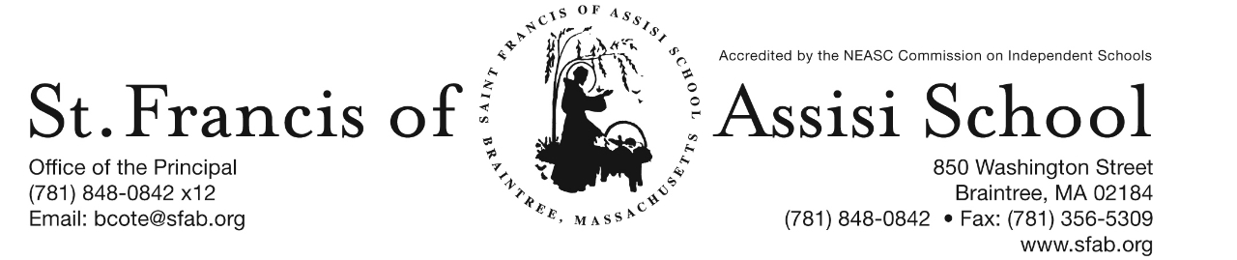

Volume 4, Issue 11 – November 23, 2016
IMPORTANT DATES

Fri, Dec. 2nd
- Picture Make-Up Day

Sun, Dec. 4th
- 2nd Sunday of Advent

Mon, Dec. 5th
- 1st Trimester (PK-grade 5) ends

Thur, Dec. 8th
- All School Liturgy (Feast of the Immaculate Conception); 8: 45

Fri, Dec. 9th
- Santa’s Workshop

Thur, Dec. 15th
- The Chateau Fundraiser; 11:15 - closing

Fri, Dec. 16th
- SFA Christmas Concerts
- 12:00 Early Dismissal; No Hot Lunch or PM Extended Care provided

Sat, Dec 17th
- Santa’s Breakfast; 8:30 – 11:00 a.m.

Fri, Dec. 23rd
- 11:30 Early Dmissal Day; Busing provided; No Lunch or P.M. Extended Day Service.

Christmas Break
- Dec. 26th – Jan. 2nd

ADVENT 2016
I hope you had a wonderful Thanksgiving with your families.

It is hard to believe that we will be turning our calendars to December tomorrow and we celebrated the First Sunday of Advent this past weekend. During the next few weeks, we will be focusing our students on Jesus’ birth during this Advent Season as we approach and reflect upon “The Reason for the Season.”

December promises to be another busy month at St. Francis of Assisi School, so please mark your calendars with various activities and events that have been included in this newsletter.

PICTURE MAKE-UP DAY
Lifetouch Photographers will be at SFA for a re-take/make-up day on Friday, December 2nd.

ADVENT PENANCE SERVICES
- Grade 3 Tuesday, December 20th at 1:00
- Grade 4 Tuesday, December 20th at 8:00
- Grade 5 Monday, December 19th at 8:00
- Grade 6 Monday, December 12th at 1:00
- Grade 7 Monday, December 19th at 1:00
- Grade 8 Monday, December 5th at 1:00 p.m.

HOLIDAY CALENDAR CAMPGAIGN

Just a reminder that our Holiday Calendar Campaign will end on December 15th, with our first drawing taking place on January 5th.

Need Your Assistance! We will be seeking students and parents who would be interested in assisting us in selling Holiday Calendars at the end of the weekend masses at St. Francis of Assisi Parish the weekends of December 10/11 and 17/18. The mass schedule includes Saturday at 4:00; Sunday at 7:00, 9:30, and 10:30. If you could help us with one of these times, it would be greatly appreciated. If interested, please contact Mrs. Daly at 781-848-0842 x10 or email cdaly@sfab.org.

1st TRIMESTER ends
Please note that the 1st trimester for students in grades pre-kindergarten through five will officially end on Monday, December 5th. Report cards will be distributed on Monday, December 12th. Parent-Teacher Conference will take place on Wednesday, January 11th.

FEAST OF THE IMMACULATE CONCEPTION LITURGY
On Thursday, December 8th, our students will attend liturgy at 8:45 in honor of the Feast of the Immaculate Conception. This liturgy is being planned and coordinated by our grade 5 students.

DRESS DOWN DAY – On Friday, December 9th, Saint Francis of Assisi School will hold a red and green Dress Down Day. Students are asked to donate $1 which will be used to purchase Christmas gifts from our students to our parish priests, as well as various people who serve us each day (i.e. postman, bus drivers, crossing guard, etc).

Santa’s Workshop is Coming Soon to SFA!
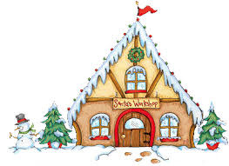
Santa’s Workshop is a Holiday Gift Shop for the children of Saint Francis of Assisi School to purchase gifts for their loved ones. We all have special memories of buying some small token for our parents and siblings during Christmas. We will give our students the chance to create special memories of giving to the ones they love.

Our Santa’s Workshop will be held on Friday, December 9th during the school day. The classroom teachers will bring the students to Santa’s Workshop. There will be a large variety of gifts from .50 cents to $10 to choose from. In preparation for this day, a budget envelop (Gift List Planner) will be provided in next week’s communication materials and we ask that you please assist your child in filing out the names of the people for whom they would like to purchase gifts. Please place all cash or check made payable to SFA in the envelope. Our grade eight students will assist the other students throughout the day.

SFA FUNDRAISER AT THE CHATEAU
SAVE THE DATE!!! On Thursday, November 15th, enjoy lunch/dinner or take-out at The Chateau in Braintree from 11:15 – close and SFA will receive 20% of the total bill of all food and beverages. Please note: Fundraising Tickets are Required: so when paying your check, give the server your fundraising ticket (attached to this email; or available on our school’s homepage).
Breakfast with Santa will be held on Saturday, December 17th from 8:30 – 11:00 a.m. Have your picture taken with Santa, enjoy a nice breakfast, and have fun and friends and family at this beloved Saint Francis of Assisi School tradition. Santa will arrive at 9:00 a.m … do not miss this special arrive. Tickets are $5 per person or $15 per family. We hope to see you there.

Our annual Christmas Concert will be just around the corner on Friday, December 16th. Our Christmas Concert is such a popular event that we have again decided to do two performance of this great show. Everyone works so hard to prepare for this concert that we feel they should showcase their talents more than once!

In order to fairly divide our audience for the concerts, we have split the school alphabetically by Family Names. Families with last names start with A to K will attend the first performance at 8:30 AM to 9:45 AM and families whose last names begin with L to Z will attend the second performance at 10:15 AM to 11:30 AM. Please note that this is an early release day at 12:00 noon and there will be no Extended Day Care Services provided on this day! Additional information and details regarding our upcoming Christmas Concert is attached to this email.

SKYPING IN THE CLASSROOM
As we lived our mission in “preparing our students academically for this technological age”, we at SFA are committed to providing our students with a rigorous academic program, as well as providing the necessary resources and tools to ensure that the integration of technology occurs in all of our classrooms. It is truly our goal to create 21st century learners and leaders.
Skype is an instructional tool that provides boundless opportunities for authentic teaching and learning to occur. It enables our teachers to explore beyond the four walls of our classrooms, as well as inspires our students, the next generation of global citizens through transformative learning. The integration of skype lessons brings the curriculum to life in ways never before possible.
On Friday, our kindergarten students, along with their grade four buddies will skype with children’s book author Lori Degman. We are certain that all of our students will truly enjoy this interactive experience as Ms. Degman reads her new book “Norbert’s Big Dream.” Ms. Degman will also share with our students the excitement and fun of reading and writing; her journey as an author; how a picture book is created, and offer a period of time for questions and answers. In addition, our students will have an opportunity to purchase their own personalized copy of her new book.

BASKETBALL INFORMATION
One of the several extracurricular activities that St. Francis of Assisi School offers is its organized basketball teams for both girls and boys. Our school is a member and participates in the South Shore Parochial School League (S.S.P.S.L.). This league runs a basketball program for full-time students in grades three through eight, attending Boston's "South Shore" Parish/Catholic Schools. This program is overseen by the Office for New Evangelization of Youth & Young Adults and administered by the Archdiocese of Boston CYO Program.

The schedule of games has been finalized and may be accessed at www.sspsl.net or a link has been added to our school’s website (www.sfab.org) that will automatically bring you to the various schedules.

Please note that SFA’s home court will be at the University Sports Complex, 645 Washington Street in Hanover, not the Daughraty School as currently posted on the website. Looking forward to a wonderful basketball season.

BASKETBALL COACH
We are in desperate need of a basketball coach for our SFA Boys’ 7th and 8th Grade Basketball Team. If you are available to assist us in this capacity, please contact Mr. Cote a.s.a.p. In the event that we may not find a coach, we may not be able to have a 7th and 8th grade team this season. Thanks!

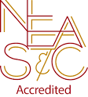
NEASC – RE-ACCREDITATION
In this preparatory phase of the self-study, our parents/guardians are given the opportunity to give feedback about our school (its mission, admission policy, programs, curriculum, etc...). We welcome all constructive information that will assist us in writing our self-study, as well as our multi-year plan.

We want to take this opportunity to express our appreciation and thank the many parents who have already completed the survey. If you have not, we ask that you please do; your input and feedback is so important and valuable to us.

The parent survey may be accessed with the following link: https://www.surveymonkey.com/r/BMT9VTG

FACEBOOK
Make sure you check and like us on our school’s facebook page.
https://www.facebook.com/sfabraintree

