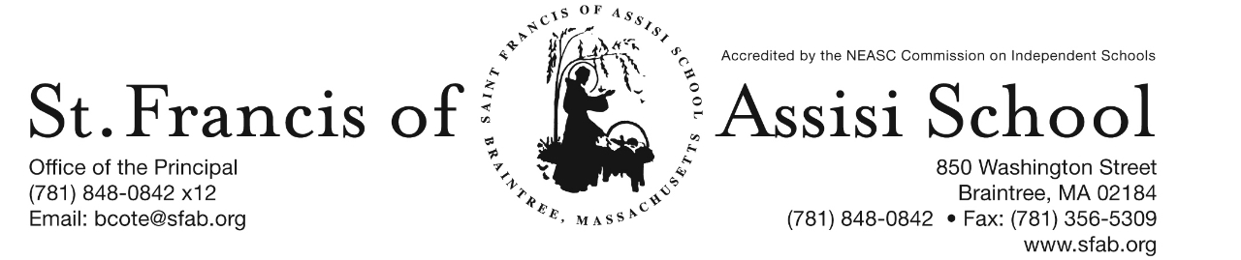

Volume 5, Issue 11 – Nov. 22, 2017

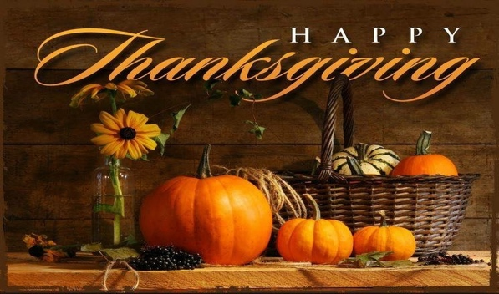
Give Thanks!
IMPORTANT DATES

Wed, Nov. 22nd
- 11:30 Early Dismissal; Busing provided, but No Hot Lunch or PM Extended Day Services provided.

Thur, Nov. 23rd
- Happy Thanksgiving

Thur, Nov. 30th
- Grade 3 Field Trip to The Commonwealth Museum, Boston

Fri, Dec. 1st
- Grades 4 & 7 Field Trip to the movie “Wonders”

Sun, Dec. 3rd
- 1st Sunday of Advent

Mon, Dec. 4th
- 1st Trimester (grades PK-5) ends

Wed, Dec. 6th
- The Parent Connection Meeting; 7:00 p.m. in the School Hall

Thur, Dec. 7th
- Professional Day – No School for Students

Fri, Dec. 8th
- All School Liturgy (Feast of the Immaculate Conception); 8:45; All are Welcome!

Great God, giver of all good gifts, we ask you, above all, to give us truly grateful hearts. May we give thanks for the beauty all around us, in Your creation, in our relationships, in our families and in our school community. May we never take for granted your daily gifts and always enjoy them with thanksgiving.
Thank you, too, for the comfort of our homes, for the blessing of our family life, and the richness of our school community. And though sometimes we feel the heavy weight of our burdens and care, thank You for the grace to see them through.
As we come to the end of each day, may our hearts still be grateful and hopeful and our prayer full of thanksgiving. Amen

On behalf of the Administration and Faculty at SFA, I want to wish you a Safe, Healthy and Happy Thanksgiving.

EARLY DISMISSAL
Just a reminder that Tomorrow, November 22nd, it will be an 11:30 Early Dismissal. Busing will be provided; but there will be No Lunch or PM Extended Day Services provided.

BREAKFAST WITH SANTA MEETING
On Monday, November 27th, at 7:00 p.m., we will be holding an organizational and planning meeting for our upcoming Breakfast with Santa event. All are welcome!

UPCOMING IMPORTANT DATES:

- Grade 3 Field Trip
On Thursday, November 30th, our grade three students will be visiting The Commonwealth Museum in Boston from 9:00 a.m. – 2:00 p.m.

- Grades 4 & 7 Field Trip
On Friday, December 1st, our students in grades four and seven will be visiting AMC to watch “Wonders.”

- 1st Trimester ends
On Monday, December 4th, the 1st Trimester (grades PK – 5) ends.

- Parent Connection Meeting
On Wednesday, December 6th, a Parent Connection Meeting will take place at 7:00 in the School Hall.

- Professional Day
On Thursday, December 7th, it is a Professional Day. No School for the Students!

- All-School Liturgy
On Friday, December 8th, our SFA School community will gather for an All-School Liturgy in honor of the Feast of the Immaculate Conception. The students in Grade Three will be planning and coordinating this Liturgy.

HOLIDAY CALENDAR CAMPGAIGN
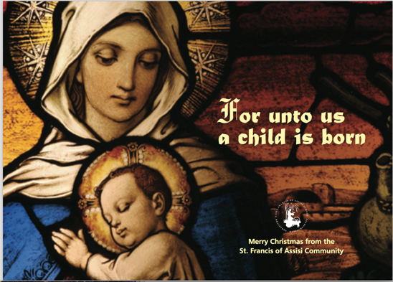
With Thanksgiving right around the corner, what an ideal time to ask family and friends to support our school by purchasing one of our Holiday Calendars.

Just a reminder that our Holiday Calendar Campaign will end on December 15th, with our first drawing taking place on January 4th.

COATS, MITTENS AND HATS
Now that the weather is finally changing and becoming seasonable colder, just a reminder that students should dress accordingly; the students will continue to have outside recess and physical education (weather permitted).

COMMUNICATIONS FROM THE KITCHEN
All students will have the option of ordering the "Special Entrée" as their lunch selection beginning on December 1, 2017. Previously, it has only been offered to grades 6-8; it will be available to all grades beginning December 1, 2017. Please make sure that if your child wants the "special entrée" that they order it in the morning so that we will have it made & available to them.

St. Francis participates in the USDA School Lunch Program and must comply with the program’s requirements. It was brought to our attention recently that preschoolers (ages 2-4) are not allowed to choose flavored milk as their beverage. Therefore, effective immediately, they can only choose either orange juice or low-fat white milk to accompany their lunch (or to purchase alone as a beverage).
You can contact me at 781-848-0842 or cpalermo@braintreema.gov if you have any questions or concerns.

Carol Palermo
St. Francis Kitchen Manager

SAVE THE DATES:

- Dec. 14th – The Chateau from 11:15 am – Close; SFA will receive 20% of food and beverages (eat-in or take-out included);

- Dec. 15th – Santa’s Workshop;

- Dec. 16th – Santa’s Breakfast;

- Dec. 20th – Christmas Concerts;

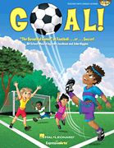
CONGRATULATIONS to the cast of our SFA Jr. Drama Club for an outstanding performance of "Goal!" on Friday evening. They were fantastic! A special word of appreciation and thanks to Mrs. Murray, our drama/music director for sharing her gifts and talents with all of us at SFA. Special thanks to Miss Murray for her assistance in making our performance such a huge success. Finally, thank you to our parents for their continued support of our school! Check out some of the highlights of this outstanding performance located on our SFA Facebook Page.

THANK YOU
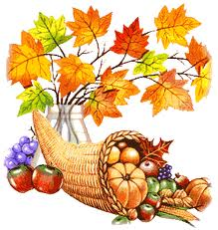
On behalf of Braintree Holidays, St. Francis of Assisi St. Vincent dePaul and St. Francis of Assisi School, we want to express our appreciation and thank you for your participation in our recent Dress Down Day, as well as Thankgiving Basket Drive, which were huge success.

“At the end of life we will not be judged by how many diplomas we have received, how much money we have made, how many great things we have done.

We will be judged by "I was hungry, and you gave me something to eat, I was naked and you clothed me. I was homeless, and you took me in.”
― Mother Teresa

Facebook – Make sure you check and like us on our school’s facebook page.
https://www.facebook.com/sfabraintree

