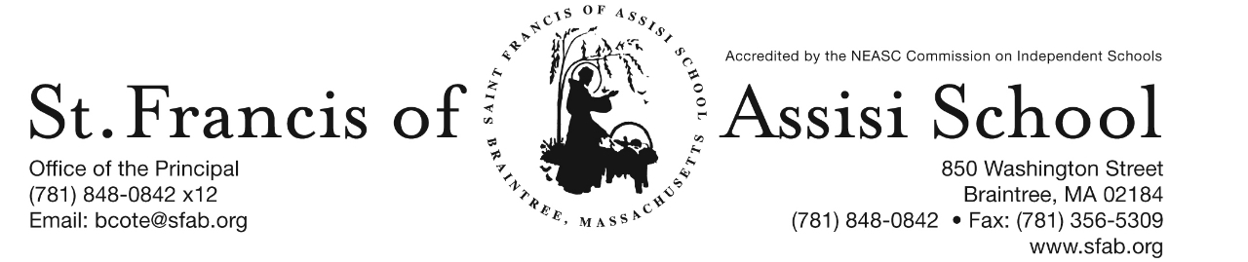

**Volume 5, Issue 9 – Nov. 15, 2017**

**IMPORTANT DATES**

**Thur, Nov. 16th**

* Parent-Teacher Conferneces (grades 6 – 8); 12:30 – 8:00 p.m.
* 11:30 a.m. Early Dismissal (grades 6 – 8) Only

**Fri, Nov. 17th**

* SFA’s Jr. Drama Club Production; 7:00 p.m. School Hall
* Dress Down Day!

**Mon, Nov. 20th**

* Lifetouch photographer’s Picture Make-Up Day

**Wed, Nov. 22nd**

* 11:30 a.m. Early Dismissal Day; busing available; no lunch or extended P.M. care services

**Thur, Nov. 23rd**

* Thanksgiving

**PARENT-TEACHER CONFERENCES**

Optional parent-teacher conferences for the Middle School (grades 6 – 8) will be held on Thursday, November 16, 2017 from 12:30 – 8:00 p.m. ***Students in grades 6 – 8 only, will be dismissed at 11:30 a.m. on Thursday, November 17th.*** Buses will comply with our schedule. Extended Day Program will be available.

Following your child’s progress on TeacherEase should assist you in determining whether or not to schedule a conference. We will be using the on-line system to make appointments for these conferences again this year. If you would like to schedule a conference, log onto **https://pickatime.com/client?ven=11604701**. The site will be open on Monday, November 13th at 8:00 a.m.and closed on Wednesday, November 15th at 2:00 p.m. You will be brought to a home page and need to use your email address and create a password to enter the site

**C:\Documents and Settings\Owner\Local Settings\Temporary Internet Files\Content.IE5\TCSVBUA3\MC900050976[2].wmf**

**THANKSGIVING BASKETS DRIVE 2017**

Dear SFA Families,

As the Thanksgiving holiday approaches, we are reminded of how fortunate and blessed we are. At this time, the Saint Francis of Assisi School community would like to reach out to those in need within SFA parish and town of Braintree (Braintree Holidays). Each year, we collect non-perishables, money, and supermarket gift cards to provide holiday food items for families in need.

Your child’s teacher will explain the Thanksgiving Basket Drive to the class. Each classroom teacher will ask for donations of non-perishable items, supermarket gift cards, and money. We also welcome any additional donations that could be used for the holiday meals. Canned vegetables, packages of stuffing, gravy mix, rice, crackers, canned cranberry sauce, mixes of quick breads, tea bags, and coffee are always needed. Any other type of nonperishables you may have will be appreciated, as well. **Your money donations, cards, and non-perishables may be sent to school through Thurs., Nov. 16th .** Distribution time is needed.

Thank you for any help you can give us in making this holiday food drive a success.

**DRESS DOWN DAY**

On Friday, November 17th, SFA will be sponsoring a Dress Down Day to assist our SFA St. Vincent DePaul Society in providing the necessities to those in need in our local community. We are asking for $1 donation to dress down on this day! Thank you in advance for your support

../../../Desktop/SFA%202017%20Jr.%20Drama%20Club%20Flyer%20Goal!

Our students not only strive to excel academically, but will soon light up the stage with their talents. Our SFA Junior Drama Club, which consist of 30 of our students in grades 1 – 3 who have been working diligently for the last couple of months under the direction of Mrs. Lucia Murray and Ms. Sarah Murray learning their music, lines and choreography in preparation for their upcoming performance. **On Friday evening, November 17th at 7:00p.m. in our School Hall, our SFA Junior Drama Club will present the musical “Goal!”** The musical features 5 original songs representing musical styles from Latin to Rap and Pop to Broadway. Soccer is the setting for this musical that not only celebrates the beauty and glory of the sport, but also the value of good sportsmanship, setting goals, and being a part of a team. Tickets may be purchased at the door!

**PICTURE RETAKE DAY**

On Monday, November 20th, Lifetouch Photographers will be back to SFA for any picture retakes.

**THANKSGIVING EARLY RELEASE**

On Wednesday, November 22nd, there will be an 11:30 a.m. Early Release for all Students and Faculty.

**GRADE THREE FIELD TRIP**

On Thursday, November 30th, our grade three students will be visiting The Commonwealth Museum in Boston from 9:00 a.m. – 2:00 p.m.



Do you know how to Kahoot?  Mrs. Shea’s seventh grade does! Kahoot is a free online game based learning system for teachers to support and reinforce learning in the classroom.  Mrs. Shea creates Kahoot multiple choice games to reinforce topics in math, science, and American History.  Student  players answer questions on their IPads while the game questions are displayed on the Smartboard. Students actively work to solve problems and answer questions while enjoying the game format. The seventh grade students enjoy this exciting and engaging  way to practice skills and they say it is fun to  learn new information.  Technology based assessments like Kahoot  are beneficial to teaching as well. The assessments allow teachers to quickly evaluate students. Teachers can use the data provided from the technology based assessments to learn about what the students need and to guide next steps in instruction.

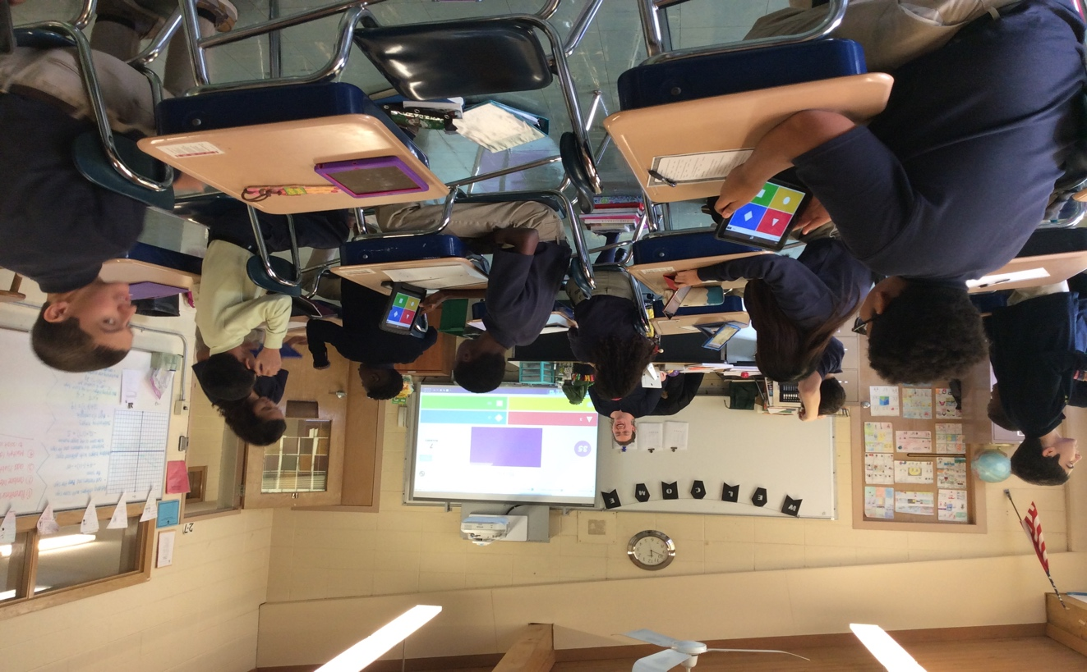

**HOLIDAY CALENDAR CAMPGAIGN**

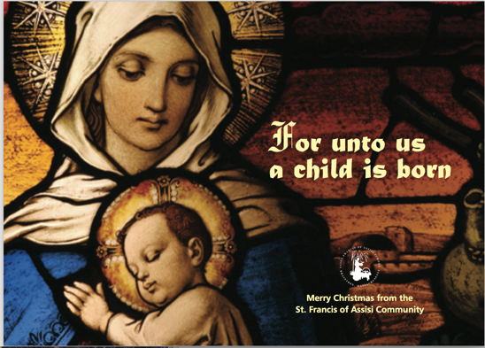

With Thanksgiving right around the corner, what an ideal time to ask family and friends to support our school by purchasing one of our Holiday Calendars. Students will be bringing home the Holiday Calendars today!

Just a reminder that our Holiday Calendar Campaign will end on December 15th, with our first drawing taking place on January 4th.

**COATS, MITTONS AND HATS**

Now that the weather is finally changing and becoming seasonable colder, just a reminder that students should dress accordingly; the students will continue to have outside recess and physical education (weather permitted).

**SAVE THE DATES:**

* Dec. 14th – The Chateau from 11:15 am – Close; SFA will receive 20% of food and beverages (eat-in or take-out included);
* Dec. 15th – Santa’s Workshop;
* Dec. 16th – Santa’s Breakfast;

* Dec. 20th – Christmas Concerts;

**Literacy Project** - Recently, members of the Rotary Club of Braintree visited St. Francis of Assisi School and presented a dictionary to each student in our grade three and a thesaurus to each student in our grade five. This Literacy Program sponsored by the Rotary Club was instituted several years ago and is a true commitment and support to all of the students within the Town of Braintree. The dictionaries and thesauruses that are provided to our students are invaluable reference tools and resources that they will use throughout their educational journey and beyond. These reference materials will be utilized on a daily basis by our students at SFA to achieve their academic potential. A word of thanks and appreciation to the Braintree Rotary Club!

**Facebook** – Make sure you check and like us on our school’s facebook page.

[**https://www.facebook.com/sfabraintree**](https://www.facebook.com/sfabraintree)