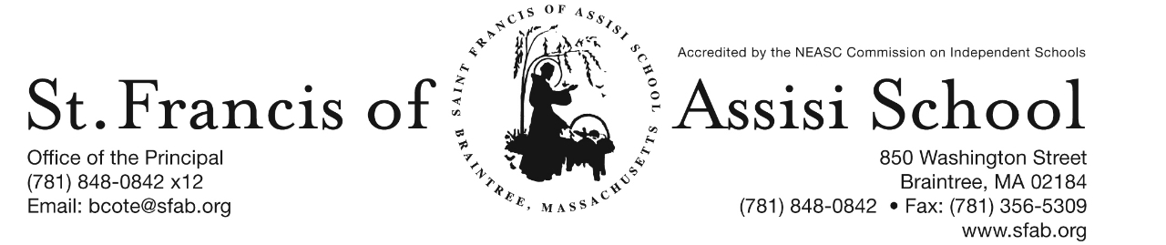

**Volume 5, Issue 8 – Nov. 1, 2017**

**IMPORTANT DATES**

**Wed, Nov. 1st**

* All-School Liturgy; 8:45; planned by grade 4
* The Yougurt Bar fundraiser
* The Parent Connection Meeting; 7:00; School Hall

**Sun, Nov. 5th**

* Daylight Saving Time ends

**Tue, Nov. 7th**

* Professional Day (NEASC)

**Wed, Nov. 8th**

* 1st Term end (grs. 6 – 8)

**Thur, Nov. 9th**

* Dress Down Day

**Fri, Nov. 10th**

* Veteran’s Day – No School

**Mon, Nov. 13th**

* 1st Term Report Cards distributed (grades 6 – 8)

**Wed, Nov. 15th**

* Grade 8 Visit to Cardinal Spellman High School

**Thur, Nov. 16th**

* Parent-Teacher Conferneces (grades 6 – 8); 12:30 – 8:00 p.m.
* 11:30 a.m. Early Dismissal (grades 6 – 8) Only

**Fri, Nov. 17th**

* SFA’s Jr. Drama Club Production; 7:00 p.m. School Hall



**SFA PARENT CONNECTION MEETING - TONIGHT!**

Please join us at our 1st SFA Parent Connection meeting Tonight at 7:00 p.m. in the School Hall!

**THE YOGURT BAR FUNDRAISER**

Today from 12:00 p.m. – 9:00 p.m., SFA presents a special fundraising event at The Yogurt Bar. A percentage of all sales will be donated to our school! Tell your friends and stop in!

**../../../Desktop/St.%20Francis%20-NOV%202017%20FUNDRAISER%2001.p**

**NOVEMBER** begins with All Saints’ Day on the first and All Souls’ Day on the second.  Veteran’s Day is celebrated on the eleventh and Thanksgiving is on the twenty-third.  It certainly will be a month of saints, souls, giving thanks, and providing prayer and community service to those in need.

**ALL SAINT’S LITURGY**

This morning our SFA School community gathered for Liturgy in honor or the Feast of All Saints’ Day. A word of thanks to Mrs. Lane and the students in grade four for coordinating and planning this Liturgy, as well as Mrs. Murray and our student choir for leading us in song.



**DAYLIGHT SAVING TIME ENDS**

Remember to Turn Your Clock Back on November 5th!

**ELECTION DAY – NO SCHOOL**

On Tuesday November 7th, as indicated on our monthly/yearly calendar, it will be NO SCHOOL for our students. Our Faculty and Staff will be using this day working on our self-study for NEASC re-accreditation.

**SFA PARENTS’ NIGHT OUT**

Join us on Thursday, November 9, 2017 from 7:00 – 9:00 p.m. for the Parents’ Connection First FUN-raiser of the Year at Bin Ends. Enjoy Wine Tasting, Appetizers, Friends and Fun! As a bonus – receive 10% off all purchases. For more information, please see the attached form for more information!

**VETERANS DAY**

Please note that there will be No School on Friday, November 10th in observance of Veteran’s Day.

**SFA Celebrates Veterans Day with America’s White Table**

By tradition, branches of the U.S. military set "America's White Table" for dinner on Veterans Day in remembrance of all veterans. This year for Veterans Day, Saint Francis classes will set a White Tables located in the lower foyer to honor all veterans. Classes will be reading a story written by Margot Theis Raven called America’s White Table which shares the details of the White Table tradition. Classes will be discussing the sacrifices veterans made while serving in wars, such as missing the chance to attend college and leaving their families.

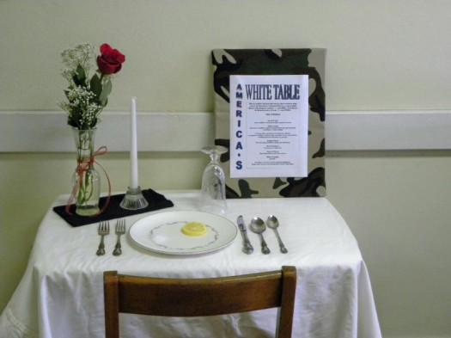Each item on the table has a specific meaning.

* A **white candle** symbolizes peace.
* A **white cloth** honors a soldier’s pure heart when our country calls him/her to duty.
* A **slice of lemon** shows a captive soldier’s bitter fate.
* **Grains of salt** symbolize the tears of waiting families.
* **Empty chair** represents the missing soldiers.
* A **turned over glass** stands for the meal that won’t be eaten.
* The **black napkin** signifies the sorrow of captivity.
* A **red rose** represents the hope that all missing soldiers will return.

If you are interested in reading/viewing the book, we have provided you with the book slides that can be accessed at <http://www.slideshare.net/aheern/americas-white-table-5742673>

**VETERAN’S OUTREACH**

Ms.Michelle Christy, the Recreation Director of Grove Manor in Braintree reached out to SFA in preparation for their upcoming Annual Veteran’s Recognition. There are approximately 30 WW2 Veterans that reside at this assisted living facility. Our students were asked to draw pictures, make cards, or write a letter in giving thanks to these veterans who served our country.

**DRESS DOWN DAY**

In observance of Veterans Day, SFA will also be having a red, white, and blue **dress down day** (optional) on **Thursday, November 19th**. We will be collecting $1.00 from students to donate to the Wounded Warrior Project. The mission of the Wounded Warrior Project is to foster service members in our nation, raise awareness of the needs of injured service members, and help injured service members aid and assist each other.

**PARENT-TEACHER CONFERENCES**

Optional parent-teacher conferences for the Middle School (grades 6 – 8) will be held on Thursday, November 16, 2017 from 12:30 – 8:00 p.m. ***Students in grades 6 – 8 only, will be dismissed at 11:30 a.m. on Thursday, November 17th.*** Buses will comply with our schedule. Extended Day Program will be available.

Following your child’s progress on TeacherEase should assist you in determining whether or not to schedule a conference. We will be using the on-line system to make appointments for these conferences again this year. If you would like to schedule a conference, log onto **https://pickatime.com/client?ven=11604701**. The site will be open on Monday, November 13th at 8:00 a.m.and closed on Wednesday, November 15th at 2:00 p.m. You will be brought to a home page and need to use your email address and create a password to enter the site

Please note ***to make an appointment for Mrs. Shea and Mrs. Dobrev, please sign up under Mrs. Dobrev. These conferences will be with the two teachers together, held in the Grade 8 classroom.***

**C:\Documents and Settings\Owner\Local Settings\Temporary Internet Files\Content.IE5\TCSVBUA3\MC900050976[2].wmf**

**THANKSGIVING BASKETS DRIVE 2017**

Dear SFA Families,

As the Thanksgiving holiday approaches, we are reminded of how fortunate and blessed we are. At this time, the Saint Francis of Assisi School community would like to reach out to those in need within SFA parish and town of Braintree (Braintree Holidays). Each year, we collect non-perishables, money, and supermarket gift cards to provide holiday food items for families in need.

Your child’s teacher will explain the Thanksgiving Basket Drive to the class. Each classroom teacher will ask for donations of non-perishable items, supermarket gift cards, and money. We also welcome any additional donations that could be used for the holiday meals. Canned vegetables, packages of stuffing, gravy mix, rice, crackers, canned cranberry sauce, mixes of quick breads, tea bags, and coffee are always needed. Any other type of nonperishables you may have will be appreciated, as well. Your money donations, cards, and non-perishables may be sent to school through Thurs., Nov. 16th . Distribution time is needed.

Thank you for any help you can give us in making this holiday food drive a success.

**UPCOMING IMPORTANT DATES**

* **Braintree Rotary Club**

Sometime during the week of November 13th, members of the Braintree Rotary will present a dictionary to all the students in grade three and a thesaurus to our students in grade five.

* **Grade 8 Visit to Cardinal Spellman High School**

On Wednesday, November 15th, our grade eight students will be visiting Cardinal Spellman High School, Brockton from 8:30 a.m. – 12:00 p.m.

* **SFA’s Jr. Drama Performance**

On Friday evening, November 17th, our SFA’s Jr. Drama Club will present its Fall Musical at 7:00 p.m. in the School Hall.

* **Picture Retake Day**

On Monday, November 20th, Lifetouch Photographers will be back to SFA for any picture retakes.

* **Thanksgiving Early Release**

On Wednesday, November 22nd, there will be an 11:30 a.m. Early Release for all Students and Faculty.

* **Grade 3 Field Trip**

On Thursday, November 30th, our grade three students will be visiting The Commonwealth Museum in Boston from 9:00 a.m. – 2:00 p.m.

**SAVE THE DATES:**

* Dec. 14th – The Chateau from 11:15 am – Close; SFA will receive 20% of food and beverages (eat-in or take-out included);
* Dec. 15th – Santa’s Workshop;
* Dec. 16th – Santa’s Breakfast;

* Dec. 20th – Christmas Concerts;

**ARCHERY**

On The Mark Archery will once again be held at SFA. Learn to shoot a bow this fall and discover your inner archer! Archery is an exciting focus oriented sport that helps students improve muscle memory, coordination and mental discipline. All equipment is provided. This afterschool program for grades 4 and up will take place on Tuesday afternoon from October 31st – November 21st from 2:15 – 3:15 p.m. Still time to register! The cost of the program is $72. Sign up today at www.on themarkarchery.com/SFA.

**“Robin Hood Performance”**  - Yesterday, our school had the opportunity to attend the Windy City Player’s performance of the classic tale “Robin Hood.” Our students were certainly engaged and enjoyed this special performance. Pictures highlighting this event can be seen on our school’s facebook page.

**Facebook** – Make sure you check and like us on our school’s facebook page.

[**https://www.facebook.com/sfabraintree**](https://www.facebook.com/sfabraintree)