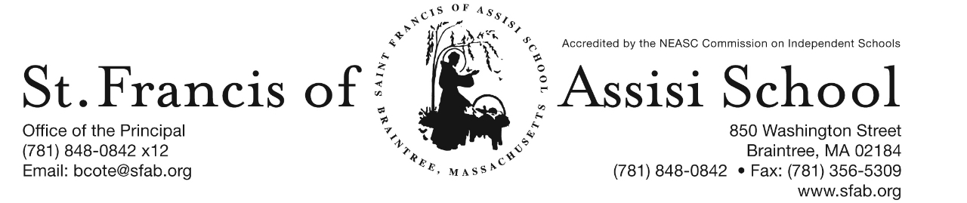

Volume 4, Issue 24– March 15, 2017

IMPORTANT DATES

Fri, Mar. 17th
- St. Patrick’s Day – Wearin’ of the Green Dress Down Day

Sun, Mar. 19th
- Championship Basketball Game; 2:00 p.m.; Catholic Memorial High School
- 3rd Sunday of Lent

Tue, Mar. 21st
- First Penance; 12:15 p.m.

Wed, Mar. 22nd
- 2nd Trimester (grades PK-5) Report Cards

Thur, Mar. 23th
- Professional Day – No School for Students

Fri, Mar. 24th
- Sheryl Faye presents Amelia Earhart performance; 9:30; School Hall
- Spring Middle School Dance (grades 6-8); 7:00 – 10:00; St. Jerome School (Weymouth)

Sun, Mar. 26th
- 4th Sunday of Lent

Tue, Mar. 28th
- Individual Spring Picture Day

Thur, Mar. 30th
- MARC Presentation for students (grades 4 – 8).

ST. PATRICK’S DAY DRESS DOWN DAY– On Friday, March 17th, in honor of St. Patrick’s Day, SFA will be sponsoring a Dress Down Day or “Wearin’ of the Green! We are asking each student to dontate $1 to dress down that will go to a chosen charity.
CHAMPIONSHIP BOUND - Congratulations to our 5th/6th Boys’ Basketball Team who won their semifinal game against St. Raphael School of Medford last Sunday afternoon, with the score of 41 - 14. We are so proud of our team! The boys will now advance and compete in the Championship Game of the Archdiocese of Boston CYO Tournament against Immaculate Conception School of Revere this Sunday, 3/19th at Catholic Memorial High School, 235 Baker Street, West Roxbury at 2:00 p.m. Let's Go and Show our Support for our School and Boys!!!

SFA FIRST PENANCE - On Tuesday afternoon, March 21st at 12:15 p.m., many of our grade 2 students from St. Francis of Assisi Parish will be making their First Penance. Let us keep these students, as well as all of our students in grade two who will be making this sacrament in our thoughts and prayers.

PROFESSIONAL DAY (NO SCHOOL) – Please note as indicated on our School and Monthly Calendars that next Thursday, March 23th, it is a Professional Day and there will be No School.

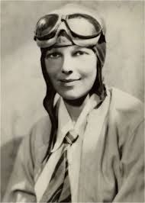
AMELIA EARHART PERFORMANCE: Pioneer in Aviation
Friday, March 25th at 9:00 a.m.
in the School Hall

During Catholic Schools Week, SFA had once again embarked on an all-school read aloud initiative called One School, One Book. Throughout the week, all our students at every grade level listened to the same book, Who Was Amelia Earhart? by Kate Boehm Jerome and illustrated by Nancy Harrison and David Cain. With this One School, One Book initiative, we aimed to further build a community of readers at our school. As a follow-up activity, a performance of Amelia Earhart: Pioneer in Aviation by Sheryl Faye Presents Historical Women will be performed on Friday, March 24th.
Amelia Earhart’s fearless, adventuresome spirit leads to hair-raising rides down her homemade rollercoaster, and she is enthralled with the wonders of the new “Flying machines” during a family vacation to the Iowa State Fair. As she matures, she is fulfilled by her work as a nurse’s aide and begins to consider a career in medicine. This idea “flies out the window,” however, when she pays a pilot $1.00 to take her up for a short “hop” in his plance. From then on, the science of aviation becomes her passion as flying becomes her career. She follows her dreams with an indomitable spirit, and her story will inspire our students to pursue their own budding interests, whatever they may be, and will also reinforce the importance of family, respect for others and individuality.

“This program is supported in part by a grant from the Randolph Cultural Council), a local agency which is supported by the Massachusetts Cultural Council, a state agency.”

MIDDLE SCHOOL SPRING DANCE – On Friday, March 24th, a Middle School Spring Dance has been scheduled from 7:00 – 10:00 at St. Jerome Elementary School in North Weymouth. A flyer/permission slip was sent home with students today. Please note that the completed permission slip along with $8.00 must be returned to SFA by March 17th.

“SPRING PORTRAITS” - On Tuesday, March 28th , your child will be having his/her “Spring” portrait taken by Lifetouch School Portraits. Students do not need to wear their school uniforms for these pictures. Next week, your child will bring home a Form with additional information regarding these “Spring” portraits. Please note that No Money is required at this time, but the Form must be returned on Picture Day, indicating which background you would like.

A WAY WITH WORDS – It was a great night at St. Francis of Assisi School as we held our Area 5 Regional Spelling Bee. Eleven our schools competed with 42 competitors, which took nearly two hours to name the winners! It is with great pride to extend a word of Congratulations to Alexandra Lacandula (grade 5) from SFA, who earned the title of Champion by winning First Place. What a fantastic accomplishment! First runner-up was Carl-Henry Charlot from St. Agatha School; Second place was John Ternullo from St. Jerome School; Third place was Colson Ganthier from St. Mary of the Hills School and Fourth place was Nicholas Ternullo from St. Jerome School. Each one of these students was awarded an Amazon gift card. Also competed were Grace Burgoyne (grade 6), Anthony Apromollo (grade 7) and Thao Ho (grade 8); who did a fine job of representing SFA. We are certainly proud of all our students at SFA.

7th ANNUAL RUN for CHARLOTTE – Let’s Offer our Help, Support, and Hope to Families Fighting Pediatric Cancer by participating in this year’s 5K Road Race ~ 5K Walk for Charlotte on April 23rd at 10:00 a.m. For more information or to register: www. prayersforcharlotte.org. Once again this year, SFA would like to offer a challenge! The class with the best percentage of race registrants at the race will be awarded with a pizza party! So lace up your sneakers and we hope to see you all at the race! It’s a fun filled family event and a cause we are always happy to support here at SFA!

SAVE THE DATE!!! SFA 2nd ANNUAL SPRING SOCIAL
Join us for the SFA 2nd Annual Spring Social on Friday, May 12th at Great Pond Hall in Braintree. This event will feature a cocktail reception, silent auction, raffles and more! All of the proceeds raised from this event will go towards supporting and enhancing our high quality programs at SFA. Bring your friends and neighbors and enjoy a fun adult night out to support our school! More information and details regarding this event will be forthcoming!

RE-REGISTRATION INFORMATION – It is the time of the year that we must begin the process of re-registration, as well as planning for the 2017 – 2018 school year.

All re-registration forms for students enrolling in our Pre-Kindergarten – Grade 8 for the 2017 – 2018 school year have been sent home with students and are now due.

Sibling registration forms are also available and may be obtained by contacting Mrs. Daly.

NEW STUDENT REFERRAL PROGRAM – “Become a SFA Ambassador & Receive a $500 Tuition Credit” (2017-2018 school year). As mentioned above, our annual Catholic Schools Week Open House will take place on Sunday, January 29th from 1:00 – 3:00 p.m. and as in the past many of our families initially hear about St. Francis of Assisi School through a personal referral from an existing school family. We want to once again reward you for promoting our school to you family and friends! We recognize that our parents are our best ambassadors. The Student Referral Program awards a referring SFA family with a $500 tuition credit for each student referred to SFA and enrolls for the 2017 – 2018 school year. Attached to this email is the New Student Referral Program form, which outlines in greater detail how the program works.

FACEBOOK
Make sure you check and like us on our school’s facebook page.
https://www.facebook.com/sfabraintree

