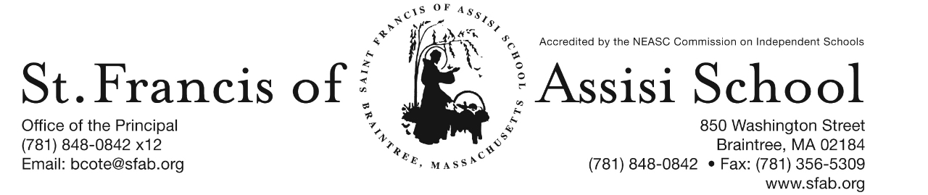

Volume 5, Issue 16 – January 10, 2018

IMPORTANT DATES

Thur, Jan. 11th
- Parent-Teacher Conference (grs K-5); Busing & Extended PM Care Services provided;
- 11:30 Early Dismissal for students (Grs. K – 5).
- Gr. 2 MAP Testing (math); 8:15
- Gr. 5 MAP Testing (reading); 8:15

Fri, Jan 12th
- Gr. 8 MAP Testing (language); 8:15
- Grs. 6&7 MAP Testing language); 9:00

Mon, Jan. 15th
- Martin Luther King Jr. Birthday – NO SCHOOL

Tue, Jan. 16th
- Gr. 3 MAP Testing (language); 8:15

Wed, Jan. 17th
- Gr. 4 MAP Testing (reading); 8:15

Thur, Jan. 18th
- Gr. 2 MAP Testing (reading); 8:15
- Gr. 5 MAP Testing (language); 8:15
- Gr. 6 Field Trip to Museum of Fine Arts
- Pre-Kindergarten Parent-Teacher Conferences

Our next SFA Parent Connection meeting is scheduled for TONIGHT, January 10th at 7:00. Please join us as we will be discussing and planning some of our upcoming events.

MARTIN LUTHER KING JR. DAY
In observance of MLK Jr, there is no school on Monday, January 15th.

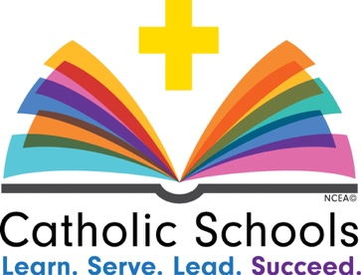
CATHOLIC SCHOOLS WEEK 2018
Will take place beginning on Sunday, January 28th – Saturday, February 3rd. This year’s theme encompasses the core products and values that can be found in Catholic schools across the country. Not only are we teaching students to become future servant leaders, faith-filled disciples and enriched citizens in our communities, we, as educators, are growing with them. At SFA, we are all learners, servants and leaders. These shared qualities are what makes Catholic schools work. They are what make Catholic schools succeed.

National Catholic Schools Week is an opportunity for you to see what I’m talking about. I am so proud of our students, and I can’t wait for you to visit our school. It is also a time for me to say publicly what I think every single day: I am grateful for the dedication and commitment of our teachers, staff, administrators, board members, parents, parishioners and volunteers who make our school such a success. They help our school community thrive.

RE-REGISTRATION INFORMATION - It is almost the time of the year that we must begin the process of re-registration, as well as planning for the 2018 – 2019 school year.

Today, re-registration forms for students enrolling in our Pre-Kindergarten and Kindergarten programs for the 2018 – 2019 school year will be sent home with students. These forms will also be posted on our school’s website and are due back by Friday, January 19, 2018.

Sibling registration forms are also available. They may be obtained by contacting Mrs. Daly.

Re-registration forms for grades 1 – 8 will be sent home on Wednesday, January 17, 2018.

OPEN HOUSE FOR NEW PROSPECTIVE FAMILIES - Do you have a friend or relative who might be interested in enrolling their child at SFA for the 2018 – 2019 school year? If so, please invite them to attend our Open House, which will be held on Sunday, January 28, 2018 from 1:00 p.m. to 3:00 p.m. Highlights of the day include the following: An information session; guided tours directed by SFA students; meet administration, faculty, and staff; hear from current students, parents, and alumni; and learn about SFA’s curriculum and extracurricular activities. In addition, prospective families may also visit our school throughout Catholic Schools Week (January 29th – February 2nd) from 9:00 a.m. – 1:00 p.m. Applications will be accepted (pending availability) on a first come, first serve basis. Enroll Today!

NEW STUDENT REFERRAL PROGRAM – “Become a SFA Ambassador & Receive a $500 Tuition Credit” (2017-2018 school year). As mentioned above, our annual Catholic Schools Week Open House will take place on Sunday, January 28th from 1:00 – 3:00 p.m. and as in the past many of our families initially hear about St. Francis of Assisi School through a personal referral from an existing school family. We want to once again reward you for promoting our school to you family and friends! We recognize that our parents are our best ambassadors. The Student Referral Program awards a referring SFA family with a $500 tuition credit for each student referred to SFA and enrolls for the 2018 – 2019 school year. Attached to this email is the New Student Referral Program form, which outlines in greater detail how the program works.

MAP TESTING (WINTER SESSION)
SFA along with other schools in the Archdiocese of Boston will continue to use and implement the NWEA MAP on-line assessment tool for all students in grades one through eight. This testing is not done to measure one school against another or solely to identify a student’s strengths or weaknesses. Test results are evaluated by teachers to assure that individual academic growth occurs and that the flow of curriculum avoids repetition and allows for our curriculum to fully benefit each child. Over the next few weeks, we will be administering the Winter Session assessments.

8  Grs. 7&8 (math) 8:15  Gr. 6 (math) 9:00 | 9  Gr. 3 (reading) 8:15 | 10  Grs. 7&8 (reading) 8:15  Gr. 6 (reading) 9:00 | 11  Gr. 2 (math) 8:15  Gr. 5 (reading) 8:15 | 12  Gr. 8 (language) 8:15  Grs. 6&7 (language) 9:00
15  Martin Luther King Jr. Day | 16  Gr. 3 (language) 8:15 | 17  Gr. 4 (reading) 8:15 | 18  Gr. 2 (reading) 8:15  Gr. 5 (language) 8:15 | 19
21 | 22  Gr. 1 (math) 8:15 | 23  Gr. 3 (math) 8:15 | 24  Gr. 4 (language) 8:15 | 25  Gr. 2 (language) 8:15  Gr. 5 (math) 8:15
29  Gr. 1 (reading) 8:15 | 30 | 31  Gr. 4 (math) 8:15 | 1 | 2

HOLIDAY CALENDAR WINNERS 2018
On Tuesday, January 8th, we held Week 1 drawing of our Holiday Calendar Raffle. Congratulations to our winners!

Date Prize Winner
1/1 $50 Paul O’Brien
1/2 $500 Linh Vu
1/3 $75 Pat O’Riordan
1/4 $100 Olga Mikhailidi
1/5 $75 Ben Allfrey
1/6 $100 Lisa Li
1/7 $75 Julie Ann Pepi
1/8 $250 Sharon Wade Fagan
1/9 $100 Coleman Halloran

IMPORTANT “NO SCHOOL” INFORMATION
Now that inclement winter weather is here! Generally, we follow Braintree Public Schools regarding school cancellations and delayed school openings. Radio and TV stations will carry the Braintree announcement and we will also use the ConnectEd automated phone system to notify every St. Francis of Assisi School family of a “no school” announcement or message about a delayed opening. In addition, we will also post this information on our facebook page!

EXTENDED DAY (DELAYED OPENING)
When school is canceled, there will be no morning or afternoon Extended Day Program. If a one-hour delay is announced, the before school program will begin at 8:00 a.m. If a two-hour delay is announced, it will open at 9:00 a.m. In the event of a snow emergency being declared in the Greater Boston area and/or an early dismissal at SFA, student must be picked up by 4 p.m. rather than the usual 6 p.m. deadline. On the chance that parents may not be able to leave work early, please have a backup plan in place for your child to be picked up by an alternate safe adult. Our goal is creating a procedure to ensure that all students and faculty members are transported safely in the event of a weather emergency. Thanks for your cooperation with this matter.
SFA FUNDRAISER AT JAKE n JOES
SAVE THE DATE!!! On Thursday, January 25th, enjoy lunch/dinner or take-out at Jake n Joes in Braintree from 11:30 – close and SFA will receive 20% of the total bill of all food and beverages. More information to follow!

SAFETY CONCERNS
When crossing Washington Street at arrival and dismissal, Shannon, our traffic guard has asked for your cooperation in making sure that all parents and students cross at the crosswalk under the direction of the crossing guard. This is to ensure the safety of all!

Also, many of our students bring water bottles to school. We are asking parents to please do not send in glass water bottles. As always, thank you for your continued support and cooperation with this matter!

FACEBOOK – Make sure you check and like us on our school’s Facebook page
https://www.facebook.com/sfabraintree

