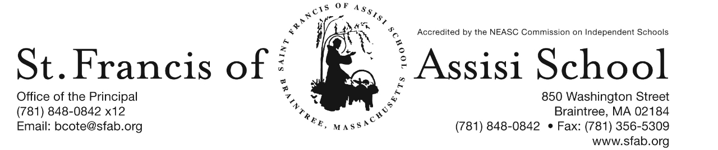

Volume 4, Issue 21– February 15, 2017

IMPORTANT DATES

Thur, Feb. 16th
- MAP Testing: Gr. 5 Reading; 8:30

Feb 20th – 24th
- Mid-Winter Break

Tue, Feb. 28th
- Chess Club – 2:00 – 3:00 pm

Wed, Mar. 1st
- Ash Wednesday Liturgy; 8:45 am; planned by grade 4.

Thur, Mar. 2nd
- Class Picture Day
- Read Across America Day

Fri, Mar. 3rd
- 3rd Term (grade 6-8) Mid-Point

HAVE A SAFE, HEALTHY, and WONDERFUL MID-WINTER BREAK!

MID-WINTER BREAK Students and teachers alike are always pleased that their mid-winter vacation comes in February. This year, the school vacation will begin on Monday, February 20th, Presidents’ Day, and will conclude on Friday, February 24th. I look forward to welcoming all of our students when they return to school on Monday, February 27th. May they all have a safe, healthy and wonderful vacation.

SFA’S GOT TALENT
Third times – a charm! After our Mid-Winter Break, we will re-schedule our SFA’s Got Talent Show!

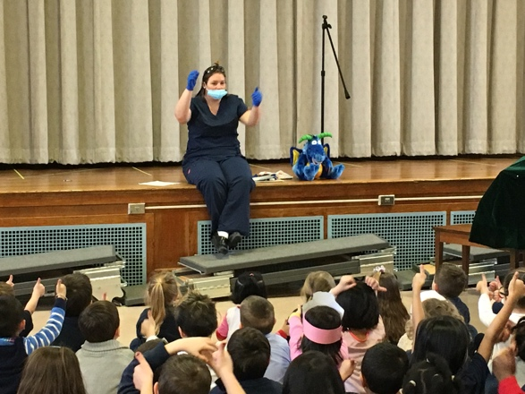

DR. ALLEN’S DENTAL PRESENTATION
Also in the month of February, we observe as National Dental Prevention month. Today, as part of our observance, Dr. Jen, a local dentist offered a special dental presentation today to our students in grades PK – 2.

JUMP ROPE FOR HEART
Once again this year as a service project for the month of February, our students will participate in the “Jump Rope for Heart” program. Through this community service effort, our students will have the opportunity to learn how to take care of their heart, as well as our school will make a donation to the American Heart Association.

ASH WEDNESDAY LITURGY
On Wednesday, March 1st our school community will gather for our Ash Wednesday Liturgy at 8:45 am. This liturgy is being planned and coordinated by our grade four students. All are welcome to attend as we begin the Lenten Season.

CLASS PICTURE DAY
On Thursday, March 2nd beginning at 8:15 a.m., class pictures will be taken by Lifetouch Photography in our school hall. Today, your child has brought home a Class Picture Order Form. Please note that this form along with $12 must be returned to school in order to purchase your child’s class picture. Order forms must be received and paid on or before Picture Day!

3rd TERM MID-POINT

The 3rd Term mid-point for grades 6 – 8 is Friday, March 3rd.

SCHOLASTIC BOOK FAIR
In celebration of Reading across America, SFA will be sponsoring a Scholastic Book Fair on March 6th – 9th in the lower church hall. The times are Monday evening, March 6th from 6:00 pm – 7:00 pm; Tuesday March 7th from 8:00 am – 1:00 pm; Wednesday, March 8th from 8:00 am – 1:00 pm; and Thursday, March 9th from 8:00 am – 1:00 pm.
Our parents and families are certainly encouraged and invited to take advantage of our Book Fair. All are welcome. Books are certainly an investment in a child’s education and future.

RE-REGISTRATION INFORMATION – It is the time of the year that we must begin the process of re-registration, as well as planning for the 2017 – 2018 school year.

All re-registration forms for students enrolling in our Pre-Kindergarten – Grade 8 for the 2017 – 2018 school year have been sent home with students and are now due.

Sibling registration forms are also available and may be obtained by contacting Mrs. Daly.
NEW STUDENT REFERRAL PROGRAM – “Become a SFA Ambassador & Receive a $500 Tuition Credit” (2017-2018 school year). As mentioned above, our annual Catholic Schools Week Open House will take place on Sunday, January 29th from 1:00 – 3:00 p.m. and as in the past many of our families initially hear about St. Francis of Assisi School through a personal referral from an existing school family. We want to once again reward you for promoting our school to you family and friends! We recognize that our parents are our best ambassadors. The Student Referral Program awards a referring SFA family with a $500 tuition credit for each student referred to SFA and enrolls for the 2017 – 2018 school year. Attached to this email is the New Student Referral Program form, which outlines in greater detail how the program works.

SAVE THE DATE!!! SFA 2nd ANNUAL SPRING SOCIAL
Join us for the SFA 2nd Annual Spring Social on Friday, May 12th at Great Pond Hall in Braintree. This event will feature a cocktail reception, silent auction, raffles and more! All of the proceeds raised from this event will go towards supporting and enhancing our high quality programs at SFA. Bring your friends and neighbors and enjoy a fun adult night out to support our school! More information and details regarding this event will be forthcoming!

FACEBOOK
Make sure you check and like us on our school’s facebook page.
https://www.facebook.com/sfabraintree

