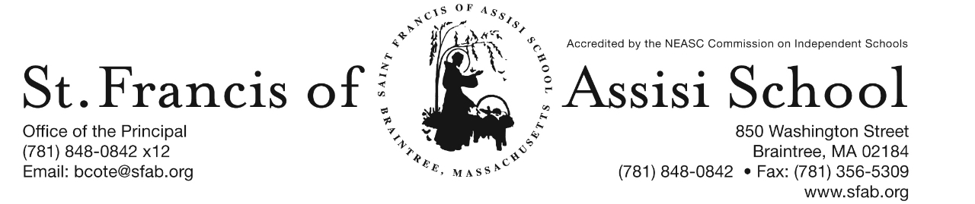

Volume 4, Issue 13 – December 7, 2016
IMPORTANT DATES

Thur, Dec. 8th
- All School Liturgy (Feast of the Immaculate Conception); 8: 45

Fri, Dec. 9th
- Santa’s Workshop

Thur, Dec. 15th
- The Chateau Fundraiser; 11:15 - closing

Fri, Dec. 16th
- SFA Christmas Concerts
- 12:00 Early Dismissal; No Hot Lunch or PM Extended Care provided

Sat, Dec 17th
- Santa’s Breakfast; 8:30 – 11:00 a.m.

Fri, Dec. 23rd
- 11:30 Early Dmissal Day; Busing provided; No Lunch or P.M. Extended Day Service.

Christmas Break
- Dec. 26th – Jan. 2nd

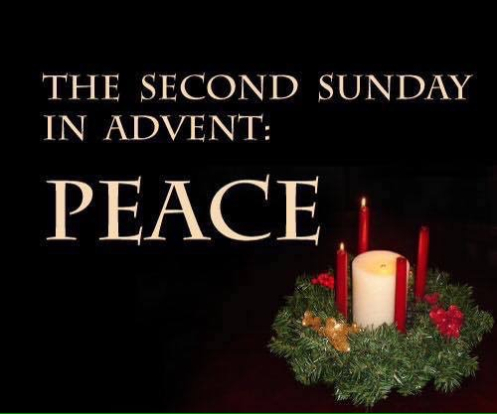

ADVENT PENANCE SERVICES
- Grade 3 Tuesday, December 20th at 1:00
- Grade 4 Tuesday, December 20th at 8:00
- Grade 5 Monday, December 19th at 8:00
- Grade 6 Monday, December 12th at 1:00
- Grade 7 Monday, December 19th at 1:00

HOLIDAY CALENDAR CAMPGAIGN

A special word of thanks to all of our school families who have returned their Holiday Calendars.

If you have not, please return them by December 15th in order that they will be included in our first drawing that will take place on January 5th.

Your support is greatly appreciated!
1st TRIMESTER REPORT CARDS
Please note that the 1st trimester for students in grades pre-kindergarten through five report cards will be distributed on Monday, December 12th. Parent-Teacher Conference will take place on Wednesday, January 11th.

FEAST OF THE IMMACULATE CONCEPTION LITURGY
On Thursday, December 8th, our students will attend liturgy at 8:45 in honor of the Feast of the Immaculate Conception. This liturgy is being planned and coordinated by our grade 5 students.

DRESS DOWN DAY – On Friday, December 9th, Saint Francis of Assisi School will hold a red and green Dress Down Day. Students are asked to donate $1 which will be used to purchase Christmas gifts from our students to our parish priests, as well as various people who serve us each day (i.e. postman, bus drivers, crossing guard, etc).

Santa’s Workshop is Coming this Friday to SFA!
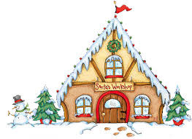
Santa’s Workshop is a Holiday Gift Shop for the children of Saint Francis of Assisi School to purchase gifts for their loved ones. We all have special memories of buying some small token for our parents and siblings during Christmas. We will give our students the chance to create special memories of giving to the ones they love.

Our Santa’s Workshop will be held this Friday, December 9th during the school day. The classroom teachers will bring the students to Santa’s Workshop. There will be a large variety of gifts from .50 cents to $10 to choose from. In preparation for this day, a budget envelop (Gift List Planner) has been provided in today’s communication materials and we ask that you please assist your child in filing out the names of the people for whom they would like to purchase gifts. Please place all cash or check made payable to SFA in the envelope. Our grade eight students will assist the other students throughout the day.

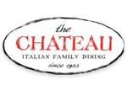
SFA FUNDRAISER AT THE CHATEAU
SAVE THE DATE!!! On Thursday, November 15th, enjoy lunch/dinner or take-out at The Chateau in Braintree from 11:15 – close and SFA will receive 20% of the total bill of all food and beverages. Please note: Fundraising Tickets are Required: so when paying your check, give the server your fundraising ticket (attached to this email; or available on our school’s homepage).

Breakfast with Santa will be held on Saturday, December 17th from 8:30 – 11:00 a.m. Have your picture taken with Santa, enjoy a nice breakfast, and have fun and friends and family at this beloved Saint Francis of Assisi School tradition. Santa will arrive at 9:00 a.m … do not miss this special arrive. Tickets are $5 per person or $15 per family. We hope to see you there.

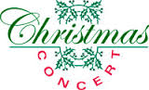
Our annual Christmas Concert will be just around the corner on Friday, December 16th. Our Christmas Concert is such a popular event that we have again decided to do two performance of this great show. Everyone works so hard to prepare for this concert that we feel they should showcase their talents more than once!

In order to fairly divide our audience for the concerts, we have split the school alphabetically by Family Names. Families with last names start with A to K will attend the first performance at 8:30 AM to 9:45 AM and families whose last names begin with L to Z will attend the second performance at 10:15 AM to 11:30 AM. Please note that this is an early release day at 12:00 noon and there will be no Extended Day Care Services provided on this day! Additional information and details regarding our upcoming Christmas Concert is attached to this email.

Basketball (December) Schedules:

Grade 5/6 Girls

Fri. 12/9/16 5 pm SFA vs. Quincy Catholic Quincy Catholic Academy

Mon. 12/12/16 5:30 pm SFA vs. Boston Catholic Academy University Sports Complex

Mon. 12/19/16 5:30 pm SFA vs. St. Johns University Sports Complex

Wed. 12/21/16 5:30 pm SFA vs. Blessed Sacrament MPLEX

Grade 5/6 Boys

Wed. 12/7/16 7:30 pm SFA vs. St. John St. John (Canton)

Fri. 12/9/16 8 pm SFA vs. Blessed Sacrament Blessed Sacrament (Walpole)

Mon. 12/12/16 6:30 pm SFA vs. St. Francis Xavier University Sports Complex

Fri. 12/16/16 7:00 pm SFA vs. Blessed Sacrament Blessed Sacrament (Walpole)

Mon. 12/19/16 6:30 pm SFA vs. St. Paul University Sports Complex

Grade 7/8 Boys

Fri. 12/9/16 7 pm SFA vs. PJPII Pope John Paul II (Boston)

Sat. 12/17/16 3 pm SFA vs. St. Catherine St. Catherine (Norwood)

Mon. 12/19/16 7:30 pm SFA vs. St. Francis Xavier University Sports Complex

Tue. 12/20/16 7 pm SFA vs. Monsignor Haddad Monsignor Haddad (Needham)

Afterschool Enrichment Winter Program - St. Francis of Assisi School will be once again offering chess instruction sponsored by Chess Wizard for students in grades K – 5. Let your child be part of a successful chess academy. Chess Wizards offers specifically designed classes that cater to all levels of chess ability. Each child is challenged by fun games and lessons from great chess teachers. It is proven chess enhances cognitive development in children, improves both verbal and mathematical skills, and increased all levels of academic performance. Our winter session will begin on Wednesday, January 10th … so don’t hesitate to register today on-line. More information about this program has been attached to this email-blast.

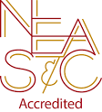
NEASC – RE-ACCREDITATION
In this preparatory phase of the self-study, our parents/guardians are given the opportunity to give feedback about our school (its mission, admission policy, programs, curriculum, etc...). We welcome all constructive information that will assist us in writing our self-study, as well as our multi-year plan.

We want to take this opportunity to express our appreciation and thank the many parents who have already completed the survey. If you have not, we ask that you please do; your input and feedback is so important and valuable to us.

The parent survey may be accessed with the following link: https://www.surveymonkey.com/r/BMT9VTG

FACEBOOK
Make sure you check and like us on our school’s facebook page.
https://www.facebook.com/sfabraintree

