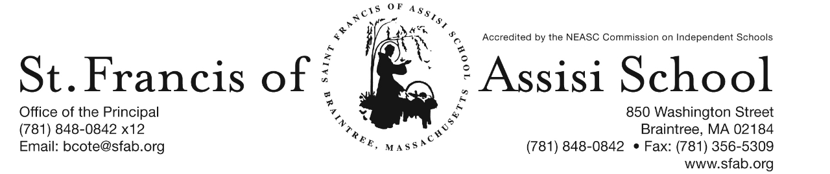

Volume 5, Issue 12 – Nov. 29, 2017
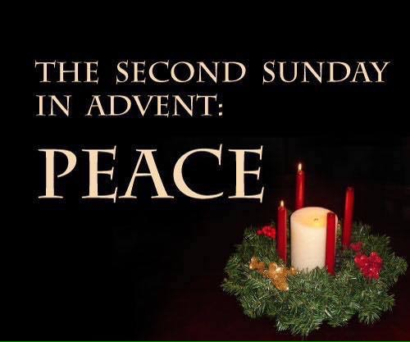
IMPORTANT DATES

Thur, Dec. 7th
- Professional Day – No School for Students

Fri, Dec. 8th
- All School Liturgy (Feast of the Immaculate Conception); 8:45; All are Welcome!

Sun, Dec. 10th
- 2nd Sunday of Advent

Mon, Dec. 11th
- Report Cards distributed in grades PK – 5.
- Grade 3 Penance Service; 8:00
- Grade 5 Penance Service; 1:00

Wed, Dec. 13th
- Grade 4 Penance Service; 8:00

Thur, Dec. 14th
- 2nd Term (grs. 6 – 8) Mid-Point

Fri, Dec. 15th
- Santa’s Workshop

Sat, Dec. 16th
- Breakfast with Santa; 8:30 – 11:00

Sun, Dec. 17th
- 3rd Sunday of Advent

Wed, Dec. 20th
- Christmas Concerts; 8:30 & 10:15
- 12:00 Early Dismissal; No PM Extended Care Services provided

PROFESSIONAL DAY – NO SCHOOL
On Thursday, December 7th, there will be NO School for the students for it is a Professional Day. On this day, our faculty and staff will be re-certified in CPR as well as continued to work on our school’s self-study for our upcoming NEASC visit.

ALL SCHOOL LITURGY
On Friday, December 8th, our SFA School community will gather for an All-School Liturgy in honor of the Feast of the Immaculate Conception. The students in Grade Three will be planning and coordinating this Liturgy.

HOLIDAY CALENDAR CAMPGAIGN
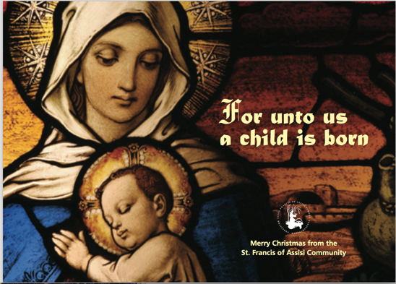
Just a reminder that our Holiday Calendar Campaign will end on December 15th, with our first drawing taking place on January 4th.

Need Your Assistance! We will be seeking students and parents who would be interested in assisting us in selling Holiday Calendars at the end of the weekend masses at St. Francis of Assisi Parish the weekends of December 9/10 and 16/17. The mass schedule includes Saturday at 4:00; Sunday at 7:00, 9:30, and 10:30. If you could help us with one of these times, it would be greatly appreciated. If interested, please contact Mrs. Daly at 781-848-0842 x10 or email cdaly@sfab.org.

1st TRIMESTER REPORT CARDS
On Monday, December 4th. Report cards will be distributed on Monday, December 11th.

SFA FUNDRAISER AT THE CHATEAU
SAVE THE DATE!!! On Thursday, November 14th, enjoy lunch/dinner or take-out at The Chateau in Braintree from 11:15 – close and SFA will receive 20% of the total bill of all food and beverages. Please note: Fundraising Tickets are Required: so, when paying your check, give the server your fundraising ticket (attached to this email; or available on our school’s homepage).

Santa’s Workshop is Coming Soon to SFA!
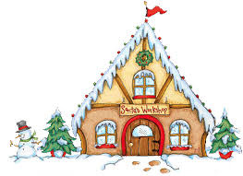
Santa’s Workshop is a Holiday Gift Shop for the children of Saint Francis of Assisi School to purchase gifts for their loved ones. We all have special memories of buying some small token for our parents and siblings during Christmas. We will give our students the chance to create special memories of giving to the ones they love.

Our Santa’s Workshop will be held on Friday, December 15th during the school day. The classroom teachers will bring the students to Santa’s Workshop. There will be a large variety of gifts from .50 cents to $10 to choose from. In preparation for this day, a budget envelope (Gift List Planner) will be provided in next week’s communication materials and we ask that you please assist your child in filing out the names of the people for whom they would like to purchase gifts. Please place all cash or check made payable to SFA in the envelope. Our grade eight students will assist the other students throughout the day.

Breakfast with Santa will be held on Saturday, December 16th from 8:30 – 11:00 a.m. Have your picture taken with Santa, enjoy a nice breakfast, and have fun and friends and family at this beloved Saint Francis of Assisi School tradition. Santa will arrive at 9:00 a.m. … do not miss this special arrival. Tickets are $5 per person or $15 per family. We hope to see you there.

Our annual Christmas Concert will be just around the corner on Wednesday, December 20th. Our Christmas Concert is such a popular event that we have again decided to do two performances of this great show. Everyone works so hard to prepare for this concert that we feel they should showcase their talents more than once!

In order to fairly divide our audience for the concerts, we have split the school alphabetically by Family Names. Families with last names start with A to K will attend the first performance at 8:30 AM to 9:45 AM and families whose last names begin with L to Z will attend the second performance at 10:15 AM to 11:30 AM. Please note that this is an early release day at 12:00 noon and there will be no Extended Day Care Services provided on this day!

CHRISTMAS SERVICE PROJECTS
In keeping with the tradition of giving this holiday season, our school community will participate in a variety of Christmas service projects.

In our middle school (grades 6 – 8), our students will be participating in a Christmas service project to help the homeless that are served by our local communities. From December 4th through December 15th, we will be collecting hats, gloves, mittens, scarves, and socks, in children and adult sizes, for those less fortunate than ourselves. All donations will be brought to an area bank that will send these items to the Salvation Army to be distributed as the need arises.

In our elementary school (grades PK – 5), our students will be participating in a Christmas service project to help keep children warm in the cold. From December 4th through December 20th, we will be collecting school aged size pajamas for children in need. All donations will be delivered to the Massachusetts Department of Children & Family located in Braintree.

Mrs. Lane’s fourth grade class has truly developed the idea of kindness in their recent read of R.J. Palacio’s book, Wonder. If you haven’t read the book, it is a must read! The main character, Auggie Pullman, was born with a facial deformity. He was homeschooled until fifth grade and is going to start 5th grade at a middle school. Auggie faces many challenges each day because of his facial deformity, and going to middle school will be one of his biggest challenges yet. The book has a wonderful message to “choose kind” and that all people should be treated with kindness and respect. The book also features some wonderful references to popular music such as Natalie Merchant’s song Wonder and Beautiful by Christina Aguilera. So, the fourth graders took on a new challenge. They are listening to the songs in Wonder and reading the song lyrics to make connections to the characters and events in Wonder. Making text to text connections is an important reading comprehension skill for students to learn. Making text to text connections helps students to think more deeply about what they are reading and helps to develop critical thinking skills. Using music lyrics to make connections is engaging and motivating for the students to learn this skill. Students quickly realize the value of close reading with a song so they can appreciate the story behind the song. Also, check out Mrs. Lane’s Locker decorations that feature Auggie’s astronaut costume. Students decorated the costumes. Then, the students visited each locker to write a special, positive message about each student.

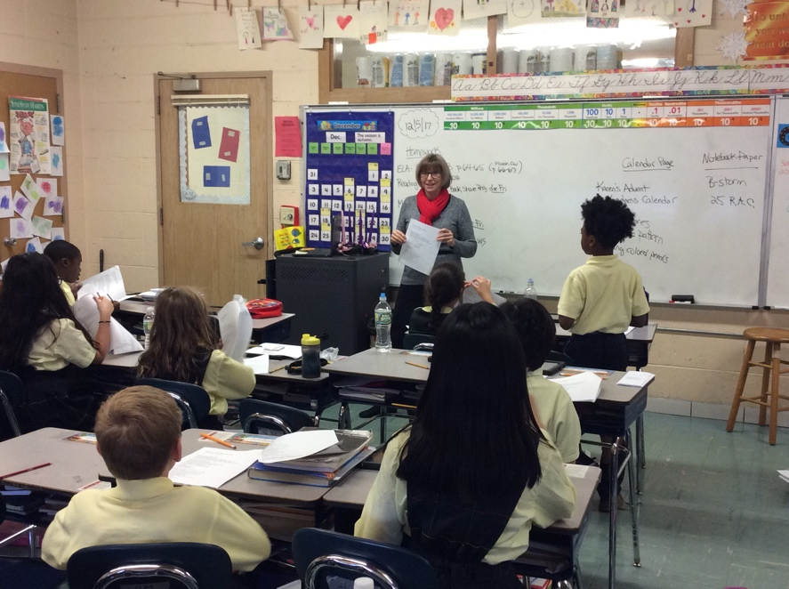
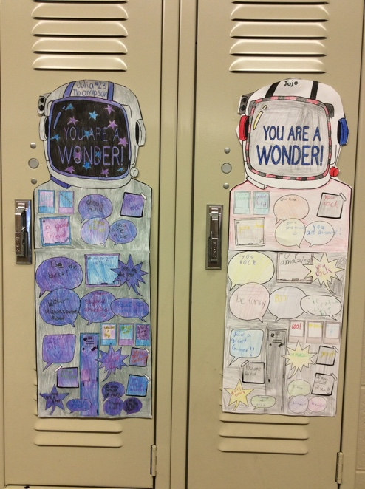

SECOND STEP CHILD SAFETY/PROTECTION PROGRAM
At the beginning of the school year, I mentioned both in writing as well as in my Opening of School remarks that we along with all of the other Catholic schools in the Archdiocese of Boston, we would be implementing a new safety program for the safety of our students. As many of you know, we have used the Talking About Touching program in the past, which is somewhat now outdated. We will now be using the Second Step Program in your child’s classroom (grades pre-kindergarten – 5). The Second Step Child Protection Program is a research-based program that teaches children important skills for getting along with others and doing well in school. It also helps our school be a safe and supportive place where everyone can learn. The lessons are developmentally age-appropriate on safety, not keeping secrets and touching. It also gives our teachers the tools to recognize and respond to abuse and the confidence to comfortably teach students about this sensitive subject. In the very near future, your child’s classroom teacher will be providing you with a copy of a Family Letter, which also includes an on-line login in to get additional information about what your child is learning in the Second Step program. If for any reason you do not want your child to particiate in these lessons, please complete, sign and return the bottom portion of this letter.

FACEBOOK – Make sure you check and like us on our school’s Facebook page.

https://www.facebook.com/sfabraintree

