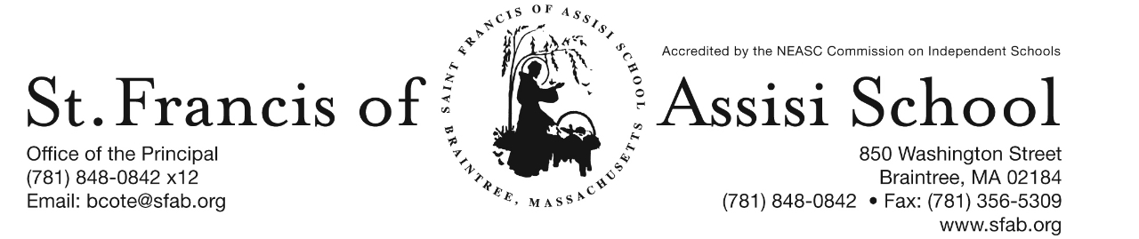

**Volume 4, Issue 13 – December 7, 2016**

**IMPORTANT DATES**

**Fri, Dec. 23rd**

* 11:30 Early Dmissal Day; Busing provided; No Lunch or P.M. Extended Day Service.

**Christmas Break**

* Dec. 26th – Jan. 2nd

**Tue, Jan. 3rd**

* School resumes

**Wed, Jan. 11th**

* Parent-Teacher Conferences (PK-Grade 5); 11:30 Early Dismissal for PK-Grade 5 students only; Lunch and PM Extended Day Services provided
* Sacramental Meeting (grade 2 parents); 7:00 pm; Church Hall

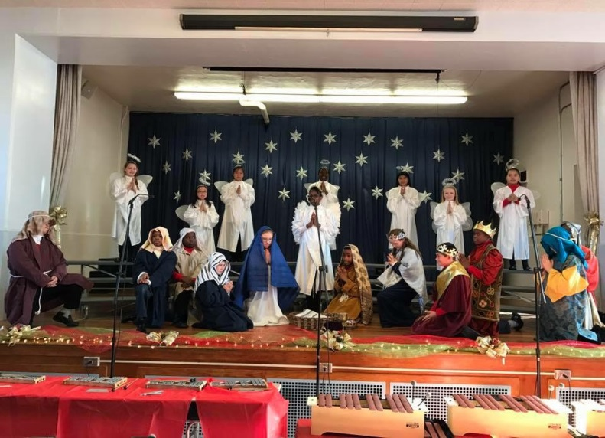

**MERRY CHRISTMAS!**

On behalf of the administration, faculty and staff at Saint Francis of Assisi School, I would like to take this opportunity to wish all of you a Blessed and Holy Christmas. Let us keep our hearts and minds on the Birth of Jesus, the Greatest Gift of all. May each day of your Christmas be filled with peace and may God’s love continue to light your way through the New Year. Let this Christmas be a time filled with family and friends, enthusiastically enjoying activities and traditions that will be part of your memory forever.

We wish all of you a Joyful, Safe, and Healthy Christmas Break and look forward to your return to school on Tuesday, January 3, 2017.

**DRESS DOWN DAY**

On Friday, December 23rd, the students may dress down. No cost to dress down.

**CHRISTMAS BREAK**

Our Christmas Break officially begins on Friday, December 23rd at 11:30 a.m. Please note that this day is an early dismissal day; Busing will be provided, but there will be No Lunch or PM Extended Day Services provided. School will resume on Tuesday, January 3rd.



A special word of thanks to all of our school families who have returned their Holiday Calendars.

If you have not, please return them by tomorrow, in order that they will be included in our first drawing that will take place on January 5th.

Your support is greatly appreciated!

**SAVE THE DATES …**

**SACRAMENTAL MEETING (GRADE 2)**

On Wednesday, January 11th, Mrs. Diane Hopkins, Religious Ed. Director, will lead an informative meeting at 7:00 p.m. in the Church Hall for second grade parents whose children (baptized Catholics) who will be receiving their First Communion and First Penance at SFA. Important information will be shared and books distributed. If for some reason you are not able to attend, please contact Mrs. Hopkins (dhopkins@sfab.org ).

C:\Documents and Settings\Owner\Local Settings\Temporary Internet Files\Content.IE5\3IVL1NON\MC900088966[1].wmf**PARENT TEACHER CONFERENCES**

Optional parent-teacher conferences for the grades Pre-kindergarten through five will be held on Wednesday, January 13th from 12:30 – 8:00 p.m. ***Students in these grades only, will be dismissed at 11:30 a.m. on Wednesday, January 13th.*** Buses will comply with our schedule and Extended Day Program will also be available. More information to follow!



**Afterschool Enrichment Winter Program -** St. Francis of Assisi School will be once again offering chess instruction sponsored by Chess Wizard for students in grades K – 5. Let your child be part of a successful chess academy. Chess Wizards offers specifically designed classes that cater to all levels of chess ability. Each child is challenged by fun games and lessons from great chess teachers. It is proven chess enhances cognitive development in children, improves both verbal and mathematical skills, and increased all levels of academic performance. Our winter session will begin on Wednesday, January 10th … so don’t hesitate to register today on-line. More information about this program has been attached to this email-blast.

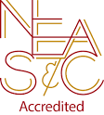**NEASC – RE-ACCREDITATION**

In this preparatory phase of the self-study, our parents/guardians are given the opportunity to give feedback about our school (its mission, admission policy, programs, curriculum, etc...). We welcome all constructive information that will assist us in writing our self-study, as well as our multi-year plan.

We want to take this opportunity to express our appreciation and thank the many parents who have already completed the survey. If you have not, we ask that you please do; your input and feedback is so important and valuable to us.

The parent survey may be accessed with the following link: <https://www.surveymonkey.com/r/BMT9VTG>

C:\Documents and Settings\Owner\Local Settings\Temporary Internet Files\Content.IE5\SQDYZKJ6\MC900105222[1].wmf

We at SFA, are so fortunate for such a fantastic school community. There are so many to thank.

**CHRISTMAS CONCERT**

What an enjoyable and spectacular Christmas Concert. A special word of thanks and congratulations to our music director, Mrs. Murray, the grade 8 students, and the entire student body who shared their talents and helped us remember the true meaning of Christmas. We would like to thank all of our families, friends and parishioners, who attended the concert. It was so nice to see so many people gathered to support our school, most of all the SFA students.

**SANTA’S BREAKFAST**

C:\Documents and Settings\Owner\Local Settings\Temporary Internet Files\Content.IE5\90M5VOBE\MC900304875[1].wmfDespite the inclement weather, this special morning was certainly enjoyed by all who attended. I would like to express my appreciation and thank everyone who made this event such a great success; a special thanks to all of our parents and students who volunteered their time and talents, Mrs. March for coordinating our arts and crafts, Mrs. Murray and our choir for providing such beautiful music, and to our school families who supported this event. This event certainly has put us into the spirit of Christmas!

And finally a word of Appreciation and Thank you for all who participated in our recent fundraiser at The Chateau Restaurant.

**CALLING ALL ALUMNI**

As families will soon gather to celebrate Christmas, St. Francis of Assisi School would like to offer its alumni four great ways to stay connected so that you can receive news about our school, alumni events, and alumni news. But, we need your help by updating your contact information by:

* Completing our on-line Alumni Update Form located on our school’s website ([www.sfab.org/sfabschool](http://www.sfab.org/sfabschool));
* Joining us on Facebook at www.facebook.com/sfabraintree
* Sending your current contact information (name, address, city, state, zip, telephone, year of graduation) and email address as well as news about what you have been up to [alumni@sfab.org](mailto:alumni@sfab.org); or
* Contacting us at (781)-848-0842.

Help us spread the news to other SFA alumni and parents of alumni and we look forward to reconnecting with you. Thank you for staying in touch.

**FACEBOOK**

Make sure you check and like us on our school’s facebook page.

[**https://www.facebook.com/sfabraintree**](https://www.facebook.com/sfabraintree)