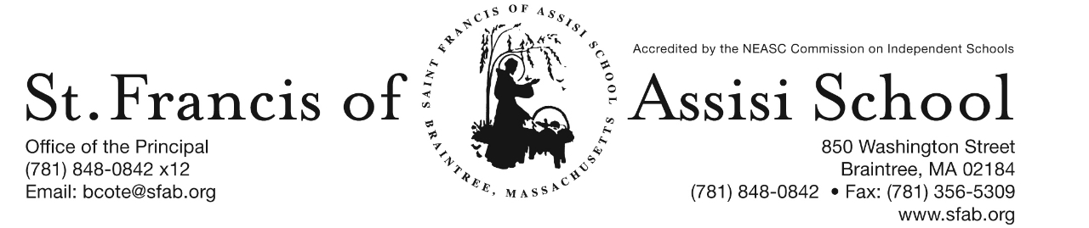

**Volume 5, Issue 14 – Dec. 20, 2017**

**IMPORTANT DATES**

**Wed, Dec. 20th**

* Christmas Concerts; 8:30 & 10:15
* 12:00 Early Dismissal; No PM Extended Care Services provided

**Thur, Dec. 21st**

* Grades 1 & 2 Ornament Decorating; 8:30 – 1:00; School Hall

**Fri, Dec. 22nd**

* Christmas Break begins at 2:00 p.m.

**Tue, Jan. 2nd**

* School resumes

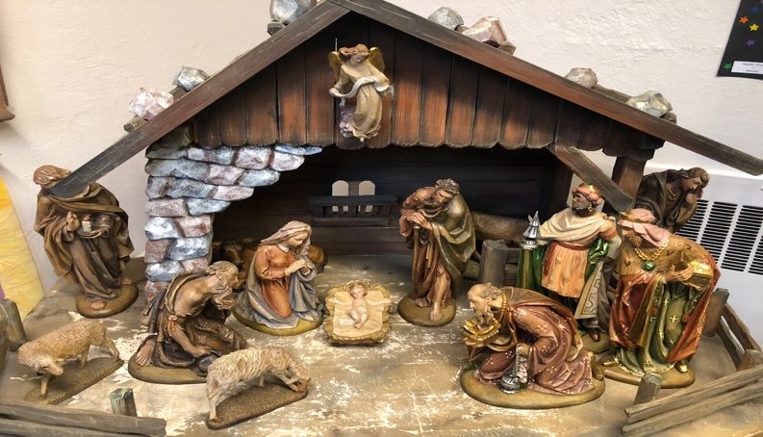

**MERRY CHRISTMAS!**

On behalf of the administration, faculty and staff at Saint Francis of Assisi School, I would like to take this opportunity to wish all of you a Blessed and Holy Christmas. Let us keep our hearts and minds on the Birth of Jesus, the Greatest Gift of all. May each day of your Christmas be filled with peace and may God’s love continue to light your way through the New Year. Let this Christmas be a time filled with family and friends, enthusiastically enjoying activities and traditions that will be part of your memory forever.

We wish all of you a Joyful, Safe, and Healthy Christmas Break and look forward to your return to school on Tuesday, January 2, 2018.

**CHRISTMAS ORNAMENT DECORATING**

Today, our students in grades 1 and 2 will be decorating Christmas ornaments in the School Hall. Glitter galore!

**DRESS DOWN DAY**

Tomorrow, Friday, December 22nd , the students may dress down. No cost to dress down.

**CHRISTMAS BREAK**

Our Christmas Break officially begins on Friday, December 22nd at 2:00 p.m.. School will resume on Tuesday, January 2nd ***Please note that there will be no Extended P.M. Care Services provided on this afternoon.***

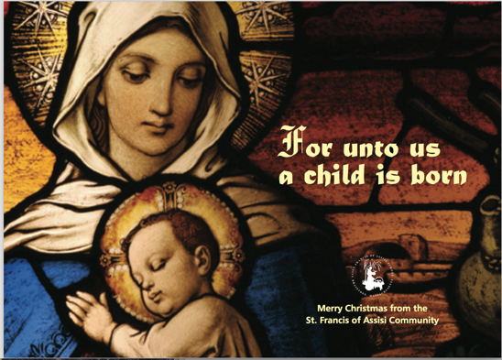

A special word of thanks to all of our school families who have returned their Holiday Calendars.

If you have not, please return them by tomorrow, in order that they will be included in our first drawing that will take place on January 4th.

Your support is greatly appreciated!

**SAVE THE DATES…**

C:\Documents and Settings\Owner\Local Settings\Temporary Internet Files\Content.IE5\3IVL1NON\MC900088966[1].wmf**PARENT TEACHER CONFERENCES**

Optional parent-teacher conferences for the grades kindergarten through five will be held on Thursday, January 11th from 12:30 – 8:00 p.m. ***Students in these grades only, will be dismissed at 11:30 a.m. on Thursday, January 11th.*** Buses will comply with our schedule and Extended Day Program will also be available. More information to follow! Optional parent-teacher conferences for the students in pre-kindergarten will take place on Thursday, January 4th.

**SFA’s GROUP OUTING AT THE PROVIDENCE BRUINS**

St. Francis of Assisi is planning a group outing with the Providence Bruins. This promises to be a wonderful event with great seats for our school to watch the Bruins play against the SPR. The game will take place on Sunday, January 21st at 3:05 at the Dunkin Donut Center. All of our students will receive a free P-Bruins hat, popcorn and a drink. Attached to this email is a flyer with addition details and ticket purchasing information. Please note that the Ticket Form must be returned, along with payment to SFA on or before January 9th.

**SFA FUNDRAISER AT JAKE n JOES**

SAVE THE DATE!!! On Thursday, January 25th, enjoy lunch/dinner or take-out at Jake n Joes in Braintree from 11:30 – close and SFA will receive 20% of the total bill of all food and beverages. **More information to follow!**

**Mrs.** **Aiello’s Pre-K Classroom**

Can you imagine describing the world around us without using color? Mrs. Aiello’s class not only learns their colors, but skills that will help them learn throughout life! During a recent lesson, Mrs. Aiello read a story, “Bear Sees Colors” by Karma Wilson. to her class. The pre-k friends gathered quietly on the classroom rug to meet.~ The children were excited to be read to. Throughout the lesson, the students were engaged. The lesson began with phrases very familiar to the pre-k students. “Hocus pocus…time to focus.” “Click on your learning antennas.”~ With a few words, the children’s attention was given to a new learning activity. A story time song was sung before beginning. The story “Bear Sees Colors”, was about animal friends and colors. Through the use of rhyming, the children helped predict the next color that would be introduced in the story. ~Students were alert and involved as the story was read.~ They met a bear, badger, wren, raven, and mole in the story. As bear found colors with his friends, Mrs. Aiello found colors with her “pre-k friends.”~ They were detectives finding the color on the page. Taking turns, the students would proudly point out to their friends the color blue in the flowers, sky, and water, or the yellow galoshes and honeycomb on the page. Children were acknowledged for their effort and attentiveness. When finished reading, Mrs. Aiello assessed their understanding of colors by a “Hands on head” game to show recognition of colors. They followed up by completing a Hooray for Hats paper which they colored, after finding the specific crayon color that Mrs. Aiello requested.Everyone knows pre-k in Mrs. Aiello’s room is fun and active, but it is amazing how much foundational learning is being introduced. Listening, oral communication, vocabulary, colors, thinking skills, rhyming, and following directions were all part of this one lesson.~ What an enjoyable way for a child to begin their adventure in learning!

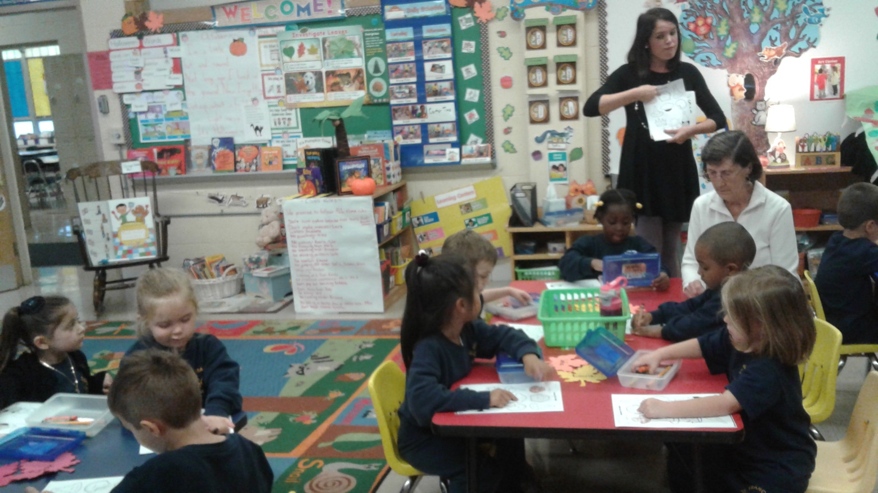

C:\Documents and Settings\Owner\Local Settings\Temporary Internet Files\Content.IE5\SQDYZKJ6\MC900105222[1].wmf

We at SFA, are so fortunate for such a fantastic school community. There are so many to thank.

**CHRISTMAS CONCERT**

What an enjoyable and spectacular Christmas Concert. A special word of thanks and congratulations to our music director, Mrs. Murray, the grade 8 students, and the entire student body who shared their talents and helped us remember the true meaning of Christmas. We would like to thank all of our families, friends and parishioners, who attended the concert. It was so nice to see so many people gathered to support our school, most of all the SFA students.

**SANTA’S BREAKFAST**

C:\Documents and Settings\Owner\Local Settings\Temporary Internet Files\Content.IE5\90M5VOBE\MC900304875[1].wmfThis special morning was certainly enjoyed by all who attended. I would like to express my appreciation and thank everyone who made this event such a great success; a special thanks to Mrs. Sheridan and her committee, all of our parents and students who volunteered their time and talents, Mrs. March for coordinating our arts and crafts, Mrs. Murray and our choir for providing such beautiful music, and to our school families who supported this event. This event certainly has put us into the spirit of Christmas!

And finally a word of Appreciation and Thank you for all who participated in our recent fundraiser at The Chateau Restaurant.

**PICTURES FROM SANTA’S BREAKFAST**

Here is the link to the Photos with Santa.

<https://drive.google.com/open?id=1tjTlj6cDt4NzkbAswpPwZbfwuHx84rGw>

The link will be available for the whole month of December.

The print outs of these photos(in 4" x6") will be available on or before Wednesday, December 20th to be delivered to the student's respective classrooms. Thank you Mr. & Mrs. Lacandula … the pictures came out fantastic

**CHRISTMAS RAFFLE**

On behalf of the SFA School Community, I want to thank all of your for your continued support and generosity. I have listed the winner of our Christmas Raffle: Super Heroes Basket – Van Nguyen; Snow Day Survival Basket – Joy McCaffrey; Slime Basket – The Connelly Family; iTunes Basket – Maryann McMorrow; Wine Basket – Alexis Bristol; Americian Girl Basket – Joan Bailey; Bike – LouAnna Kelly; and Gingerbread Sleigh – Peggy K.

**FACEBOOK** – Make sure you check and like us on our school’s Facebook page

[**https://www.facebook.com/sfabraintree**](https://www.facebook.com/sfabraintree)