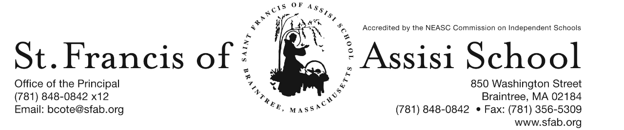

**Volume 4, Issue 13 – December 14, 2016**

**IMPORTANT DATES**

**Thur, Dec. 8th**

* All School Liturgy (Feast of the Immaculate Conception); 8: 45

**Fri, Dec. 9th**

* Santa’s Workshop

**Thur, Dec. 15th**

* The Chateau Fundraiser; 11:15 - closing

**Fri, Dec. 16th**

* SFA Christmas Concerts
* 12:00 Early Dismissal; No Hot Lunch or PM Extended Care provided

**Sat, Dec 17th**

* Santa’s Breakfast; 8:30 – 11:00 a.m.

**Fri, Dec. 23rd**

* 11:30 Early Dmissal Day; Busing provided; No Lunch or P.M. Extended Day Service.

**Christmas Break**

* Dec. 26th – Jan. 2nd

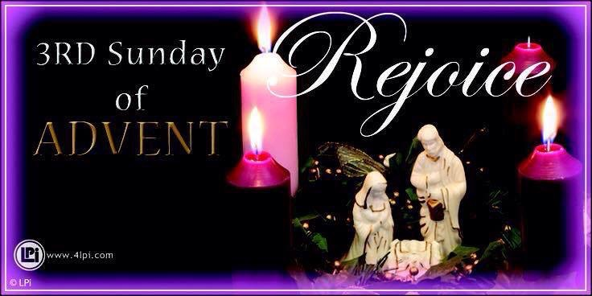

**HOLIDAY CALENDAR CAMPGAIGN**



A special word of thanks to all of our school families who have returned their Holiday Calendars.

If you have not, please return them by tomorrow, December 15th in order that they will be included in our first drawing that will take place on January 5th.

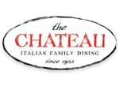Your support is greatly appreciated!

**SFA FUNDRAISER AT THE CHATEAU**

TOMORROW!!! On Thursday, December 15th, enjoy lunch/dinner or take-out at The Chateau in Braintree from 11:15 – close and SFA will receive 20% of the total bill of all food and beverages. **Please note: Fundraising Tickets are Required: so when paying your check, give the server your fundraising ticket (attached to this email; or available on our school’s homepage).**



**Breakfast with Santa** will be held on Saturday, December 17th from 8:30 – 11:00 a.m. Have your picture taken with Santa, enjoy a nice breakfast, and have fun and friends and family at this beloved Saint Francis of Assisi School tradition. Santa will arrive at 9:00 a.m … do not miss this special arrival. Tickets are $5 per person or $15 per family. We hope to see you there.

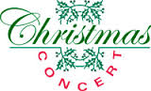Our annual Christmas Concert will be just around the corner on Friday, December 16th. Our Christmas Concert is such a popular event that we have again decided to do two performances of this great show. Everyone works so hard to prepare for this concert that we feel they should showcase their talents more than once!

In order to fairly divide our audience for the concerts, we have split the school alphabetically by Family Names. Families with last names start with A to K will attend the first performance at 8:30 AM to 9:45 AM and families whose last names begin with L to Z will attend the second performance at 10:15 AM to 11:30 AM. ***Please note that this is an early release day at 12:00 noon and there will be no Extended Day Care Services provided on this day!*** Additional information and details regarding our upcoming Christmas Concert is attached to this email.

**Christmas Ornament Decorating**

On Tuesday, December 20th, our students in grades 1 and 2 will be decorating Christmas ornaments in the School Hall from 8:30 – 11:00 a.m.

**Christmas Break**

Our Christmas Break officially begins on Friday, December 23rd at 11:30 a.m. Please note that this day is an early dismissal day; Busing will be provided, but there will be No Lunch or Extended Day Services provided. School will resume on Tuesday, January 3rd.

**Basketball (December) Schedules:**

**Grade 5/6 Girls**

Mon. 12/19/16 5:30 pm SFA vs. St. Johns University Sports Complex

Wed. 12/21/16 5:30 pm SFA vs. Blessed Sacrament MPLEX

**Grade 5/6 Boys**

Mon. 12/12/16 6:30 pm SFA vs. St. Francis Xavier University Sports Complex

Fri. 12/16/16 7:00 pm SFA vs. Blessed Sacrament Blessed Sacrament (Walpole)

Mon. 12/19/16 6:30 pm SFA vs. St. Paul University Sports Complex

**Grade 7/8 Boys**

Sat. 12/17/16 3 pm SFA vs. St. Catherine St. Catherine (Norwood)

Mon. 12/19/16 7:30 pm SFA vs. St. Francis Xavier University Sports Complex

Tue. 12/20/16 7 pm SFA vs. Monsignor Haddad Monsignor Haddad (Needham)

**Afterschool Enrichment Winter Program -** St. Francis of Assisi School will be once again offering chess instruction sponsored by Chess Wizard for students in grades K – 5. Let your child be part of a successful chess academy. Chess Wizards offers specifically designed classes that cater to all levels of chess ability. Each child is challenged by fun games and lessons from great chess teachers. It is proven chess enhances cognitive development in children, improves both verbal and mathematical skills, and increased all levels of academic performance. Our winter session will begin on Wednesday, January 10th … so don’t hesitate to register today on-line. More information about this program will be sent shortly.

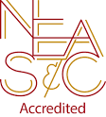**NEASC – RE-ACCREDITATION**

In this preparatory phase of the self-study, our parents/guardians are given the opportunity to give feedback about our school (its mission, admission policy, programs, curriculum, etc...). We welcome all constructive information that will assist us in writing our self-study, as well as our multi-year plan.

We want to take this opportunity to express our appreciation and thank the many parents who have already completed the survey. If you have not, we ask that you please do; your input and feedback is so important and valuable to us.

The parent survey may be accessed with the following link: <https://www.surveymonkey.com/r/BMT9VTG>

C:\Documents and Settings\Owner\Local Settings\Temporary Internet Files\Content.IE5\SQDYZKJ6\MC900105222[1].wmf

We at SFA, are so fortunate for such a fantastic school community. There are so many to thank.

First, to the fifth grade students and Mrs. Koulopoulos for the beautiful mass that they planned and coordinated for the Feast of the Immaculate Conception. A special word of thanks to Mrs. Murray and the choir for sharing their talents in providing such great music at our liturgy.

To our eighth grade students and Mrs. Dobrev for another successful Santa’s Workshop. It was so wonderful to see the smiles on the other students as they bought gifts for their family, friends and themselves.

**FACEBOOK**

Make sure you check and like us on our school’s facebook page.

[**https://www.facebook.com/sfabraintree**](https://www.facebook.com/sfabraintree)