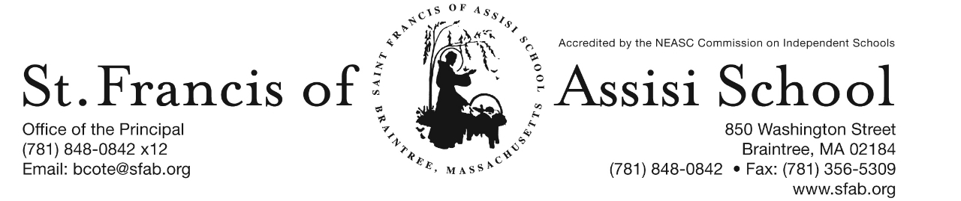

**Volume 5, Issue 13 – Dec. 13, 2017**



**IMPORTANT DATES**

**Thur, Dec. 14th**

* 2nd Term (grs. 6 – 8) Mid-Point

**Fri, Dec. 15th**

* Santa’s Workshop

**Sat, Dec. 16th**

* Breakfast with Santa; 8:30 – 11:00

**Sun, Dec. 17th**

* 3rd Sunday of Advent

**Wed, Dec. 20th**

* Christmas Concerts; 8:30 & 10:15
* 12:00 Early Dismissal; No PM Extended Care Services provided

**Thur, Dec. 21st**

* Grades 1 & 2 Ornament Decorating; 8:30 – 1:00; School Hall

**Fri, Dec. 22nd**

* Christmas Break begins at 2:00 p.m.

**Tue, Jan. 2nd**

* School resumes

**HOLIDAY CALENDAR CAMPAIGN**

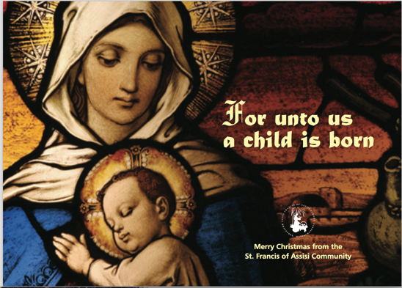 A special word of thanks to all of our school families who have returned their Holiday Calendars.

If you have not, please return them by Friday, December 15th in order that they will be included in our first drawing that will take place on January 4th. Your support is greatly appreciated!

**SFA FUNDRAISER AT THE CHATEAU**

Join us on Thursday, December 14th, and enjoy lunch/dinner or take-out at The Chateau in Braintree from 11:15 – close and SFA will receive 20% of the total bill of all food and beverages. **Please note: Fundraising Tickets are Required: so, when paying your check, give the server your fundraising ticket (attached to this email; or available on our school’s homepage).**

**Santa’s Workshop is Coming Soon to SFA!**

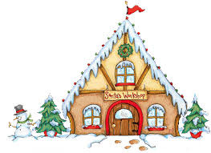Santa’s Workshop is a Holiday Gift Shop for the children of Saint Francis of Assisi School to purchase gifts for their loved ones. We all have special memories of buying some small token for our parents and siblings during Christmas. We will give our students the chance to create special memories of giving to the ones they love.

Our Santa’s Workshop will be held on this Friday, December 15th during the school day. The classroom teachers will bring the students to Santa’s Workshop. There will be a large variety of gifts from .50 cents to $10 to choose from. In preparation for this day, a budget envelope (Gift List Planner) has been provided and we ask that you please assist your child in filling out the names of the people for whom they would like to purchase gifts. Please place all cash or check made payable to SFA in the envelope. Our grade eight students will assist the other students throughout the day.

**DRESS DOWN DAY** – On Friday, December 15th, Saint Francis of Assisi School will hold a red and green Dress Down Day. Students are asked to donate $1 which will be used to purchase Christmas gifts from our students to our parish priests, as well as various people who serve us each day (i.e. postman, bus drivers, crossing guard, etc).



**Breakfast with Santa** will be held on this Saturday, December 16th from 8:30 – 11:00 a.m. Have your picture taken with Santa, enjoy a nice breakfast, and have fun with friends and family at this beloved Saint Francis of Assisi School tradition. Santa will arrive at 9:00 a.m. … do not miss this special arrival. Tickets are $5 per person or $15 per family. We hope to see you there. We ask that you please bring a donation of Pajamas that will be donated to the Pajamas for kids in Braintree sponsored by the Marge Crispin Center.



Our annual Christmas Concert will be just around the corner on Wednesday, December 20th. Our Christmas Concert is such a popular event that we have again decided to do two performances of this great show. Everyone works so hard to prepare for this concert that we feel they should showcase their talents more than once!

In order to fairly divide our audience for the concerts, we have split the school alphabetically by Family Names. Families with last names start with A to K will attend the first performance at 8:30 AM to 9:45 AM and families whose last names begin with L to Z will attend the second performance at 10:15 AM to 11:30 AM. ***Please note that this is an early release day at 12:00 noon and there will be no Extended Day Care Services provided on this day!***

**CHRISTMAS SERVICE PROJECTS**

In keeping with the tradition of giving this holiday season, our school community will participate in a variety of Christmas service projects.

In our middle school (grades 6 – 8), our students will be participating in a Christmas service project to help the homeless that are served by our local communities. From December 4th through December 15th, we will be collecting hats, gloves, mittens, scarves, and socks, in children and adult sizes, for those less fortunate than ourselves. All donations will be brought to an area bank that will send these items to the Salvation Army to be distributed as the need arises.

In our elementary school (grades PK – 5), our students will be participating in a Christmas service project to help keep children warm in the cold. From December 4th through December 20th, we will be collecting school aged size pajamas for children in need. All donations will be delivered to the Massachusetts Department of Children & Family located in Braintree.

**CHRISTMAS ORNAMENT DECORATING**

On Thursday, December 21st, our students in grades 1 and 2 will be decorating Christmas ornaments in the School Hall from 8:30 – 11:00 a.m.

**CHRISTMAS BREAK**

Our Christmas Break officially begins on Friday, December 22nd at 2:00 p.m.. School will resume on Tuesday, January 2nd Please note that there will be no Extended P.M. Care Services provided on this afternoon.

**SFA’s GROUP OUTING AT THE PROVIDENCE BRUINS**

St. Francis of Assisi is planning a group outing with the Providence Bruins. This promises to be a wonderful event with great seats for our school to watch the Bruins play against the SPR. The game will take place on Sunday, January 21st at 3:05 at the Dunkin Donut Center. All of our students will receive a free P-Bruins hat, popcorn and a drink. Attached to this email is a flyer with addition details and ticket purchasing information. Please note that the Ticket Form must be returned, along with payment to SFA on or before January 9th.

**SECOND STEP CHILD SAFETY/PROTECTION PROGRAM**

At the beginning of the school year, I mentioned both in writing as well as in my Openng of School remarks that we along with all of the other Catholic schools in the Archdiocese of Boston, we would be implementing a new safety program for the safety of our students. As many of you know, we have used the Talking About Touching program in the past, which is somewhat now outdated. We will now be using the Second Step Program in your child’s classroom (grades pre-kindergarten – 5). The Second Step Child Protection Program is a research-based program that teaches children important skills for getting along with other and doing well in school. It also helps our school be a safe and supportive place where everyone can learn. The lessons are developmentally age-appropriate on safety, not keeping secrets and touching. It also gives our teachers the tools to recognize and respond to abuse and the confidence to comfortably teach students about this sensitive subject. In the very near future, your child’s classroom teacher will be providing you with a copy of a Family Letter, which also includes an on-line login in to get additional information about what your child is learning in the Second Step program. If for any reason you do not want your child to particiate in these lessons, please complete, sign and return the bottom portion of this letter.

C:\Documents and Settings\Owner\Local Settings\Temporary Internet Files\Content.IE5\SQDYZKJ6\MC900105222[1].wmf

We at SFA, are so fortunate for such a fantastic school community. There are so many to thank.

To the third grade students and Mrs. McGrath for the beautiful mass that they planned and coordinated for the Feast of the Immaculate Conception. A special word of thanks to Mrs. Murray and the choir for sharing their talents in providing such great music at our liturgy.

**FACEBOOK** – Make sure you check and like us on our school’s Facebook page.

[**https://www.facebook.com/sfabraintree**](https://www.facebook.com/sfabraintree)