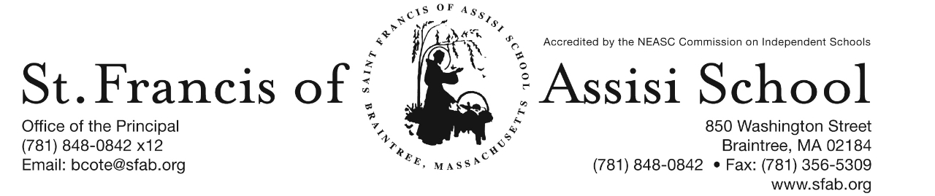

Volume 4, Issue 27– April 5, 2017

IMPORTANT DATES

Wed, Apr. 5th
- 3rd Term (grades 6 – 8) end

Mon, Apr. 10th
- Square One Order Forms Due!

Tue, Apr. 11th
- Gr. 3 Lenten Penance Service; 8:00
- Gr. 4&5 Lenten Penance Service; 1:00

Wed, Apr. 12th
- 3rd Term Report Cards (grades 6 – 8) distributed
- Grade 5 Field Trip to Boston Tea Party Ships & Museum

Fri, Apr. 14th
- Good Friday (No School)

Apr. 17th – 21st
- Spring Break

Apr. 24th – 28th
- Science Week!

NEW ENGLAND CYO TOURNAMENT – What an Outstanding Season and Accomplishment to represent Boston in the New England CYO Basketball Tournament in Bridgeport CT this past weekend. Unfortunately, our boys were defeated by St. Joseph School of Danbury, CT (40 - 29). Not only last weekend, but throughout the entire season, our boys played hard and demonstrated great sportsmanship. A special word of thanks to our coaches Mr. Rainford, Mr. Paula & Ms. Huff-Larmond for their leadership and coaching abilities; as well as to all our supportive parents and friends! A special word of thanks to our boys for representing SFA so well and know that we are so proud of them!

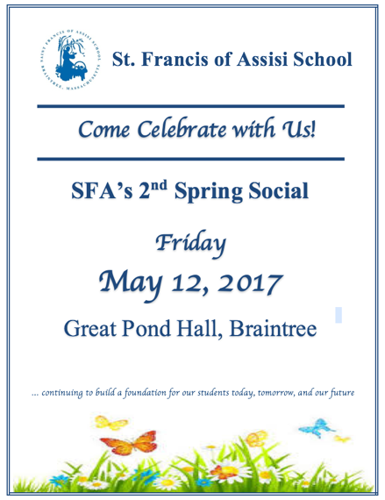
SFA’s 2nd ANNUAL SPRING SOCIAL
Come celebrate our St. Francis of Assisi School community on Friday, May 12, 2017 when we host our 2nd Annual Spring Social at the Great Pond Hall in Braintree from 6:00 pm – 10:00 pm. Like last year, our event will include a fun DJ, delicious hearty appetizers, desserts, and a cash bar. We will have one-of-a kind raffles, interactive fundraising games, a ‘wall of wine,’ and an amazing silent auction featuring tickets to Walt Disney World, and much more!

The funds raised at this year’s Spring Social will assist us in continuing to build a foundation for our students today, tomorrow, and our future as we continue to improve our curriculum offerings, teaching resources, and most specifically, technology needs and advancements. Early bird ticket purchases are now available at a discount, which comes with a homework pass for every child in your family. Tickets may be purchased online at http://sfabraintree.eventbrite.com?s=74493359 or visit our school’s website (www.sfab.org) for additional information and details. Once again, child care services will be provided on this evening. As always, we have the greatest appreciation for the generosity of our school families, faculty, staff, parishioners, and friends of St. Francis of Assisi School who never fail to come together to support the mission of our school.
SQUARE 1 ART
Please note that all Square 1 Art Order are due by Monday, April 10th.

SPRING BREAK – As our academic and monthly calendars indicate our Spring Break will formally begin on Friday, April 14th (Good Friday). Our students will return on Monday, April 24th.

SCIENCE WEEK – Science will once again come alive at St. Francis of Assisi School during the week of April 24th. The week promises to be fantastic with our Science Fairs, field trips and special Science presentations planned for each grade level. Listed below is the proposed schedule of events.

- Monday, Apr. 24th – Earth’s Materials Presentations for PK at 9:00 a.m.; K at 10:00 a.m. & Viewing of Middle School Science Fair projects.
- Tuesday, Apr. 25th – Forms of Energy Presentations for gr. 3 at 9:00 a.m.; gr. 4 at 10:00 a.m.; Judging of Middle School Science Fair projects & Awards Ceremony at 6:00 p.m.
- Wednesday, April 26th – Position and Motions Presentations for gr. 1 at 9:00 a.m.; gr. 2 at 10:00 a.m.
- Thursday, April 27th – Engineering Design Presentation for gr. 5 at 9:00 a.m.; and Regional Science Fair at SFXS.
- Friday, April 28th – Engineering & Erosion Presentations for gr. 7 at 9:00 a.m.; gr. 8 at 10:00 a.m. & gr. 6 visiting Legoland.

7th ANNUAL RUN for CHARLOTTE – Let’s Offer our Help, Support, and Hope to Families Fighting Pediatric Cancer by participating in this year’s 5K Road Race ~ 5K Walk for Charlotte on April 23rd at 10:00 a.m. For more information or to register: www. prayersforcharlotte.org. Once again this year, SFA would like to offer a challenge! The class with the best percentage of race registrants at the race will be awarded with a pizza party! So lace up your sneakers and we hope to see you all at the race! It’s a fun filled family event and a cause we are always happy to support here at SFA!

RE-REGISTRATION INFORMATION – It is the time of the year that we must begin the process of re-registration, as well as planning for the 2017 – 2018 school year. All re-registration forms for students enrolling in our Pre-Kindergarten – Grade 8 for the 2017 – 2018 school year have been sent home with students and are now due. Sibling registration forms are also available and may be obtained by contacting Mrs. Daly.

NEW STUDENT REFERRAL PROGRAM – “Become a SFA Ambassador & Receive a $500 Tuition Credit” (2017-2018 school year). As in the past many of our families initially hear about St. Francis of Assisi School through a personal referral from an existing school family. We want to once again reward you for promoting our school to you family and friends! We recognize that our parents are our best ambassadors. The Student Referral Program awards a referring SFA family with a $500 tuition credit for each student referred to SFA and enrolls for the 2017 – 2018 school year. Attached to this email is the New Student Referral Program form, which outlines in greater detail how the program works.

CHESS WIZARDS SPRING SESSION - St. Francis of Assisi School will be once again offering chess instruction sponsored by Chess Wizard. Let your child be part of a successful chess academy. Chess Wizards offers specifically designed classes that cater to all levels of chess ability. Each child is challenged by fun games and lessons from great chess teachers. It is proven chess enhances cognitive development in children, improves both verbal and mathematical skills, and increased all levels of academic performance. Our spring session will begin on Wednesday, April 25th … so don’t hesitate to register today on-line. More information about this program has been
attached to this email-blast.

FACEBOOK
Make sure you check and like us on our school’s facebook page.
https://www.facebook.com/sfabraintree

