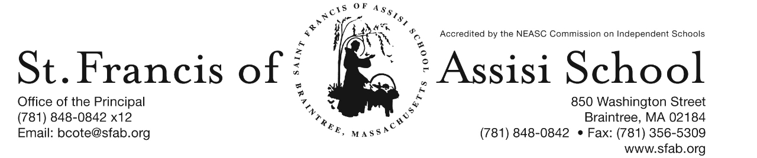

Volume 4, Issue 29– April 26, 2017

IMPORTANT DATES

Thur, Apr. 27th
- Position and Motions Presentations for gr. 1 at 9:00; and gr. 2 at 10:00.
- Regional Science Fair at SFXS

Thur, Apr. 27th
- Engineering Design Presentation for gr. 5 at 9:00;
- Donnelly’s Measurement and Fitting Day; 8:00 – 10:00 a.m.

Fri, Apr. 28th
- Engineering Design Presentation for gr. 5 at 9:00; Engineering & Erosion Presentation for gr. 7 at 9:00; and gr. 8 at 10:00; and Gr. 6 Field Trip to LegoLand.

Mon, May 1st
- MAP Testing (Math) for grs. 7 &8 at 8:30; gr. 6C at 9:00.

Tue, May 2nd
- MAP Testing (Reading) for grs. 7 & 8 at 8:30; gr. 6L at 10:15

Wed, May 3rd
- MAP Testing (Math) for gr. 6L at 8:30; (Reading) for gr. 6C at 9:00.

Thur, May 4th
- MAP Testing (Language) for grs. 7 &8 at 8:30.

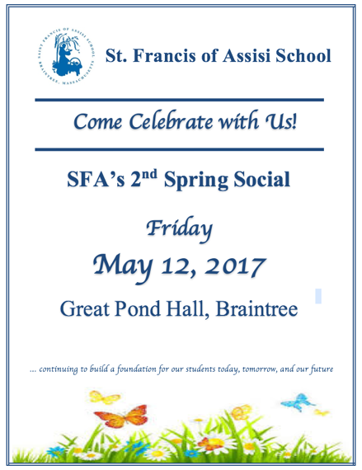
SFA’s 2nd ANNUAL SPRING SOCIAL
Come celebrate our St. Francis of Assisi School community on Friday, May 12, 2017 when we host our 2nd Annual Spring Social at the Great Pond Hall in Braintree from 6:00 pm – 10:00 pm. Like last year, our event will include a fun DJ, delicious hearty appetizers, desserts, and a cash bar. We will have one-of-a kind raffles, interactive fundraising games, a ‘wall of wine,’ and an amazing silent auction featuring tickets to Walt Disney World, an On-Field Experience with the Red Sox, July 4th Stay at Golden Eagle Lodge, Waterville Valley, NH and much more!

The funds raised at this year’s Spring Social will assist us in continuing to build a foundation for our students today, tomorrow, and our future as we continue to improve our curriculum offerings, teaching resources, and most specifically, technology needs and advancements. Tickets may be purchased online at http://sfabraintree.eventbrite.com?s=74493359 or visit our school’s website (www.sfab.org) for additional information and details. Once again, child care services will be provided on this evening. As always, we have the greatest appreciation for the generosity of our school families, faculty, staff, parishioners, and friends of St. Francis of Assisi School who never fail to come together to support the mission of our school.
TIME TO ORDER UNIFORMS - Tomorrow, Thursday, April 27th, representatives Donnelly’s Uniform Apparel will be at SFA for In-School Fitting and Measurement Day from 8:00 – 10:00 a.m.

SCIENCE WEEK – SCIENCE WEEK - This week Saint Francis of Assisi School celebrates Science through our science fairs and special presentations. Our students in grades PK, K, 3 and 4 certainly appeared to be engaged and enjoyed their special science presentations and hands-on experiments.
During the week, our students and teachers have also been decorating their classroom doors using the theme of dinosaurs. On Monday, May 1st, we will announce the winner of this years’ contest.
Listed below is schedule of our remaining events/activities:

- Thursday, April 27th – Position and Motions Presentations for gr. 1 at 9:00 a.m.; gr. 2 at 10:00 a.m.; and Regional Science Fair at SFXS.

- Friday, April 28th – Engineering Design Presentation for gr. 5 at 9:00 a.m.; Engineering & Erosion Presentations for gr. 7 at 9:00 a.m.; gr. 8 at 10:00 a.m. & gr. 6 visiting Legoland.

A special word of thanks to all who have submitted their Science Fee in order that we may continue to hold these special presentations for our students. If you have not, we ask that you please send in the Science Fee ($10) by the end of the week. Thanks for your continued support!

SCIENCE FAIR –Congratulations to all of our students in grades 6 – 8 for their participation in our Annual Science Fair over the last couple of days A special word of thanks and appreciation to Mrs. Clark and Mrs. Shea for their coordination of our Science Fair. All of our students did an outstanding job in preparing and presenting their individual projects. A special word of congratulations to our top three finalist in each grade level who will compete in our Regional Science Fair on Thursday evening, April 27, 2017. Our finalists include Grade 6 – 1st place John Ictech (The Best Stain Removee), 2nd Grayson Louvar (The Effect of Video Games), and 3rd Adrian Velazquez (Which Fruit Has the Most Vitamin C?); Grade 7 – 1st Darren Belizaire (Now You See It, Now You Don’t), 2nd Breanna Pham (Science of Making Perfume), and 3rd Daniel Murtagh (Detergent: Do Sudsy or Non-Sudsy Detergents Work Better?); Grade 8 – 1st Grace McDonald (Can Music Give You Energy?), 2nd Tyler Dao (Homemade Vacuum Chamber) and 3rd Kendall Phan (How Heavy is a Bubble?).

APRIL SHOWERS BRING MAY FLOWERS – As the month of May quickly approaches, we have so much to celebrate and such wonderful things happening at St. Francis of Assisi School. Many of our students in grade two will make their First Holy Communion next weekend. Throughout the month, our students in grades one through eight will be administered the NWEA MAP Spring Assessment. In addition to our strong academics, many enrichment and extra-curricular activities and programs will take place including field trips to Freedom Trail, Plymouth Plantation and Washington DC. We will also celebrate National Teacher’s & Nurse’s Days; and thank our wonderful faculty and staff for their dedication and commitment, as well as, the many gifts and talents that they bring to SFA.

SFA SUMMER CAMP 2017 - SFA Summer Camp Registration is now open; please find all of the registration paperwork for Summer 2017 on the Summer Program Registration Form link on the SFA website (www.sfab.org). We will be accepting registrations through June 7th. The Summer Program director is Ms. Julianna Gratta. If you have any questions regarding this summer’s information.

Please contact us at 781-848-0842 x16 or email us a jgratta@sfab.org. We are looking forward to a fun-filled and exciting summer with all of our wonderful campers.

RE-REGISTRATION INFORMATION – It is the time of the year that we must begin the process of re-registration, as well as planning for the 2017 – 2018 school year. All re-registration forms for students enrolling in our Pre-Kindergarten – Grade 8 for the 2017 – 2018 school year have been sent home with students and are now due. Sibling registration forms are also available and may be obtained by contacting Mrs. Daly.

NEW STUDENT REFERRAL PROGRAM – “Become a SFA Ambassador & Receive a $500 Tuition Credit” (2017-2018 school year). As in the past many of our families initially hear about St. Francis of Assisi School through a personal referral from an existing school family. We want to once again reward you for promoting our school to you family and friends! We recognize that our parents are our best ambassadors. The Student Referral Program awards a referring SFA family with a $500 tuition credit for each student referred to SFA and enrolls for the 2017 – 2018 school year. Attached to this email is the New Student Referral Program form, which outlines in greater detail how the program works.

FACEBOOK
Make sure you check and like us on our school’s facebook page.
https://www.facebook.com/sfabraintree

