ST. FRANCIS/ST. CLARE
BEREAVEMENT GROUP
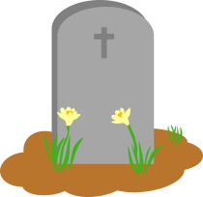

2nd & 4th Tuesdays, 1-2:30pm
downstairs in the
St. Francis Church Hall

September 13 & 27, October 11 & 25
November 8 & 22, December 13 & tbd

For more info please call 781.843.1332

NEWCOMERS WELCOME!!!

