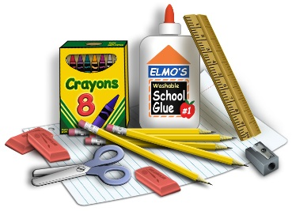

Third Grade Supply List

As future third graders, you have an exciting year to get ready for and we need to be prepared for our journey. Next year we will be using communal supplies within our classroom. I am hoping to collect our supplies right away so we can stock our classroom for the year.

Here’s a list of what you will need:

Personal Supplies:

(1) 1 ½” thick binder – any thicker than 1 ½ “ will be too bulky
(3) 2 pocket folders – one must be three-hole punched in it so it can
be put in the binder
(2) 2 pocket paper portfolio folders with 3 prongs
(1) clipboard
(1) pencil sharpener that collects shavings
(1) zipper pencil case (no plastic box cases please)

(over please)
Classroom Communal Supplies:

(20) # 2 pencils
(5) colored pens
(10) glue sticks
(1) 10 pack of colored markers
(1) 12 pack of colored pencils
(1) 24 count pack of crayons – Must not be bigger than 24 count
(1) pack of cap erasers for pencil tops
(1) pair of student scissors
(1) 12” ruler showing inches and centimeters
(2) yellow highlighters
(1) 4 pack of Expo dry erase markers for student dry erase boards
(1) Expo white board eraser for student dry erase boards
(3) packs of white index cards
(3) boxes of tissues
(2) rolls of paper towels
(1) package of baby wipes
(1) package of Clorox/Lysol disinfecting wipes
(3) boxes of Ziploc bags – 1 gallon size; 1 sandwich size; 1 quart size

I’m looking forward to seeing you all in September! Have a wonderful summer,
and thank you,
Ms. Gratta & Mrs. McGrath

