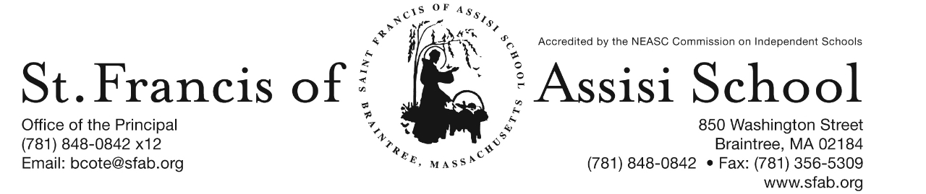

Volume 5, Issue 12 – Nov. 29, 2017
IMPORTANT DATES

Thur, Nov. 30th
- Grade 3 Field Trip to The Commonwealth Museum, Boston

Fri, Dec. 1st
- Grades 4 & 7 Field Trip to the movie “Wonders”

Sun, Dec. 3rd
- 1st Sunday of Advent

Mon, Dec. 4th
- 1st Trimester (grades PK-5) ends

Wed, Dec. 6th
- Red & Green Dress Down Day
- The Parent Connection Meeting; 7:00 p.m. in the School Hall

Thur, Dec. 7th
- Professional Day – No School for Students

Fri, Dec. 8th
- All School Liturgy (Feast of the Immaculate Conception); 8:45; All are Welcome!

Sun, Dec. 10th
- 2nd Sunday of Advent

Mon, Dec. 11th
Report Cards distributed in grades PK – 5.

ADVENT 2017
I hope you had a wonderful Thanksgiving with your families.

It is hard to believe that we will be turning our calendars to December Friday and we will celebrate the First Sunday of Advent this weekend. During the next few weeks, we will be focusing our students on Jesus’ birth during this Advent Season as we approach and reflect upon “The Reason for the Season.”

December promises to be another busy month at St. Francis of Assisi School, so please mark your calendars with various activities and events that have been included in this newsletter.

ADVENT PENANCE SERVICES
Grade 7 – Monday, December 4th at 8:00 a.m.
Grade 6 – Monday, December 4th at 1:00 p.m.
Grade 3 – Monday, December 11th at 8:00 a.m.
Grade 5 – Monday, December 11th at 1:00 p.m.
Grade 4 – Wednesday, December 13th at 8:00 a.m.
Grade 8 – Monday, December 18th at 8:00 a.m.

GRADE 3 FIELD TRIP
Tomorrow, Thursday, November 30th, our grade three students will be visiting The Commonwealth Museum in Boston from 9:00 a.m. – 2:00 p.m.

GRADES 4 & 7 FIELD TRIP
On Friday, December 1st, our students in grades four and seven will be visiting AMC to watch “Wonders”.

1st TRIMESTER ENDS
Please note that the 1st trimester for students in grades pre-kindergarten through five will officially end on Monday, December 4th. Report cards will be distributed on Monday, December 11th.

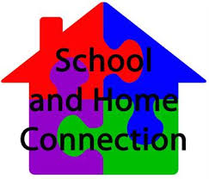
PARENT CONNECTION MEETING
On Wednesday, December 6th, a Parent Connection Meeting will take place at 7:00 in the School Hall. Please join us!

PROFESSIONAL DAY – NO SCHOOL
On Thursday, December 7th, there will be NO School for the students for it is a Professional Day. On this day, our faculty and staff will be re-certified in CPR as well as continued to work on our school’s self-study for our upcoming NEASC visit.

ALL SCHOOL LITURGY
On Friday, December 8th, our SFA School community will gather for an All-School Liturgy in honor of the Feast of the Immaculate Conception. The students in Grade Three will be planning and coordinating this Liturgy.

HOLIDAY CALENDAR CAMPGAIGN
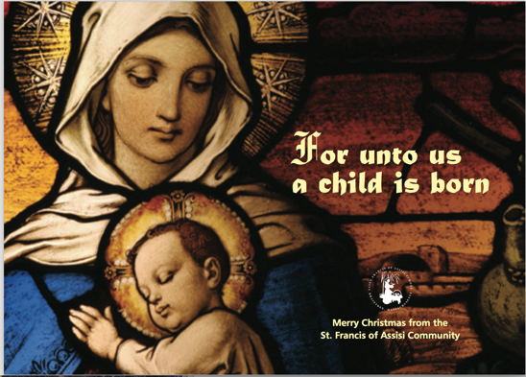
Just a reminder that our Holiday Calendar Campaign will end on December 15th, with our first drawing taking place on January 4th.

Need Your Assistance! We will be seeking students and parents who would be interested in assisting us in selling Holiday Calendars at the end of the weekend masses at St. Francis of Assisi Parish the weekends of December 9/10 and 16/17. The mass schedule includes Saturday at 4:00; Sunday at 7:00, 9:30, and 10:30. If you could help us with one of these times, it would be greatly appreciated. If interested, please contact Mrs. Daly at 781-848-0842 x10 or email cdaly@sfab.org.

SFA FUNDRAISER AT THE CHATEAU
SAVE THE DATE!!! On Thursday, December 14th, enjoy lunch/dinner or take-out at The Chateau in Braintree from
11:15 – close and SFA will receive 20% of the total bill of all food and beverages. Please note: Fundraising Tickets are Required: so when paying your check, give the server your fundraising ticket (attached to this email; or available on our school’s homepage).

Santa’s Workshop is Coming Soon to SFA!
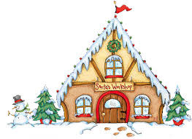
Santa’s Workshop is a Holiday Gift Shop for the children of Saint Francis of Assisi School to purchase gifts for their loved ones. We all have special memories of buying some small token for our parents and siblings during Christmas. We will give our students the chance to create special memories of giving to the ones they love.

Our Santa’s Workshop will be held on Friday, December 15th during the school day. The classroom teachers will bring the students to Santa’s Workshop. There will be a large variety of gifts from .50 cents to $10 to choose from. In preparation for this day, a budget envelope (Gift List Planner) will be provided in next week’s communication materials and we ask that you please assist your child in filling out the names of the people for whom they would like to purchase gifts. Please place all cash or check made payable to SFA in the envelope. Our grade eight students will assist the other students throughout the day.

Breakfast with Santa will be held on Saturday, December 16th from 8:30 – 11:00 a.m. Have your picture taken with Santa, enjoy a nice breakfast, and have fun with friends and family at this beloved Saint Francis of Assisi School tradition. Santa will arrive at 9:00 a.m … do not miss this special arrival. Tickets are $5 per person or $15 per family. We hope to see you there.

Our annual Christmas Concert will be just around the corner on Wednesday, December 20th. Our Christmas Concert is such a popular event that we have again decided to do two performance of this great show. Everyone works so hard to prepare for this concert that we feel they should showcase their talents more than once!

In order to fairly divide our audience for the concerts, we have split the school alphabetically by Family Names. Families with last names start with A to K will attend the first performance at 8:30 AM to 9:45 AM and families whose last names begin with L to Z will attend the second performance at 10:15 AM to 11:30 AM. Please note that this is an early release day at 12:00 noon and there will be no Extended Day Care Services provided on this day! Attached is Music Notes with additional details and information.

BASKETBALL INFORMATION
One of the several extracurricular activities that St. Francis of Assisi School offers is its organized basketball teams for both girls and boys. Our school is a member and participates in the South Shore Parochial School League (S.S.P.S.L.). This league runs a basketball program for full-time students in grades three through eight, attending Boston's "South Shore" Parish/Catholic Schools. This program is overseen by the Office for New Evangelization of Youth & Young Adults and administered by the Archdiocese of Boston CYO Program.

The schedule of games has been finalized and may be accessed at www.sspsl.net or a link has been added to our school’s website (www.sfab.org) that will automatically bring you to the various schedules.

Please note that SFA’s home court will be at the University Sports Complex, 645 Washington Street in Hanover during the month of December; and the Dana Barros Basketball Center, 1776 Washington Street in Stoughton beginning in January. Looking forward to a wonderful basketball season.

CHRISTMAS SERVICE PROJECTS
In keeping with the tradition of giving this holiday season, our school community will participate in a variety of Christmas service projects.

In our middle school (grades 6 – 8), our students will be participating in a Christmas service project to help the homeless that are served by our local communitites. From December 4th through December 15th, we will be collecting hats, gloves, mittens, scarves, and socks, in children and adult sizes, for those less fortunatel than ourselves. All donations will be brought to an area bank that will send these items to the Salvation Army to be distributed as the need arises.

In our elementary school (grades PK – 5), our students will be participating in a Christmas service project to help keep children warm in the cold. From December 4th through December 20th, we will be collecting new school aged size pajamas for children in need. All donations will be delivered to the Massachusetts Department of Children & Family located in Braintree.

Finally, as an entire school community, we will be sponsoring a “Red and Green” Dress Down Day on Wednesday, December 6th. The proceeds from this dress down day will be used to adopt a family for Christmas. As always, we thank you for your help and generosity in these matters.

FACEBOOK – Make sure you check and like us on our school’s facebook page.

https://www.facebook.com/sfabraintree

