Monday | Tuesday | Wednesday | Thursday | Friday | Special Entrée of the Week  St. Francis of Assisi School Lunch Menu  October 2017  MENU SUBJECT TO CHANGE WITHOUT NOTICE  Did you know…  October 9-13 is National School Lunch Week!  National School Lunch began in 1946 when recruits for WWII were found to be undernourished.  About 7.1 million children participated in the National School Lunch Program in its first year.  Today, over 30 million students enjoy school lunches every day.  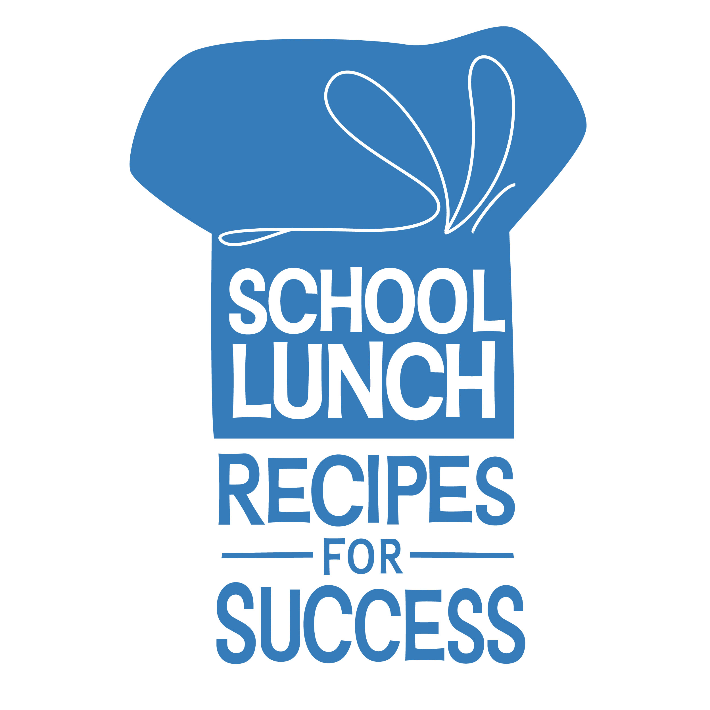  Available as entrée choices everyday:  PB & J sandwich with graham crackers and cheese stick  Fresh Garden Salad with Pita Bread  You can now prepay and check balances and transactions online! Go to www.myschoolbucks.com to register.  This institution is an equal opportunity provider
2  Creamy Homemade Mac & Cheese  Green Beans  Carrot Coins  Fresh Fruit | 3  Sloppy Joe on a Bun  Homemade Baked Beans  Roasted Red Potatoes  Apple or blueberry Crisp | 4  Chicken Potato Bowl  Creamy Mashed potatoes, topped with Whole grain coated popcorn chicken, Corn niblets , with or without gravy  Whole grain Dinner Roll  Fresh Fruit Cup | 5  Meatball Sub  Garden Side Salad  Light Ranch Dressing  Mixed Veggies  Fruit | 6  Domino’s Pizza  Baby Carrots  Fresh Broccoli florets  Creamy Ranch Hummus dip  Cookie | Chef Salad  Slice ham, turkey and hard boiled eggs with peppers and tomatoes on a bed of iceberg and Romaine lettuce
9  Columbus Day  No School  National School Lunch Week! | 10  Soft Taco  Cheese  Salsa  Shredded Romaine Lettuce  Corn  Lowfat Sour Cream  Peaches | 11  Penne Pasta  With or without meatballs & sauce  Garden Side Salad  Fresh Grapes | 12  Hot Dog on a Bun  Pickles  Condiments  Homemade Baked Beans  Fresh Watermelon | 13  Personal Pizza  Baby Carrots  Green Pepper Slices  Lite Ranch Dip  Assorted fresh and cupped fruit  Cookie | Earthy Crunchy Wrap  A whole wheat tortilla filled with creamy Sunflower butter, Crisp matchstick carrots, plump sweet raisins and crunchy sunflower seeds
16  Chicken Florentine Pasta  Soft Garlic Breadstick  Garden Side Salad  Dressing  Homemade Kale Chips  Fruit | 17  Choice of Hamburger or Cheeseburger on a WW Bun  Tomato and lettuce toppers  Pickles  Condiments  Homemade Baked Beans  Pears | 18  Grilled Cheese Sandwich  Tomato Soup  Pepperidge Farm cheddar Goldfish crackers  Applesauce | 19  French Toast Sticks  Syrup  Sausage  Tater Tots  Fresh Orange Smiles  Ketchup | 20  Big Daddy’s Pizza  Baby Carrots  Celery  Light ranch Dip  Cookie | Ham and Cheese Sub
23  Ham & Cheese Flatbread Sandwich  Pickles  Steamed Broccoli Florets Condiments  Warm Blueberry crisp  Fruit | 24  Pulled Pork on a whole wheat bun  Homemade Baked Beans  Condiments  Pickles  Choice of Pudding with or without topping | 25  Half Day  No Lunch Served | 26  Fish-In-chips  Acadian Red fish breaded in Cape Cod potato chips  Baked Krinkle Cut French fries  Homemade cole slaw  Choice of condiment (tartar sauce, BBQ Sauce, or ketchup)  Dinner roll  Fresh Fruit | National Chocolate Day! 27  Domino’s Smart Slice Pizza  Pears  Baby Carrots  Green Pepper Slices  Cherry Tomatoes  Lite Ranch Dressing  Cookie | Choco-Sunbutter & Banana Wrap  Sunflower butter and sliced fresh bananas with a sprinkling of mini chocolate chips on a wheat wrap
30  American Chop Suey  Smile Fries  Fresh Orange “Smiles” | Halloween! 31  “Bat Wings” (Chicken nuggets)  Monster Goo (BBQ sauce)  Boo-licious Broccoli Salad  Trick or Treat Tater Tots  Frightening Fruit  Choice of “Murky” Milk | Price of lunch: $3.25 (free and reduced price $0.40 meals available for families that qualify)  Al a Carte Milk: $0.50 | Milk and assorted veggies and fresh and cupped fruit is included at every meal every day. | Applications for free or reduced meals available at school office and at www.braintreeschools.org  Contact Megan Ahrenholz, RD with questions or comments at mahrenholz@braintreema.gov  Or 781-848-4000 x 7045 | Buffalo Bill Chicken Wrap

