NCEA Convention 2012
During the NCEA convention in Boston held April 11 to April 13th, the teachers at Saint Francis of Assisi had the opportunity to attend many interesting information sessions. These expert presenters helped us to develop our teaching styles and encouraged us to look deep at the school curriculum. Having time to reflect on teaching in the classroom renews our spirit and excitement and challenges us to add new dimensions to our teaching. We also had the chance to investigate many new teaching products that will bring interest to our lessons!
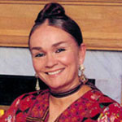
At NCEA, I had the pleasure of meeting Patricia Polacco who has inspired me both as a teacher and a parent. She is a children’s story writer and also illustrates her own books, a rarity in the children’s literature world. Having a talent to write and draw is and extreme challenge! I had her sign a book called The Art of Miss Chew, an autobiographical book about an art teacher who inspired Ms. Polacco to continue drawing. It is something my children and I will treasure.
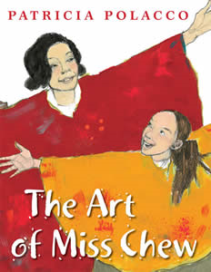
However, Polacco’s life has not always been easy. As a child she struggled with all academic areas because she has dyslexia which is a language based disability. This disability made is difficult for her to read, write, and memorize things. She remembers being very frustrated as a young learner, but shared in her discussion that “each teacher gave a new piece to the puzzle.” Her teachers also encouraged her to draw and share her gifted talent with her classmates and with others. When children hear that Ms. Polacco became a writer despite a learning disability, they feel hope that they too can overcome a personal difficulty. Enjoy looking for her books at the library and check out more about her life at her website: http://www.patriciapolacco.com/.
At my home, one of our favorite Patricia Polacco Books to read is Thundercake. In this story a young girl is staying with her grandmother and she is afraid of the upcoming thunderstorm. Her grandmother eases her fears by encouraging her to make find all the ingredients to make chocolate “Thunder” cake. By the time the thunderstorm comes, the young girl is so busy in making the cake that she forgets her fear of the thunder and lightning. As a young boy, my son Nicholas was very fearful of thunderstorms, but after reading this book and making Thunder cake together, he became excited and interested in these harsh thunderstorms.
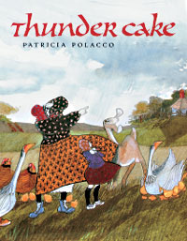
It was wonderful having the opportunity to experience the convention. Getting to meet Patricia Polacco was a highlight as she has been someone I have great admiration and respect. Her stories, her artwork , and her presentation helps me to characterize my purpose at a teacher.

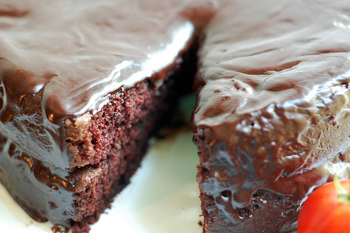
Yummy Thundercake has a surprise ingredient! Look at the recipe below and see if you can figure it out!
Thunder Cake
Pre-heat oven to 350 degrees.
Cream together one at a time:
1 cup shortening
1 3/4 cup sugar
1 teaspoon vanilla
3 eggs, separated
( blend yolks in. Beat whites until they are stiff, then fold in.)
1 cup cold water
1/3 cup pureed tomatoes
Sift together:
21/2 cups cake flour
1/2 cup dry cocoa
11/2 teaspoons baking soda
1 teaspoon salt
Mix dry mixture into creamy mixture. Bake in two greased and floured 8
1/2 inch pans at 350 degree for
35 to 40 minutes. Frost with chocolate butter frosting. Top with
strawberries.

