Fine Motor Skills and academic Success:
Did you know when we move and develop our bodies, we are also improving and developing our minds? From brain imaging, doctors can tell that there is a relationship between moving our bodies and academic success. In this newsletter, we will be sharing some specific ways that you can help your child with fine motor skills. Fine motor activities involve the use of the small muscles of the hands. Many school tasks such as writing, drawing, and cutting require good fine motor skills, so it is helpful if these skills. Many people think that only young children need to exercise fine motor skills. However, fine motor activities are helpful for all ages… even adults! Building strength in the fingers not only calms the right brain, but also stimulates the left-brain, the part of the brain needed for reading, math, and writing success. Fine motor activities are especially great for children with ADHD. Studies have shown that providing ADHD students with fine motor training would positively impacted their academic achievement. Fortunately, there are many easy and enjoyable ways to provide additional opportunities for children to actively develop their fine motor skills at home as a family.

- Coloring is the precursor to writing. Enjoying coloring together can be a relaxing and enjoyable family event. Have you child choose a favorite coloring book at the store or find coloring pictures together on websites such as Crayola.com.

- Crayons should be held in a tripod grasp. The non-dominant hand should hold the paper and an upright posture should be maintained. Coloring books, dot-to-dot books, cut and paste books, and sticker books are useful; parents may need to guide these activities to ensure success.

- Cutting with scissors is an important fine motor skill. Correct grasps require that both scissors and cutting paper are held in “thumb up” positions (thumb should be on top of the paper). Activities: paper chains, cutting coupons, cutting pictures in magazines.

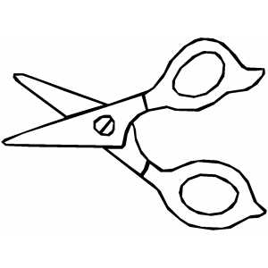
- Clay or play dough is fun to play with and requires strength and coordination. Have your child make shapes or roll out dough and cut shapes with cookie cutters. Hide buttons in dough and have your child pull them out.

- Origami paper folding crafts and Kirigami cutting paper craft. Check out the origami yoda or origami with a dollar bill.

- Clothing fasteners such as buttons, snaps, zippers, and shoelaces require hand control. Help your child practice fastening and tying. Try tying new bows on your stuffed animal collection – colored shoelaces work well.

- Crafts such as sewing, crochet, and scrapbooking can be a great way to develop dexterity in fingers.

- Stringing beads and lacing cards require coordination of both hands and rely on the child being able to watch the hands as they move.

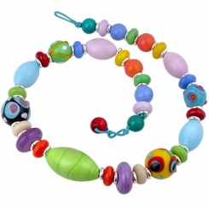

- A number of commercially available toys require fine motor coordination; these make good gifts (Trouble, pop beads, chalkboards, Lego’s, doll clothes, puzzles).

- Writing on a vertical surface promotes proper grasp. Shaving cream can be used on hard surface or an easel. Practice writing name, spelling words, or math problems.

- Let your child sort small objects for you. Nails, screws, and bolts can be sorted at the tool bench; paper clips, safety pins, rubber bands, and coins can be sorted from the desk. Putting a large number of pennies in a bank is a fun activity.

- Use of toaster tongs to pickup small objects and place them in a container develops hand strength.

- The use of simple tools may be motivating for some children, while developing fine motor control. Screw drivers, hammers, or rolling pins can be used in play or to “help” Mom and Dad during activities. Putting together a collection of varied size nuts and bolts is good for increasing finger dexterity.

- Blow up a balloon or wad up a piece of paper and play games with it as if it were a ball; hit it into the air with a paddle, racquet, paper plate, or hands. These activities help to develop hand eye coordination.

- Encourage your child to cook and try out new recipes. Molding and rolling play dough into balls - using the palms of the hands facing each other and with fingers curled slightly towards the palm. Roll dough into tiny balls (peas) using only the finger tips or cut dough with a plastic knife or with a pizza wheel. Making cookie dough and rolling cookie dough into balls

- Using pegs or toothpicks to make designs in play dough.

- Tearing newspaper into strips and then crumpling them into balls. Use to stuff scarecrow or other art creation.

- Scrunching up a sheet of newspaper in one hand. This is a super strength builder.

- Using a plant sprayer to spray plants, (indoors, outdoors) to spray snow (mix food coloring with water so that the snow can be painted), or melt "monsters". (Draw monster pictures with markers and the colors will run when sprayed.)

- Picking up objects using large tweezers. Try picking up food, small cubes, small marshmallows, pennies, etc.
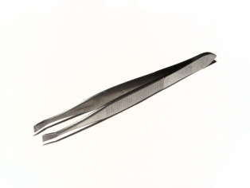

- Shaking dice by cupping the hands together, forming an empty air space between the palms.

- Using eye droppers to "pick up" colored water for color mixing or to make artistic designs on paper.

- Rolling small balls out of tissue paper, then gluing the balls onto construction paper to form pictures or designs.

- Turning over cards, coins, checkers, or buttons, without bringing them to the edge of the table.

- Making pictures using stickers or self-sticking paper reinforcements.

- Playing games with the "puppet fingers" -the thumb, index, and middle fingers. At circle time have each child's puppet fingers tell about what happened over the weekend, or use them in songs and finger plays.
- Check out the website http://therapyfunzone.com/ for fun family activties

