Dear St. Francis Community,
We are very excited to have another art show this year. The students have been worked hard this year and have tried many different ways to express themselves through art. We have learned about many artists and have used different medium.
Again I ask you to recycle old magazines, used crayons, milk bottle caps and jigsaw puzzle pieces.
We will use all of these in our art classes in the 2012/2013 school year.
I look forward to seeing everyone on the 31st.
Ellen March

ART SHOW 2012
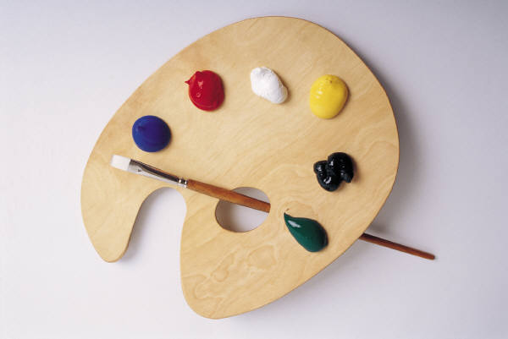

The students at Saint Francis of Assisi School have completed many different forms of art this year and we are excited to show our family and friends what we have been doing in art classes this year.

Please join us Thursday May 31st at 7 PM
Walk the halls of the Saint Francis Gallery and enjoy the many examples of student work!

